The Straw Bridge

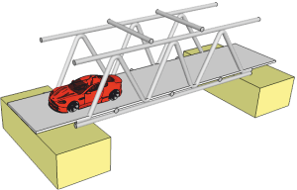Instructions
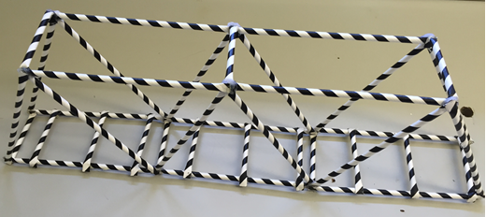

- Complete the design and construction of a truss bridge made from paper drinking straws.

- You are limited to 40 paper straws maximum. Each straw is 200mm long.

- The joins are made by hot gluing the straws together.

- The bridge will need to support a thin flexible PVC strip used as a roadway.
The roadway is 70mm wide.
A loaded trolley is 70mm wide, 100mm tall and 100mm long.
The trolley is pulled over the bridge during the strength and stability testing.

- Design a truss that can span a gap of 500mm

- Draw a side view of the truss design full scale.

- Use the drawing to accurately layout the truss.
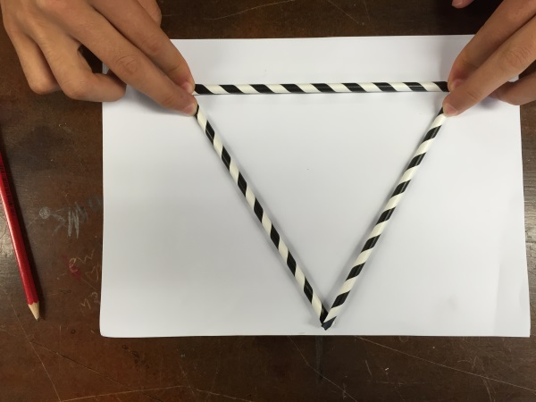
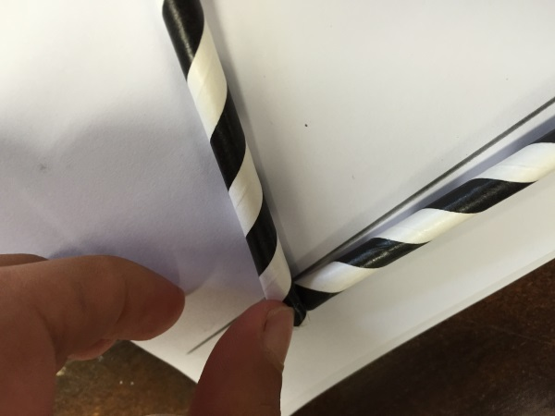
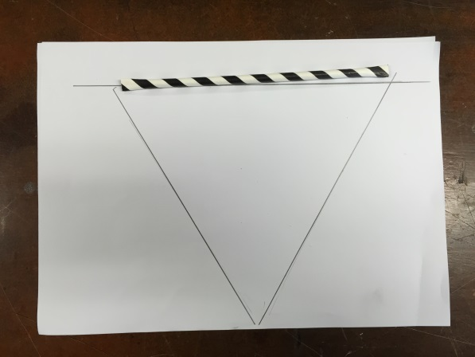
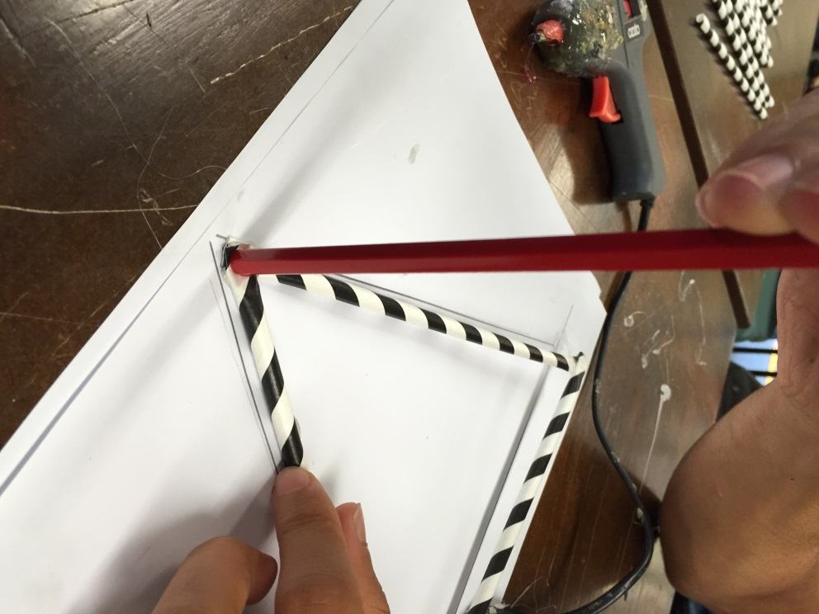
Glue each joint together. Use a pencil to press the join together as the hot glue cools.

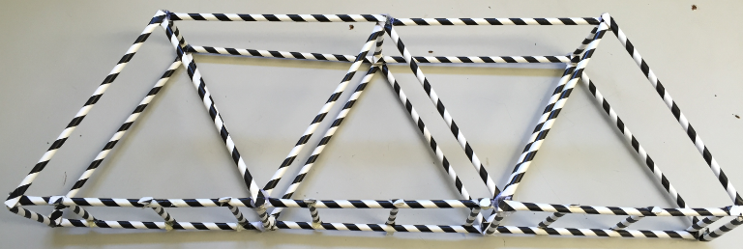
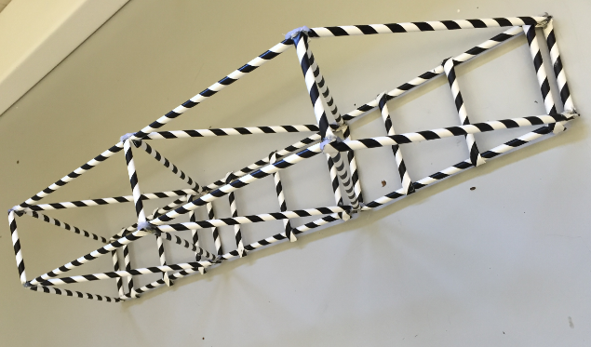

Example 1
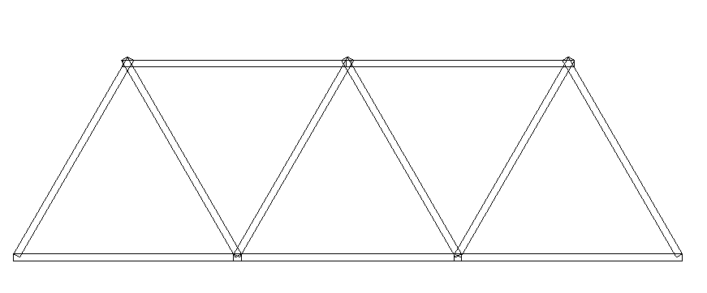

Example 2 and 3
