**Year 9 STEM Task – Term 4 2013**

**Using Maths to Solve Practical Problems**

**4 Ways To Measure The Height of a Tree – WikiHow**

Task – Using the techniques outlined on the website above, find an estimate for the height of a particular tree on western Oval.

[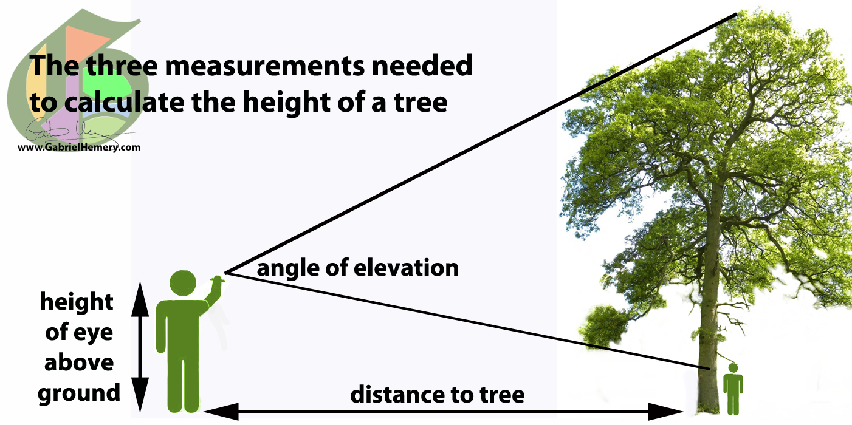](http://www.google.com.au/url?sa=i&rct=j&q=how+to+measure+the+height+of+a+tree&source=images&cd=&cad=rja&docid=_wxaK4mpAk8vwM&tbnid=DcHdAspJcdBqWM:&ved=0CAUQjRw&url=http%3A%2F%2Fgabrielhemery.com%2F2011%2F05%2F15%2Fhow-to-calculate-tree-height-using-a-smartphone%2F&ei=o3tUUse8FsTKkwXap4GwBg&bvm=bv.53760139,d.aGc&psig=AFQjCNHN1-lLB32Y6guW6_jMkamy7Vua7w&ust=1381354727666938)Over the next two weeks in small groups of 3-4 ALL 4 of the techniques outlined on the website will be utilised, and then averaged out to find the height of a particular tree on Western Oval.

Make yourself familiar with the techniques shown on the website, practice them at home if you like. Note that there are many smartphone ‘apps’ that will adequately replace the need for a clinometer.

All necessary working out must be shown and handed in for a group mark out of 10.

The calculations will be performed during Week 2.

The due date for the task is Week 3.

Your submission should be NO MORE than ONE A4 sheet of paper.