Using trigonometry to calculate height

THE DATA REQUIRED
You will need to know three things:
- The angle of elevation to the top of the tree from the horizontal
As shown below the horizontal will be equivalent to a line between your eye and someone of the same height standing next to the tree.

- The distance from where you stand to the base of the tree

- The height of your eye above the ground

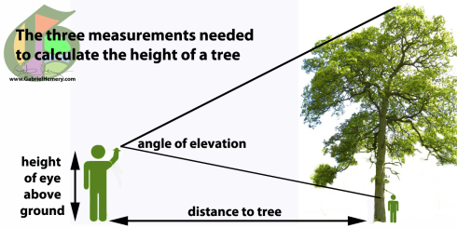
The three measurements needed to calculate the height of a tree

THE MATHS
Don’t be put off if you’re not confident about the maths as, although it may seem daunting, it’s actually quite simple. You will use trigonometry but your smartphone’s calculator will do all the hard calculations for you.
The equation you will use is:
Height = tan θ × distance to tree + height of eye above ground

Step by step guide (with working example)

1. STAND AWAY FROM THE TREE
Stand away from the tree so that you can see its top. The method works best if your angle of elevation is about 45º. In other words that your distance from the tree is equivalent roughly to the height of the tree (you’ll get better at estimating this, the more trees you measure).

2. MEASURE THE DISTANCE AWAY FROM THE TREE
If you are working with someone else they can help you measure the distance from where you’re standing to the tree. If you’re on your own, drop something where you’re standing to mark the position so that you can return once you’ve measured the distance to the tree.
I was 21m away from my tree. Write this distance down or memorise it.

3. MEASURE THE ANGLE OF ELEVATION
Standing at your spot (step 2) open the virtual spirit level app on your smartphone and select the angle measure. Bring the smartphone to your eye and sight along its edge, as if you’re looking down a gunsight, aiming at the very top of the tree. You will need to hold the phone so that your fingers are not in the way (see photo).With the app I use there is a ‘hold’ button that freezes it when you are satisfied that you are ready to record the angle. My angle of elevation was 43.7º. Write this angle down or memorise it.

4. CALCULATE TREE HEIGHT
Open the calculator on your smartphone. You will need to access the scientific calculator. For iPhones and HTCs you can do this by tilting your phone onto its side (landscape), where you will find the function for Tangent or Tan.
So my tree was 21.798m tall. Given that there is lots of room for error I would recommend that you round the result to the nearest whole number = 22m tall.

