Engineering Investigations
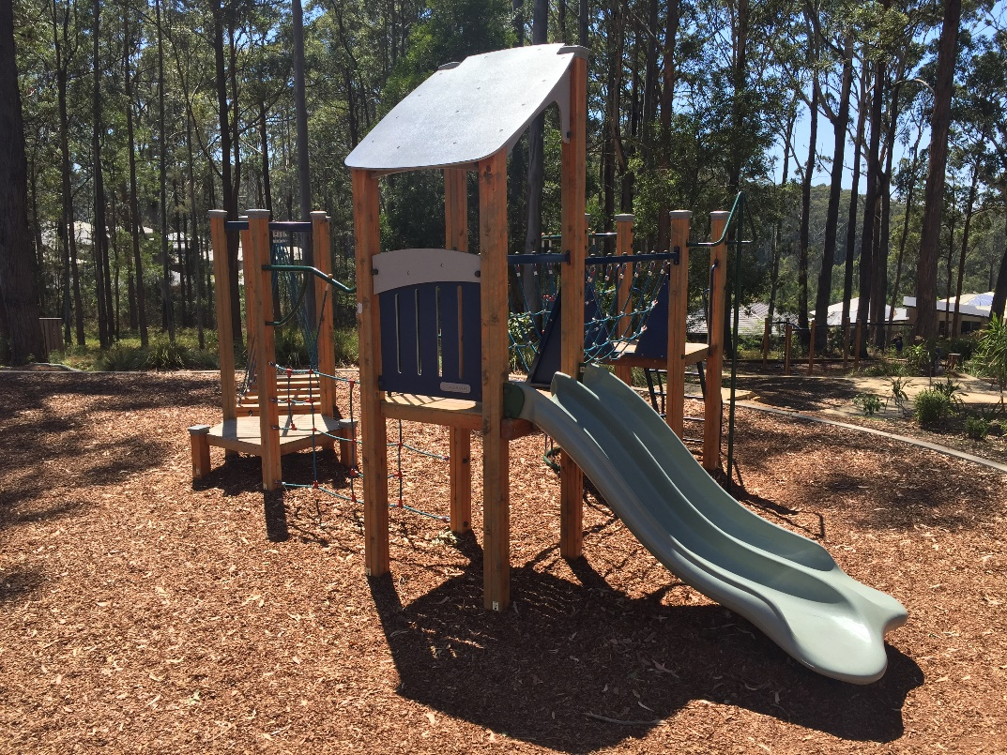
Children’s Playground
1 Engineering practices
The design of the playground would require the work of specialized engineers knowledgeable in particular areas of engineering. Those areas of engineering knowledge would include environmental, material, mechanical and many more.

- Discuss the role several engineers would play in developing a children’s playground.
- Discuss ethical issues that would be included in development of the design.
- Discuss specifically what a material engineer’s role might be in the design of equipment.
- Discuss specifically what a mechanical engineer’s role might be in the design of equipment.
- Discuss what important function teamwork would take in the development of design.
- Discuss what content might typically be included in an engineering report about a new children’s playground.
Engineering projects require engineering reports. The report will identify the scope of the project and explain to the reader the technical issues involved in developing and completing the project. Even a very basic engineering report will include an introduction, analysis, conclusions and recommendations. Acknowledgements and bibliography
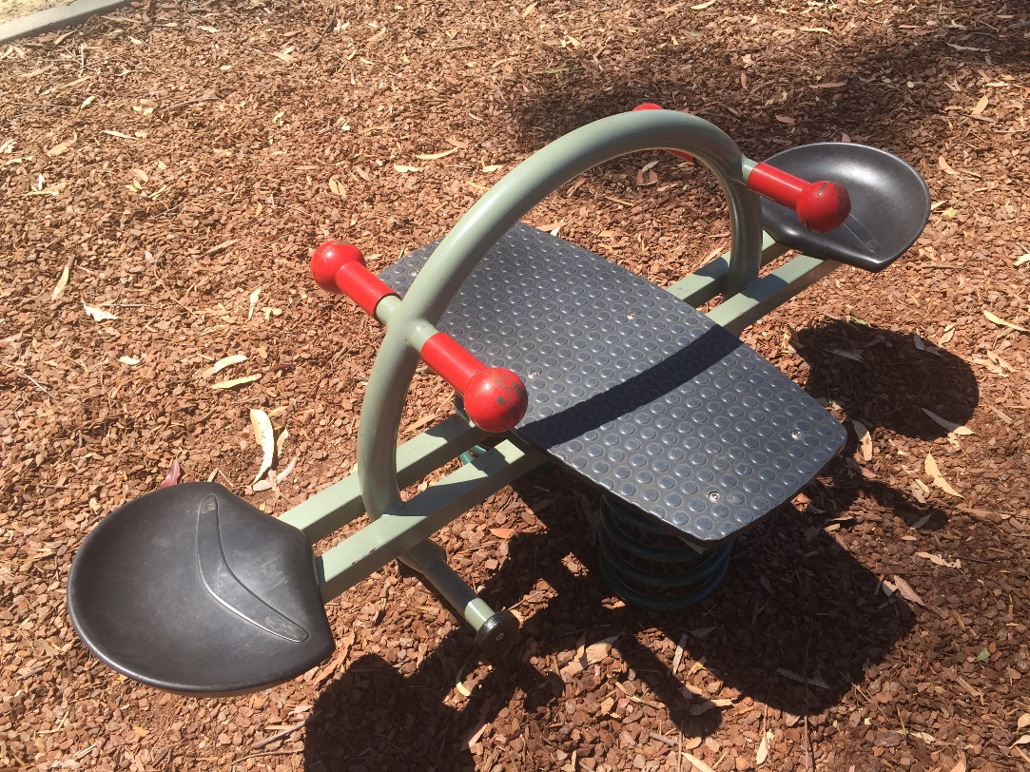

2 Engineering developments and innovation
Children’s playground design and the equipment used has changed significantly.
Effective design can play a role in community wellbeing.

- Discuss the social effects of community playgrounds
- Discuss the historical use of material types in playground equipment
- Discuss the historical application of simple machine principles in playground design
- Discuss innovation in playground equipment

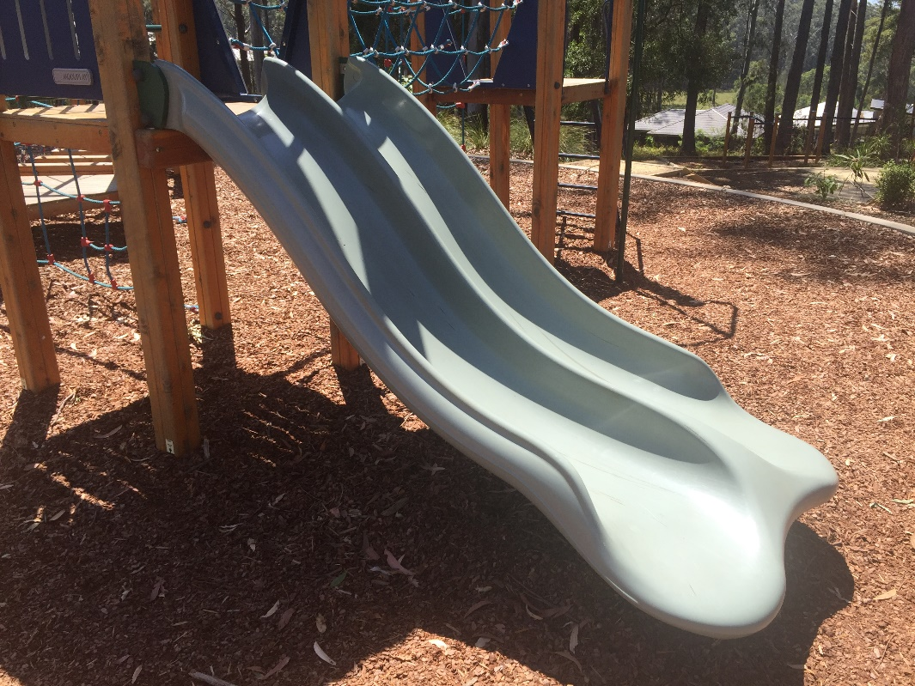

3 Engineering mechanics
Engineering mechanics involves the analysis of forces within the structures and components of the playground. Fundamentally, this analysis ensures the component performs the task that is required. The mechanical analysis also ensures that a significant factor of safety can be designed into the component. It also ensures the component is not wasteful in material use, and therefore the costs of manufacture are minimised.
Many simple machine concepts can be identified in playgrounds. They include levers, inclined planes, screws, wheels and axles, pulleys and gears.
Solving mechanical problems can be completed using mathematical and graphical solutions.
- Discuss playground equipment and identify mechanical situations
- Identify several ‘simple machines’ concepts applied within the equipment.
- Calculate the forces created using mathematical techniques
- Consider which of these analyses could have been completed efficiently using graphics.
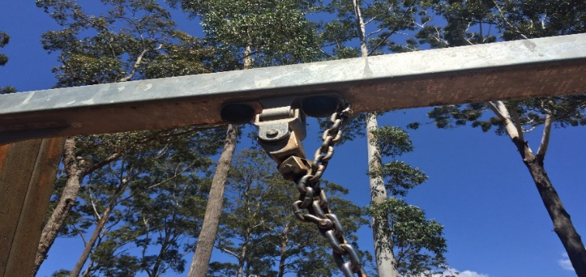
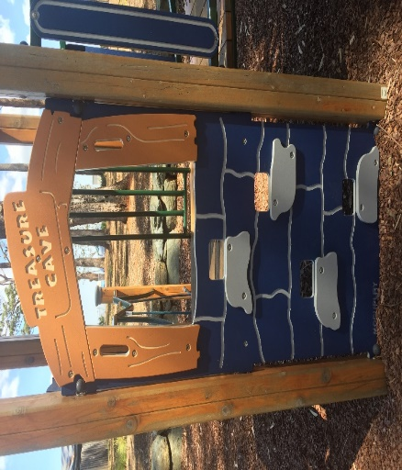
4 Engineering materials
Materials can be classified into many types. Traditional engineering categories include metal, timber, polymers, ceramics and composite materials.
Engineers must select materials suitable for the application. To make this selection a range of material properties will be taken into account.
These properties will affect how the component can be manufactured economically and how well it will perform when in use. The properties are usually determined through various destructive, or non-destructive, tests.
Environmental and ethical factors also effect decisions.
Selection of forming processes – metals,
Hot rolling, cold rolling, pressing, casting, laminating, extrusion, machining, cold forging, hot forging,
Selection of forming processes – polymers,
Blow moulding, vacuum forming, Injection moulding, extrusion, compression moulding, plastic coating,
Selection of forming processes – ceramics
Dry pressing bricks, casting, glass blowing, extrusion of bricks, slip casting.

5 Technical Graphics
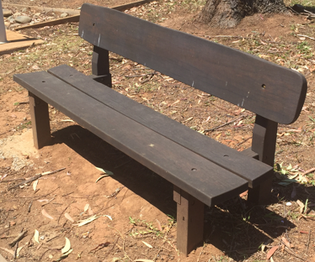

Communication of ideas is critical to engineering. Design specifications need to be transmitted clearly between design engineers and manufacturers. Mistakes in communication are costly.
Standard ways of communication specifications and ideas are essential for engineering.
For that reason there are international and Australian standards for technical graphics.
Clarity in communicating design specifications are the tags of quality engineering.
Two common types of technical graphics are orthogonal and pictorial drawing.
Two common types of creating technical drawings are by freehand sketching and by Computer Aided Drawing.

