122

Force Fundamentals

Exercise 1
Describe what is meant by the following terms?
- Scalar quantities: A scalar quantity possesses magnitude but no direction
eg. Mass-20kg; Length 500mm; Time 30 secs.

- Vector quantities: A vector quantity possesses both magnitude and direction
eg. Force, Velocity, Acceleration.

Exercise 2
Complete the table by classifying the following quantities as vectors or scalars.

Quality |  | Scalar or Vector
1 hour 35 mins | Time | Scalar
80 kg | Mass | Scalar
10 m/s North | Velocity/Direction | Vector
4m² | Length | Scalar
9.8 m/s⁻² vertical down | Acceleration/Direction | Vector
24 m/s South East | Velocity/Direction | Vector
4.5 m | Length | Scalar
50 N vertically up | Force Magnitude/Direction | Vector
1 m³ | Volume | Scalar
10 s | Time | Scalar
25 km in a North East | Velocity/direction | Vector
1 × 10⁹ | Magnitude | Scalar

Exercise 3
Determine the force created in a vertical down direction by a stack of six {6) boxes each with a mass of 6.5 kg. Use the analytical (mathematical) method.
Start with a formula and show all workings. M = 6.5 × 6 = 39kg
F = 39 × 10
= 390 N

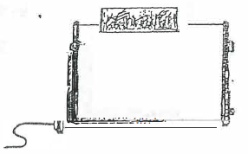
Exercise 4
- Determine the force created in a vertical downward
direction by a toaster that has a mass of 6.4 kg.
M = 6.4kg
A = g = 10m/s-²
F = m a Force: __64N__
= 6.4 × 10
= 64N
- The toaster now has four 25 gram slices of bread in the slots. Calculate the new vertical downward force created by the loaded toaster.
Mass of toaster = 6.4kg F = m a
Mass of toaster = 4 × .025 = 6.5 × 10
= .1kg = 65N
Total mass = 6.5kg
A = g = 10m/s-² Force: 65N__

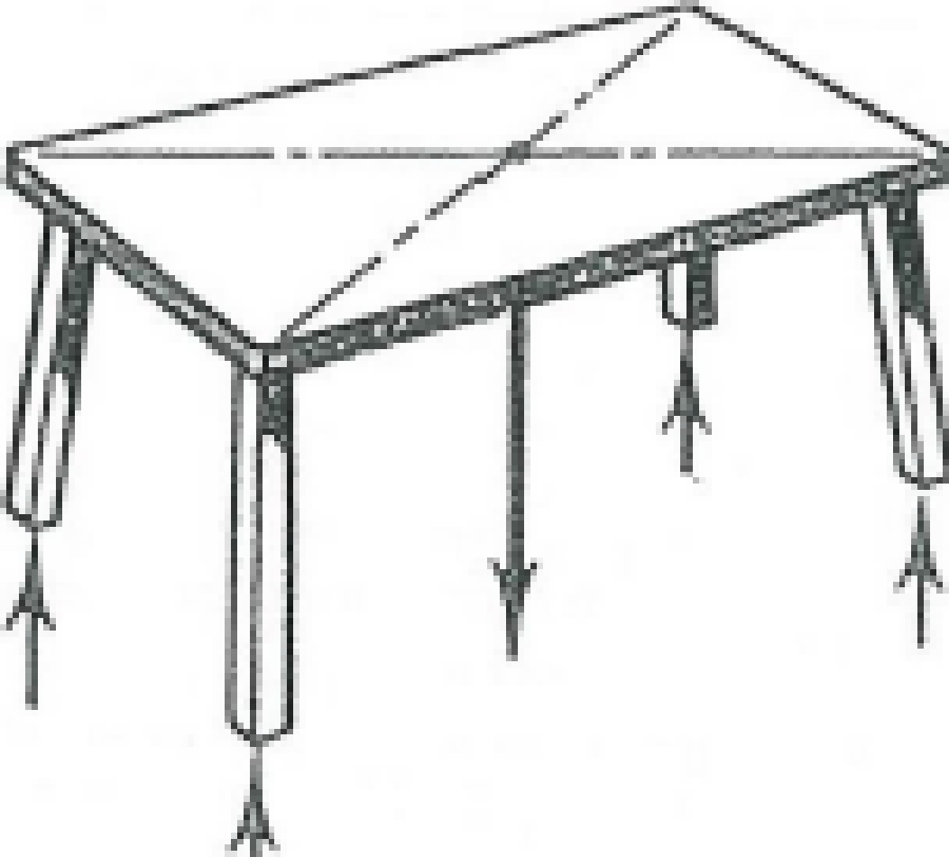
Exercise 5
What is the magnitude of the force exerted by the floor on each leg of the table of mass 50 kg.
What are these forces called?
Mass of table = 50kg
Force exerted by table
F = m a
= 50 × 10
= 500N
Force exerted by floor on legs Magnitude of force: 125N__
= 500/4 The force is called a Reaction
= 125N
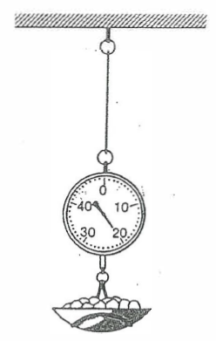
Exercise 6
Determine the tension in the cable supporting the spring balance. The spring balance has a mass of 2 kg and it is showing a reading of 20 kg.
Total mass = 22kg.
A = g = 10m/s²
F = m a
= 22 × 10
= 220

Tension in the cable: _ 220N__

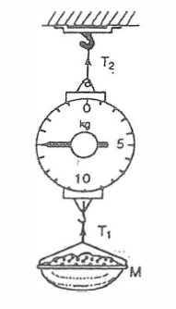
Exercise 7
Find the values:
- mass M
- Tl
- T2
Note the mass of the cable is 1.5 kg
- Mass M is reading on scales 15kg.

- Tension 1
M = 15kg. F = m a
A = g = 10 m/s² = 16.5 × 10
= 165N

- Tension 2
M = 15 + 1.5 F = m a Mass: ___15kg____
= 16.5kg = 16.5 × 10 Tension 1: ___150N____
= 165N Tension 2: ___165N____

Exercise 8
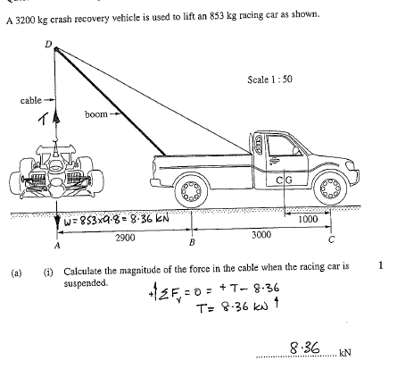

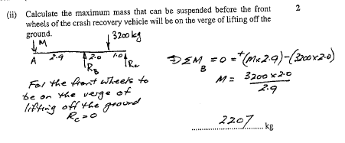
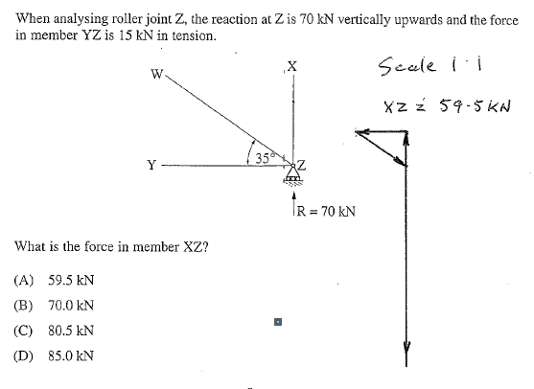
Exercise 9
A

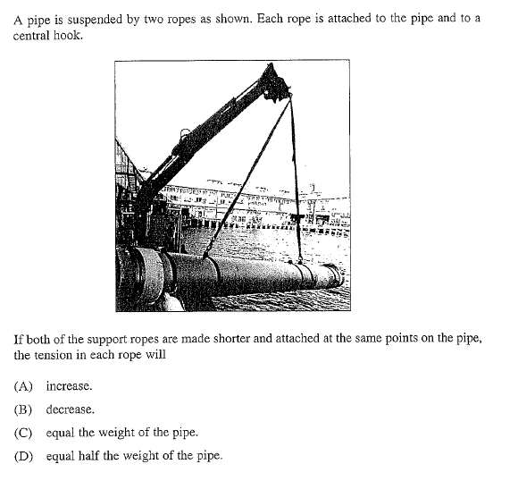
Exercise 10
A

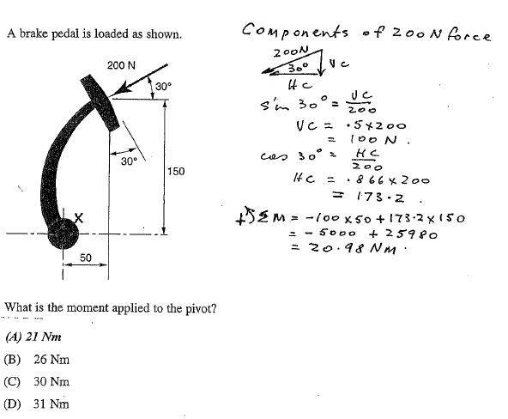
Exercise 11

Exercise 12
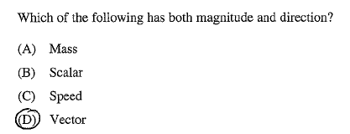

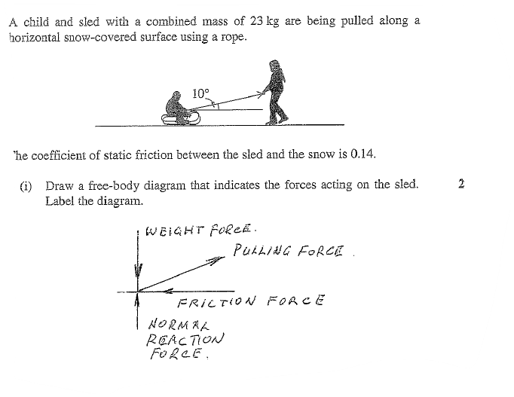
Exercise 13

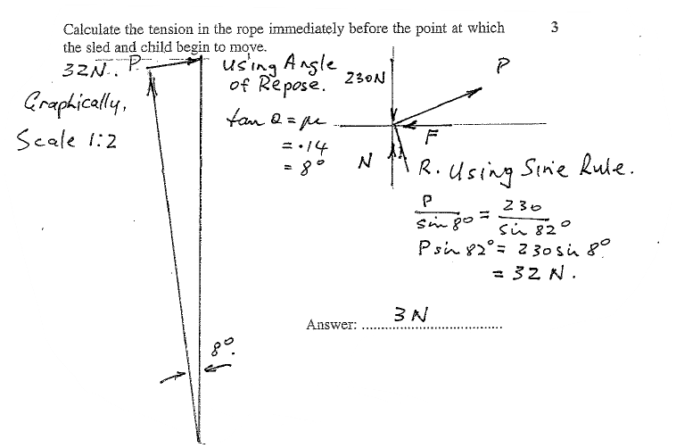
Exercise 14
Exercise 15
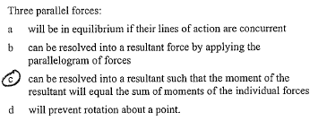

Exercise 16
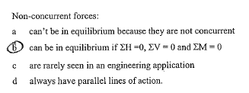

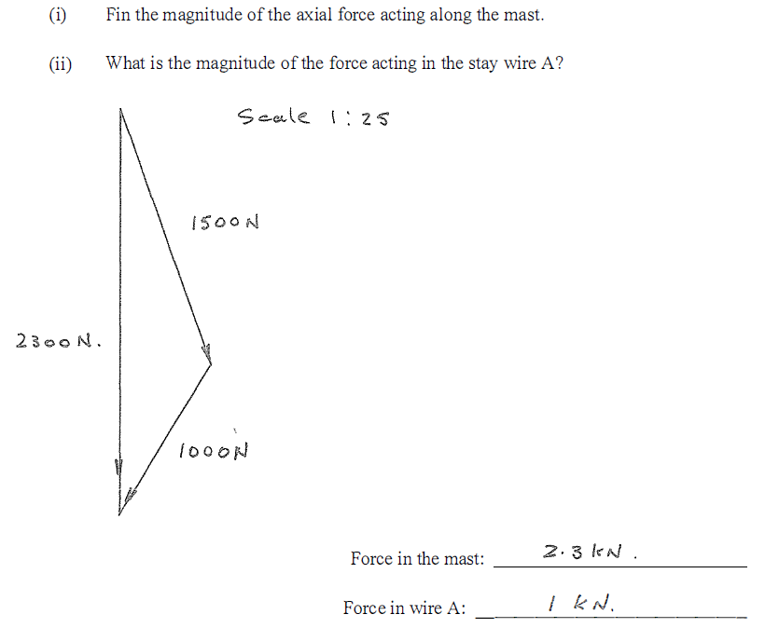
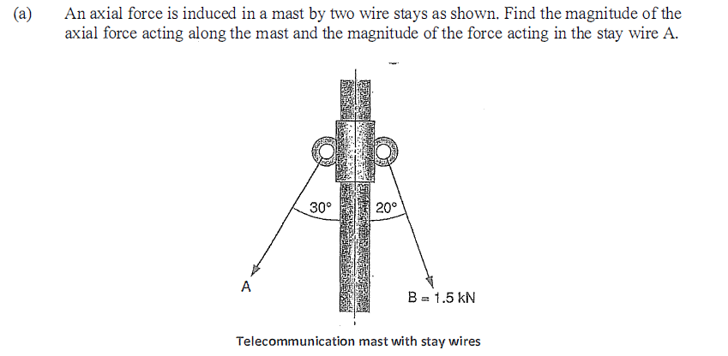
Exercise 17
Exercise 17 (Continued)
