123

Simple Machines - Fundamentals

Exercise 1
What is the Mechanical Advantage of a machine if a 30 N force lifts a 20 kg load?
_____Convert 20 kg to Newtons ________________________________________________
______20 kg = 200N__________________________________________________________
________M A = L/ E___________________________________________________________
____________= 200/ 30_______________________________________________________
____________= 6.67__________________________________________________________
___________________________________________________________________________
___________________________________________________________________________

Exercise 2
Find the effort required to lift a toad of 300 N, if a lever is 1.5 m long. A fulcrum is placed under the lever 300 mm from the load.
Free body diagram.
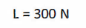
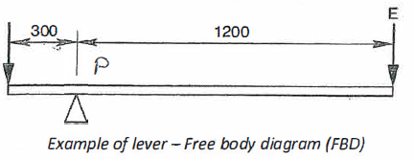

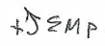
= 0
= + 300 + 300 – E x 1200 MA _____4_______
E = 90000
1200
= 75N MA = L = 300
E 75
= 4

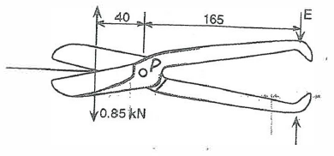
Exercise 3
If the maximum force resisting shear offered by the sheet metal is 0.85 kN, find the effort required and the mechanical advantage of the system.
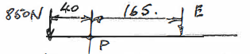

= 850 + 40 – E × 165 Effort ____206N____
165E = 34000 MA 4.13
E = 206N ؞
MA = L/ E L = 850N
= 850/ 206 = 413 E = 206N

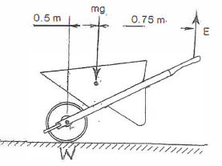
Exercise 4
Calculate the force which must be applied to the handle in order to hold the wheelbarrow up in a stationary position. What is the mechanical advantage of the system?
The wheelbarrow+ load= 46 kg.
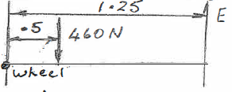
M = 46kg.
F = 46 × 10
= 460N
= -460 × .5 + E × 1.25 Force _____184N_____
1.25E = 230 MA _____2.5_______
E = 184N
MA = L/E L = 460N
= 460/ 184 E = 184N
= 2.5
Exercise 5
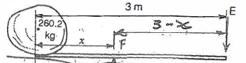
A rock, to be raised by a 3 m lever, has a mass of 260.2 kg. If a vertical effort of 425 N is available, calculate:
- The mechanical advantage of the system.
- The distance, x, for the position of the fulcrum. u L = 260.2kg
Disregard the mass of lever. = 2602N MA = L/E
E = 425N =2602/ 425
= +2602 × x – 425(3 – x) = 6.1
= 2602x – 1275 + 425x
2602x + 425x = 1275 MA _____6.1_______
3027x = 1275 Distance _____421 mm___
X = 1275/ 3027
= .421 m
= 421 mm

Exercise 6
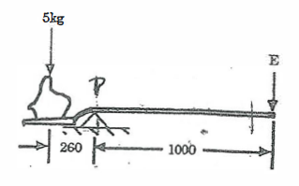
Some landscapers use a shovel as a lever to assist in moving rocks.
- Calculate the force required at E to balance the 5kg rock on the shovel as shown.
M = 5kg
= 50N
= 50 × .26 – E × 1 Convert mm to m
E = 13N Force at E: ___13N___
- Determine the mechanical advantage of the lever system shown in (a) when the shovel is used as shown.
MA = L/ E L = 50N
= 50/ 13 E = 13N
= 3.85

___3.85___
Exercise 7

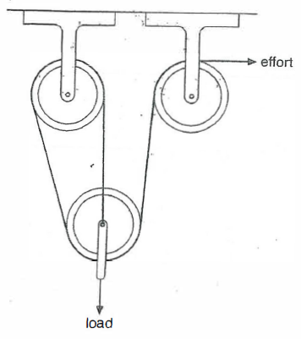
The pulley system shown is part of an apparatus attached to a bed-.in hospital to life the leg of patients.
Determine the VR ·of the system.

Number of ropes supporting the load = 3

VR _____3_____

Exercise 8
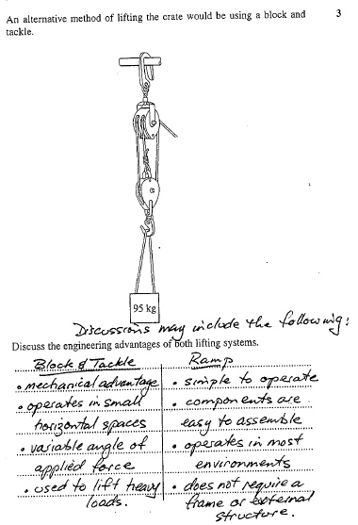

Exercise 9
