**131**

Material

**Categories, Bonding**

**and Structure**

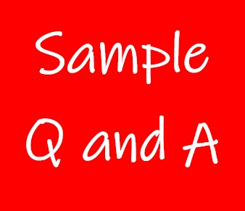

**Exercise 1**

