**241**

**Pictorial Sketching**



**Exercise 1 – Copy these isometric blocks.**

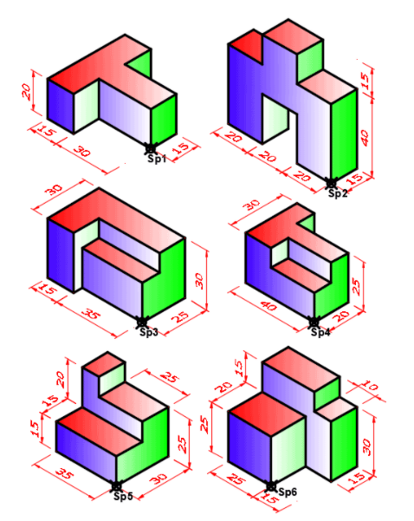

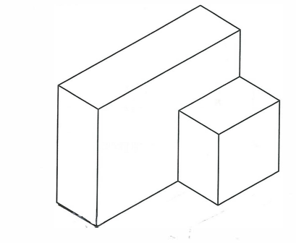

**Exercise 2**

Make an isometric drawing of the object shown below when viewed in the direction of the arrow.

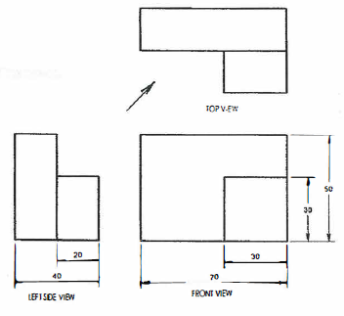

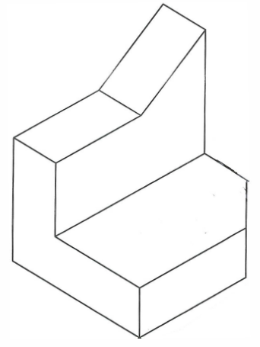

**Exercise 3**

Make an isometric drawing of the object shown below when viewed in the direction of the arrow.

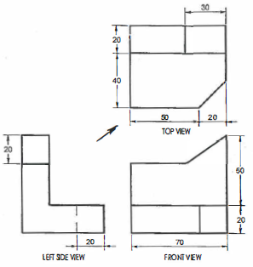

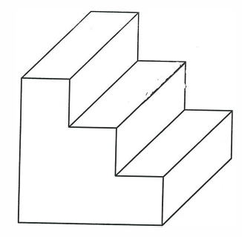

**Exercise 4**

Make an isometric drawing of the object shown below when viewed in the direction of the arrow.

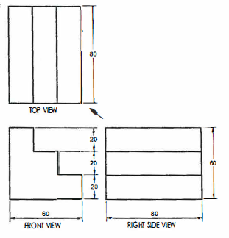

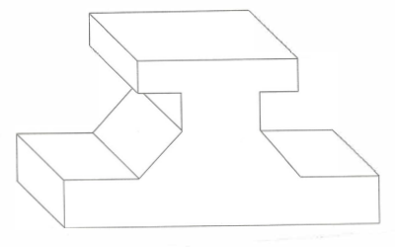

**Exercise 5**

Make an isometric drawing of the object shown below when viewed in the direction of the arrow.

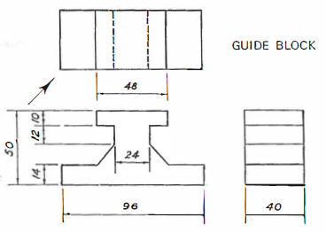

Exercise 6

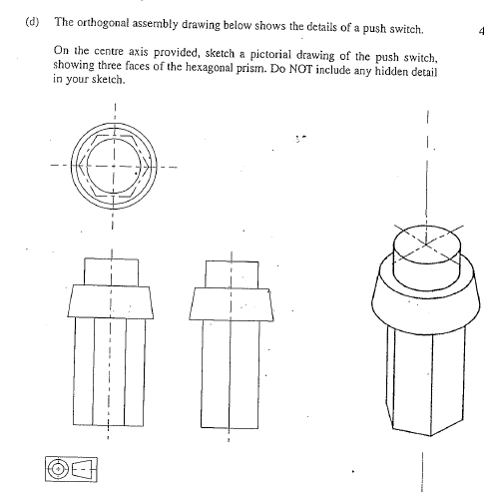

Exercise 7

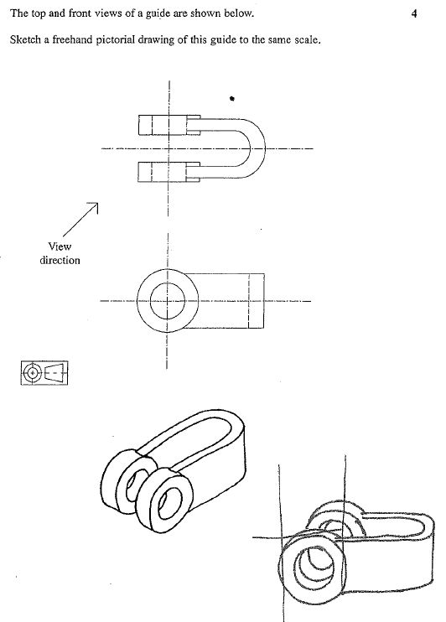

Exercise 8

