

**242**

# Orthogonal Sketching



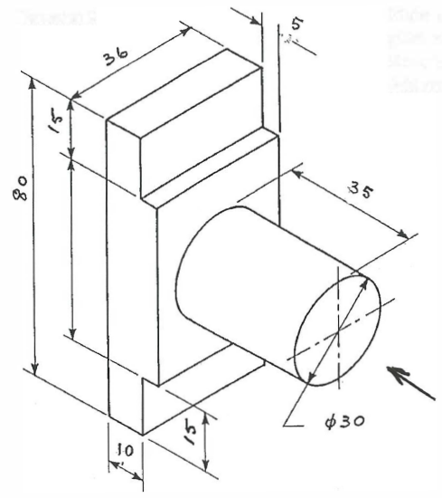**Exercise 1**

Make an orthogonal drawing of the machine piece when viewed in the direction of the arrow. Show top, front and left side views. Add main dimensions.

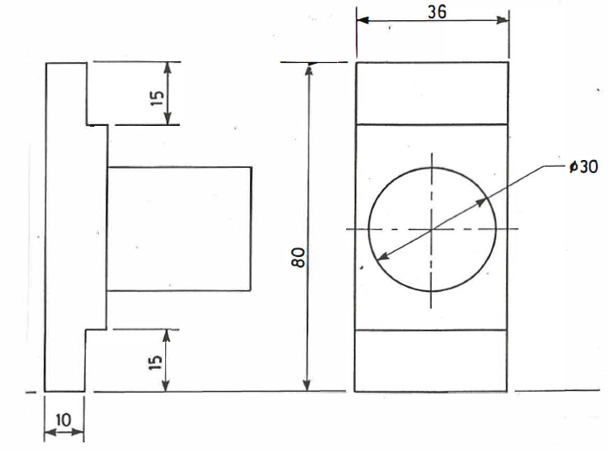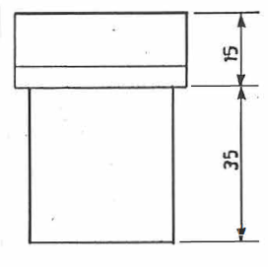

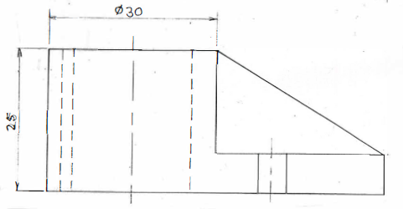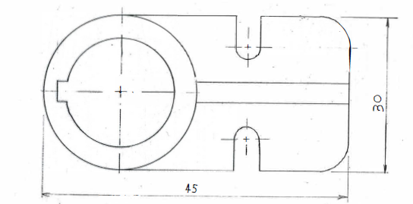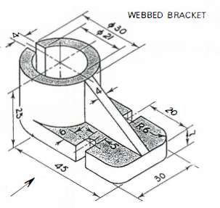

**Exercise 2**

Using full AS 100 standards make an Orthogonal drawing of the Webbed Bracket when viewed in the direction of the arrow. Show Top, Front and Right side views. Add main dimensions.

Use a scale of 2 :1

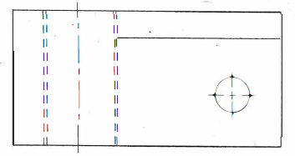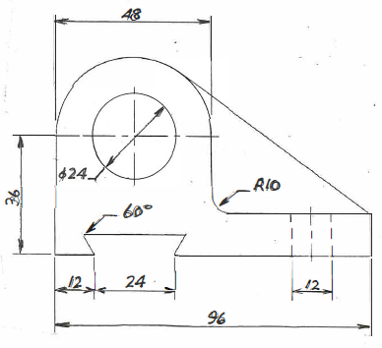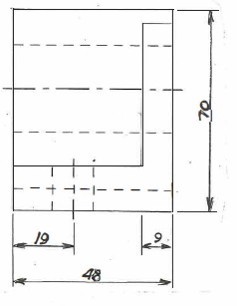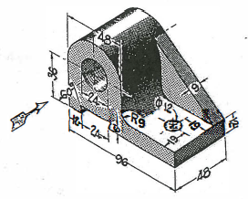

**Exercise 3**

Make an Orthogonal Drawing of the Steady Bearing showing a Top view, a Front view and a Right side view.

Add dimensions.