**435**

**Glass -**

**Shaping and Joining**



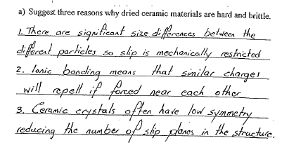**Exercise 1**

**Exercise 2**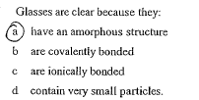

**Exercise 3**

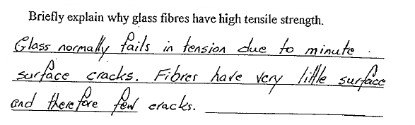

**Exercise 4**

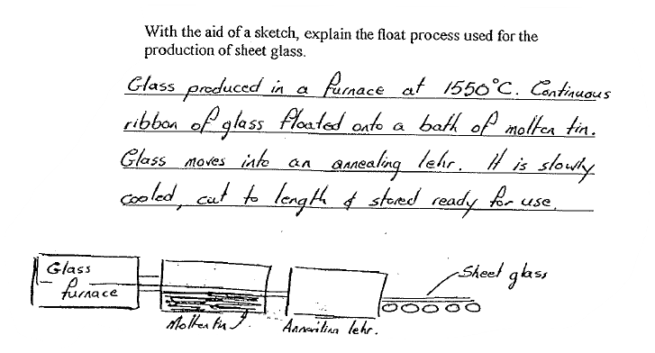

**Exercise 5**

