453

Integrated Circuits
and
Semi Conductors

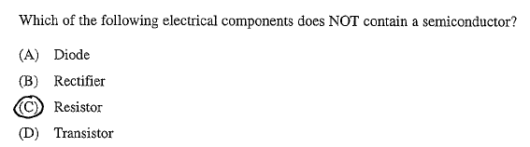
Exercise 1

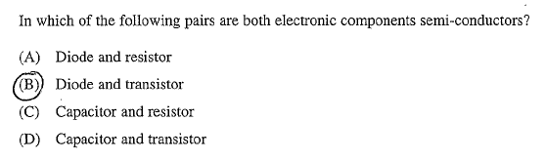
Exercise 2

Exercise 3
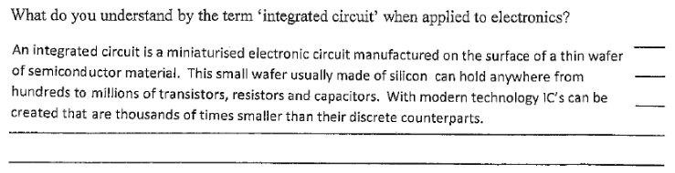

Exercise 4
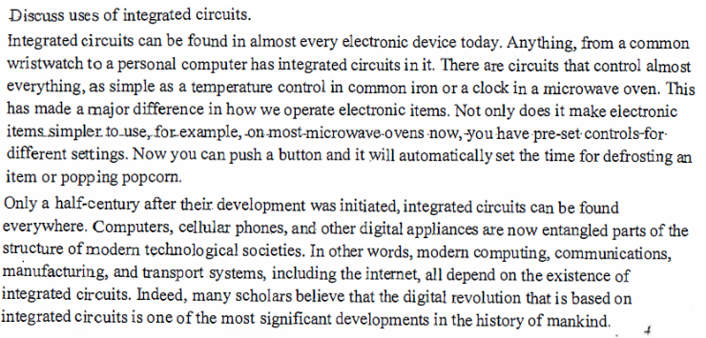

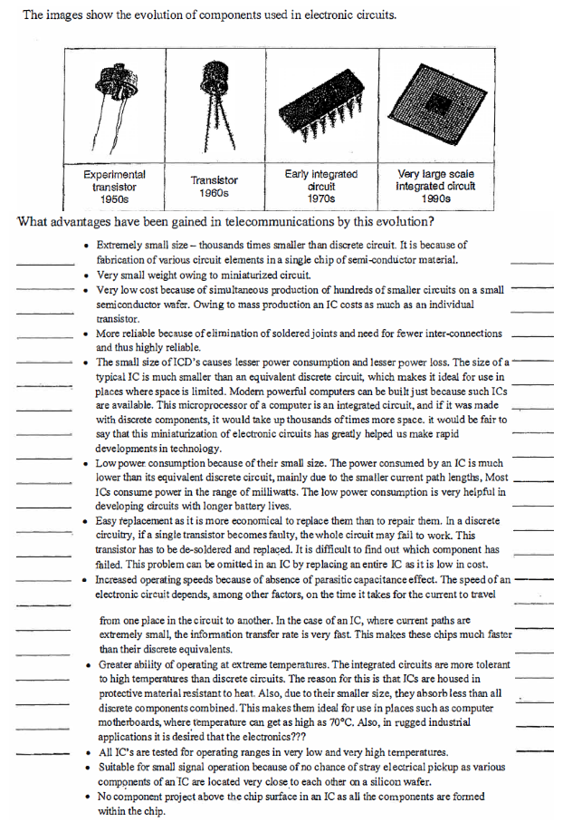
Exercise 5
Exercise 6
