**622**

**Work Power**

**Energy**

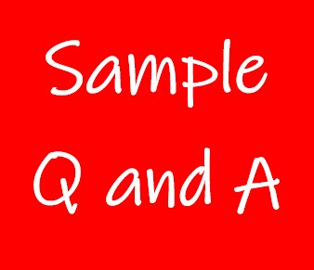

**Exercise 1**

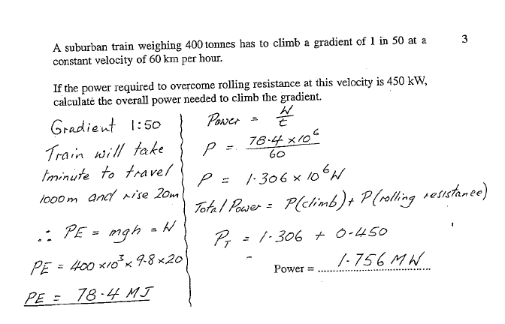

**Exercise 2**

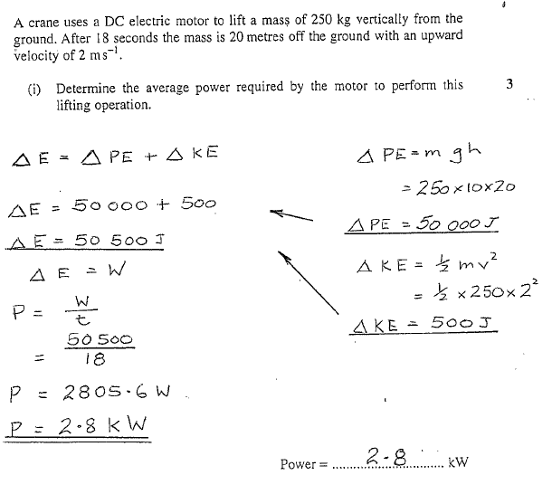

**Exercise 3**

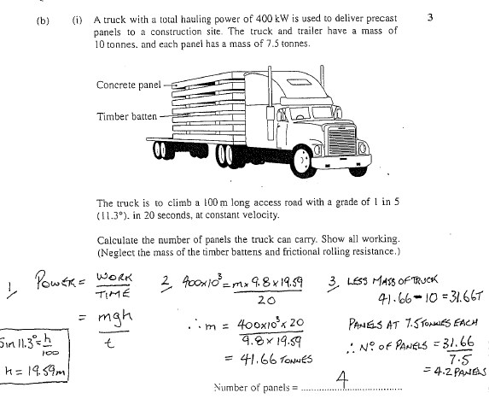

**Exercise 4**

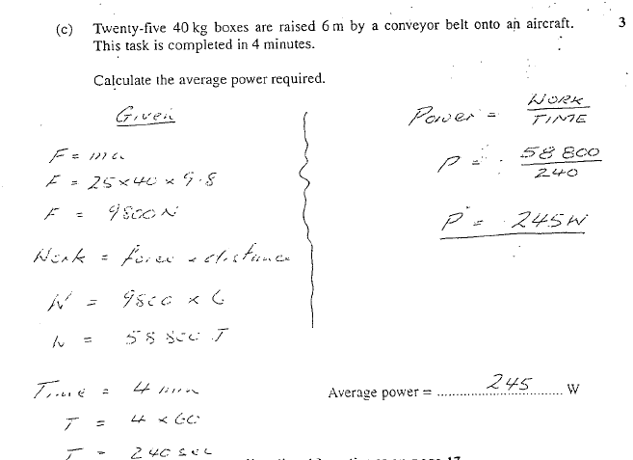

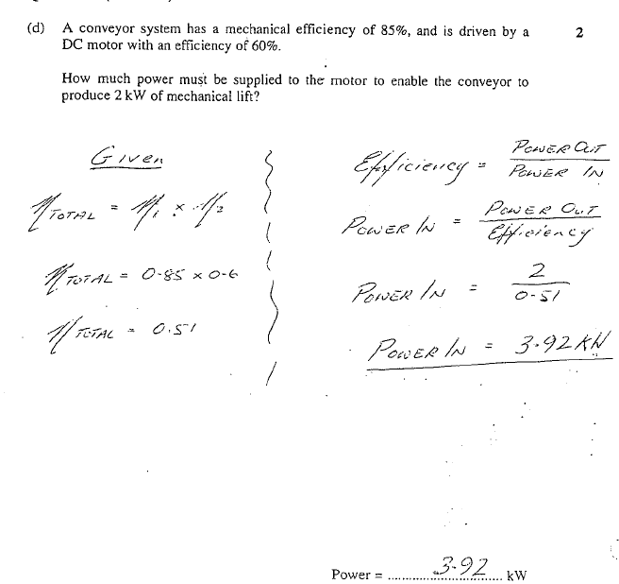**Exercise 5**



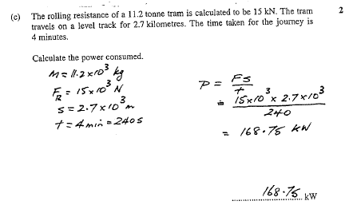**Exercise 6**



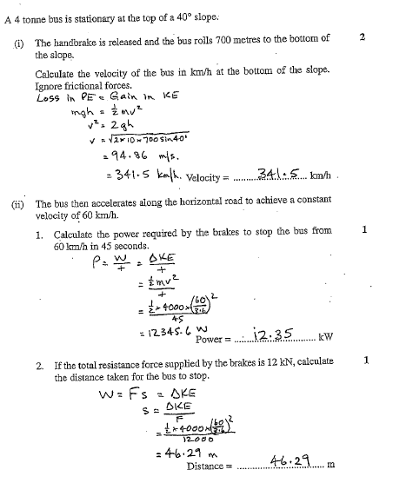**Exercise 7**

**Exercise 8**

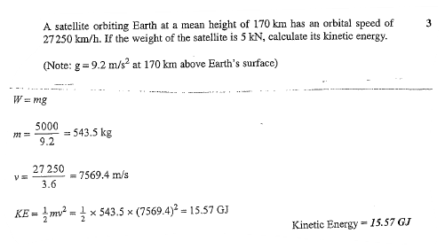

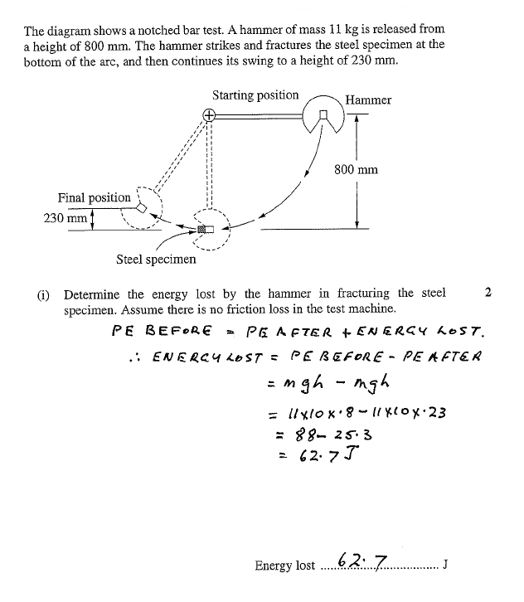**Exercise 9**

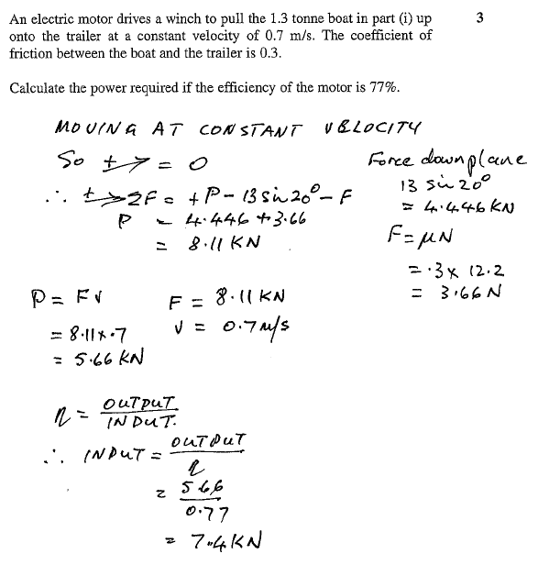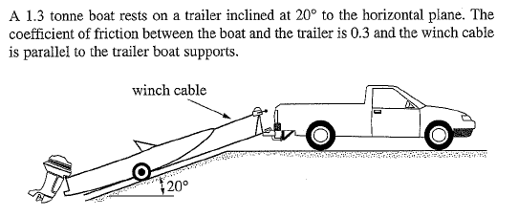**Exercise 10**

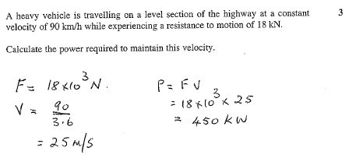**Exercise 11**

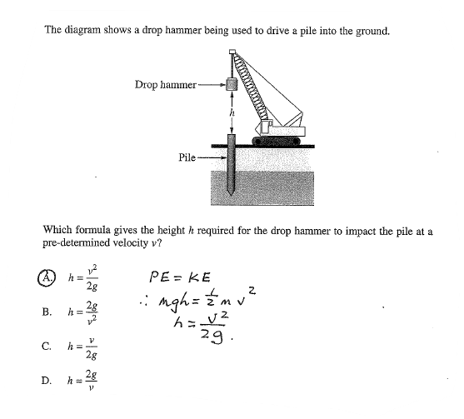**Exercise 12**

https://lh5.googleusercontent.com/ocqp81eChW9d1KYKmzEol2TTMPVLZYeics4iNcX-JnmFH8QIlPRyGXNum2u8xeo-TmeYy8WWiQv0lcoNNLyl0sc703ZlaLtmshaUkYXsP895sN5fN4MT7_rAG10VDA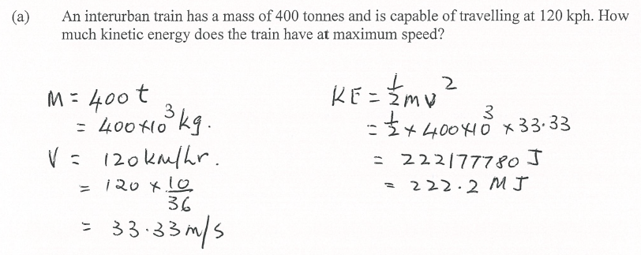**Exercise 13**

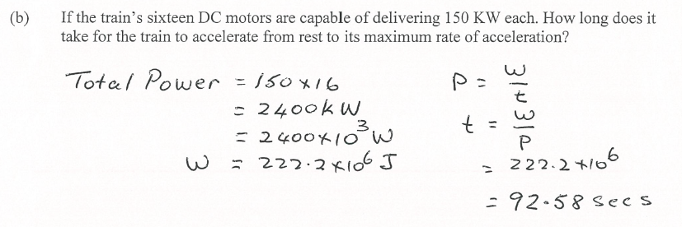

https://lh5.googleusercontent.com/uzKsMR66JpjoWFDuO96529BYDARQTxSDXZckL16CpCfRrLbbxitPYPF4Q0I47F6LmjJ3og99QrPssdMiEyJXX774H4ta5sG58DE4MXVRFOI6JonEU7OL4U7wffFrcQ