631

Work Hardening and Heat Treatment

Acknowledgement
Mr John Gibson is a highly regarded educator and engineer. John taught Industrial Arts at a number of high schools before taking a position at Sydney Teachers’ College, then University of Sydney. He had an engineering education consultancy and has extensive experiencing working with NESA on Engineering Studies syllabus development and the HSC examination committee. The STEM Industry School Partnerships (SISP) Program asked John for his responses to the iTeachSTEM topic discussion questions. SISP is grateful to John for submitting these example discussion responses.
- What are the processes that might increase the hardness of some steels?

- work/strain hardening
- hardening
- alloying
- increase the carbon content in annealed steel
- for steels between 0.4% C to 1.3% C, heat above 850°C and quench
- add alloy elements such as Mo and Mn which increase hardness
- carburise or nitride the steel
- induction harden or flame harden the steel

- What are the processes that might soften many steels?
- annealing the steel by heating to 650°C and slow-cool in still air
- alloying
- reduce the carbon content to below 0.1%

- Describe strain hardening/work hardening, including what occurs when steels are deformed during cold rolling, compressing and, elongation.

Cold rolling of PC (plain carbon) steels can effect changes in structure and strength. The structure of steels between 0%C and 2%C exhibit various proportions of Ferrite, Pearlite and Cementite.

Ferrite will be readily compressed and will work harden.

Cementite (Fe3C) is hard and brittle and can easily fail.

Pearlite, being a laminate mixture of Ferrite and Cementite, will resist deformation, adding strength to the specimen.

Strain hardening/work hardening of low carbon steels causes the uniform crystal structure to become distorted. Evidence of this is the appearance of strain bands and mechanical twinning in the microstructure.

- Describe the annealing process of a cold rolled steel and the effect on the structure and properties of the steel.
Cold roll steels need a heat treatment process to remove the effect of cold rolling.
A general guideline is that distorted grains will go through three stages as they are annealed.
- recovery: from internal stress caused by the cold rolling
- recrystalisation: the formation of a new set of stress-free crystals
- grain growth: new grains dissolve the remains of the old grains

The stages of annealing: in general terms a single phase material, such as copper has significant internal stress caused by the strain hardening process. The initial heating provides energy to allow atoms to move about, physically reducing the stress (stress relief).

The second stage occurs when there is enough annealing energy to allow a brand new crystal/grain to grow within the distorted grains. This is termed Nucleation. These new grains continue to grow at the expense of others. The important factor is that the new grains are stress-free.

If allowed to retain energy, the new grains will continue to grow (grain growth).

Low carbon steel, unlike copper, has a grain structure of two phases - Ferrite and the compound Iron Carbide.

Steel
Pure iron Tools are not made of the pure element iron, because it is simply too soft to be useful. By studying iron, however, one can understand the underlying principles of the structure of steel.
The Lattice Structure At room temperature, the atoms of iron bond together in a structure known as a lattice. Picture 1a (below) is an example of this structure, which is known as a body centered cubic (bcc).
When iron is heated to 910ºC, it undergoes what is known as a phase change. Its lattice structure is fundamentally changed and now looks like picture 1b (page 4). This is known as a face centered cubic (fcc) structure. The ability for an element like iron to exist in more than one structure is one of two fundamental principles in the understanding of steel.
The role of carbon Carbon is the principle alloying element that transforms soft iron into hard, and useful, steel. In fact, unless the carbon content in steel is greater than .2%, the steel will not even harden. The concept of substitution allows atoms of carbon to join into the lattice structure of iron.
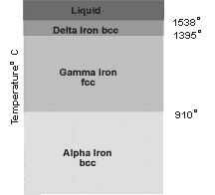
Picture 1a ~ Lattice Structure Graph
The bcc lattice is not large enough to accommodate even the much smaller carbon atom, but at 910ºC, the phase change of the lattice to fcc easily allows this to happen. See picture 1c (page 5). The blue atom represents carbon and is sometimes called an interstitial atom.
Alloys The mixture of the elements iron and carbon create what is known as an alloy, which is much harder and stronger than pure iron. Carbon, and many other elements, can be combined with iron to form various types of alloys, all of which are referred to as steel.

- Describe both hardening of high carbon steel and the tempering of the hardened steel.
Hardening:
- heat to 50° above the eutectoid temperature
- soak to even out the sample temperature
- quench in either water or a specific oil
- Using an example of 0.8% C:
Austenitising:
- raise the temperature of the sample to about 770°C and allow to soak until a uniform temperature is reached
Quenching:
- drop the red hot sample into a source of cool water, agitate, allow to cool.
Quenching Just as phase transformation takes place during the heating of steel, it also takes place during the quenching (cooling) process.
Quenching can be used to increase the hardness of steel. At high temperatures, alloying metals are completely dissolved in the base metal; quenching traps the alloying metals within the crystal structure and does not allow them to precipitate out separately.
Many methods for quenching exist, including cooling in air, water, oil, and salt. The type of cooling process used helps to determine how fast or slowly the steel cools. Ultimately, the rate of cooling helps determine many of the important characteristics of the steel.
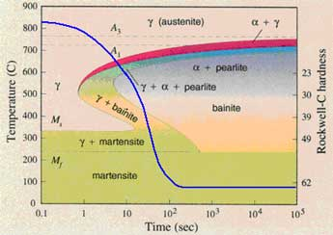

http://www.mercurius.hu/bondhus/metallurgy/body-5.htm
Picture 1b ~ Lattice Structure Phase Change Graph
- Draw the microstructure of a 0.8%C hardened steel.
0.8%C – 100% Martensite, high hardness
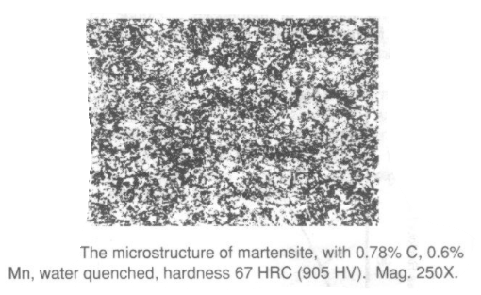
Picture 1c ~ Lattice Structure Phase Change to Face Centred Cubic (fcc)

- Describe Martensite and its engineering properties.
Martensite is the product of a number of heat treatment processes that can be carried out on specific steels. The common error is to claim that all Martensite is very hard and very brittle. This is not always the case.
Considering PC (plain carbon) steels only, and the process of hardening, the following can occur:
- when steels within the range of 0.05%C and 2%C cool under equilibrium conditions from 723°C, PC (plain carbon) steels transform into Ferrite, Pearlite and Cementite
- if steels in this range are ‘Austenitised’ and quenched, the Pearlite will transform to Martensite
- but, the Martensite hardness will be very low, in the range 0 – 0.4%C and increasingly hard, from 0.4% to 2%
- the variation is due to the amount of carbon trapped in the Austenite; the more trapped carbon, the harder the Martensite

