633

Polymers

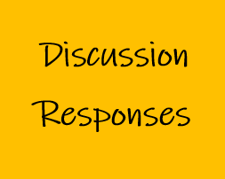

Acknowledgement
Mr John Gibson is a highly regarded educator and engineer. John taught Industrial Arts at a number of high schools before taking a position at Sydney Teachers’ College, then University of Sydney. He had an engineering education consultancy and has extensive experiencing working with NESA on Engineering Studies syllabus development and the HSC examination committee. The STEM Industry School Partnerships (SISP) Program asked John for his responses to the iTeachSTEM topic discussion questions. SISP is grateful to John for submitting these example discussion responses.

Describe the structure of a thermo-softening polymer.
The structure of a thermo-softening polymer is based on an organic chemical unit called an MER.
The MER has combined chemical bonds within its structure, as well as some free chemical bonds. These free bonds may connect with other free bonds in the structure to produce a new material known as a polymer.

- Discuss an example of shaping a thermo-softening polymer by:

- Extrusion ~ polymer tubing
- Injection moulding ~ household buckets
- Blow moulding ~ polymer bottles.

- Name three thermo-softening polymers, and the application/s they are commonly used for.

- Polyethylene ~ plastic film
- Nylon ~ bearings
- Polyethylene terephthalate ~ PET polymer bottles

