**653**

**Power Generation**

**and**

**Distribution**

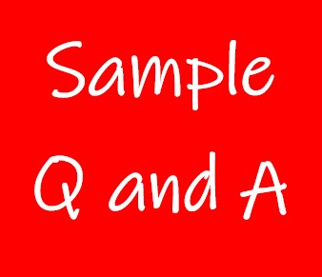

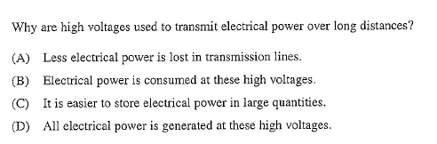**Exercise 1**

**A**

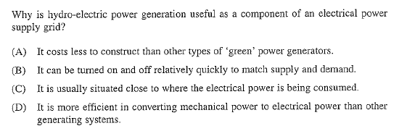**Exercise 2**

**B**

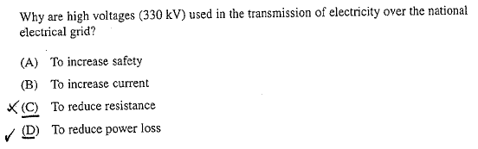**Exercise 3**

**D**

**Exercise 4**

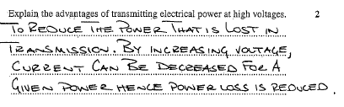

**Exercise 5**

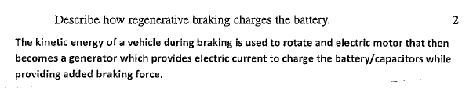

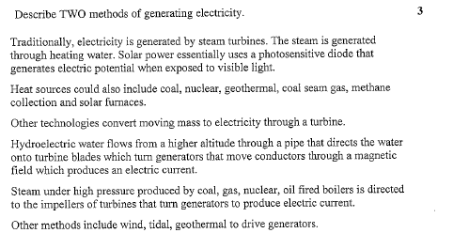**Exercise 6**

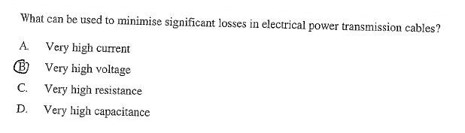**Exercise 7**

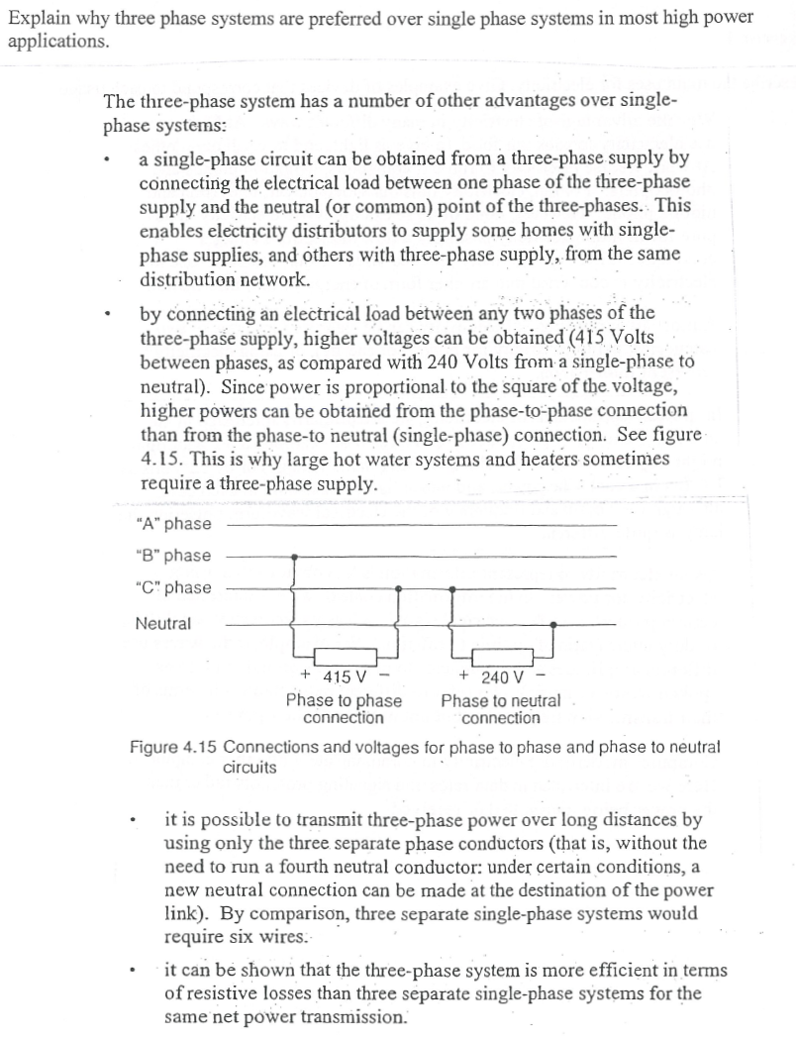**Exercise 8**

**Exercise 9**

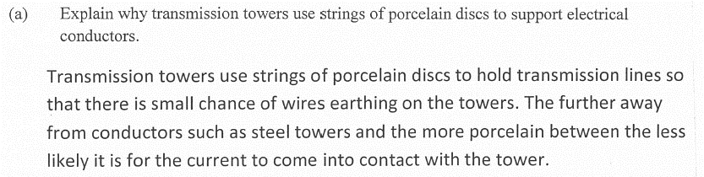

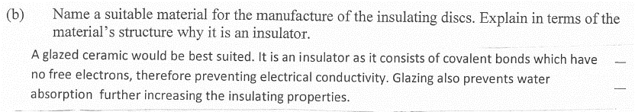

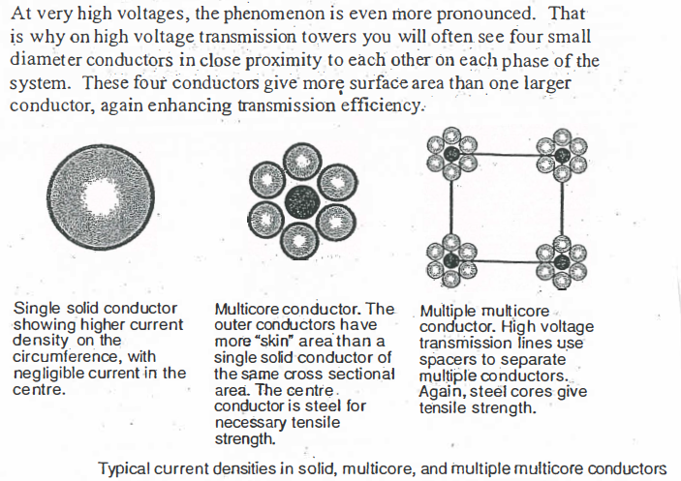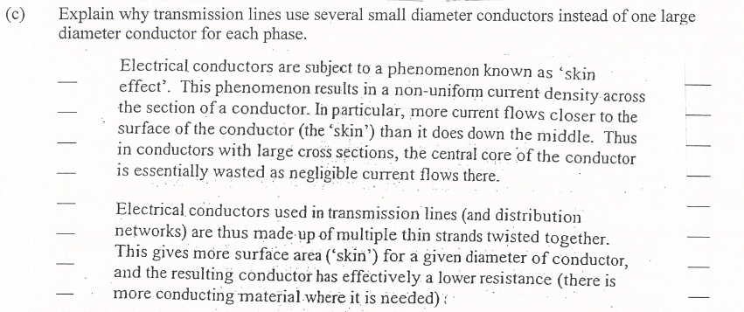**Exercise 9 (Continued)**