**734**

**Polymers and Composite**

**Material**



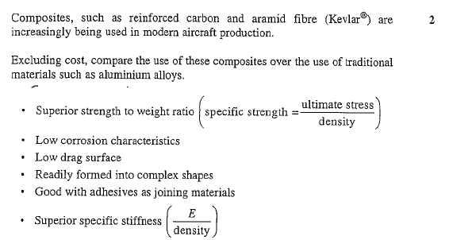**Exercise 1**

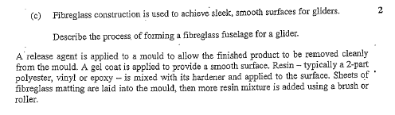**Exercise 2**

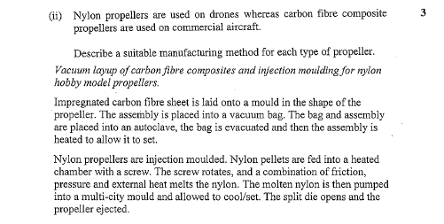**Exercise 3**

**Exercise 4**

https://lh6.googleusercontent.com/UYrzricJsRnCrRCxcLK7-U00GfYYXuit_D9MTCF_B6JSlW6tLDichvN5PfE4z6csVlCibrsB2mR1u2cpUvXGApl5RR1bGbQsActZNoe5Nks0Bkw61Eqek6R8TqifEQ

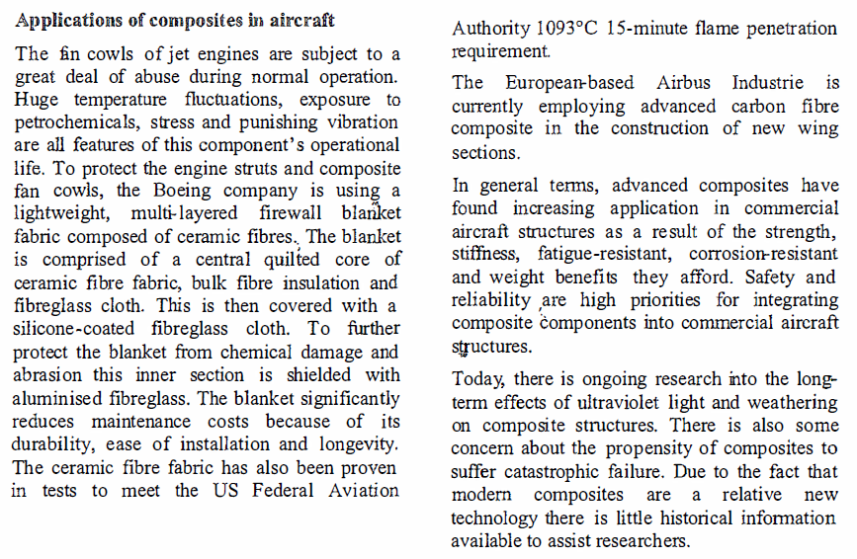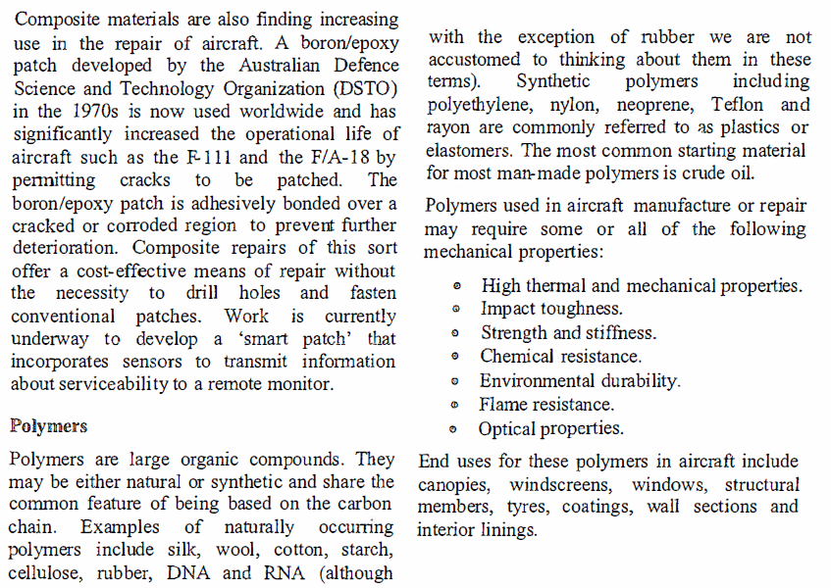

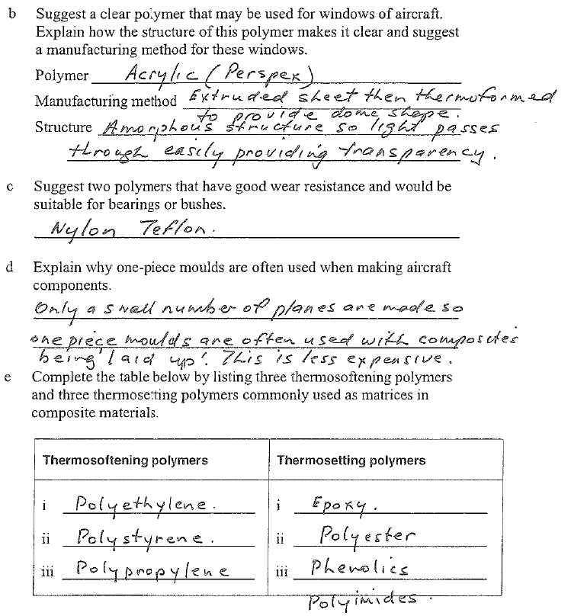**Exercise 5**

https://lh4.googleusercontent.com/QFWTSJFXXJHvmOKgqSZhhsqSTjwpndnoZVQ1vS5FZ1N_3cnC7yCebzbLUtT8y-JETs50XJY5z-W9lLzP_956P3c4SnFupMv_sg0X797UjGH_dLZPdK91frLzTqRC1A**Exercise 6**

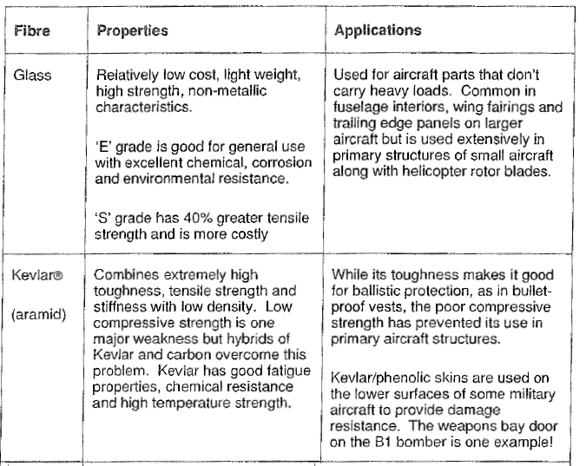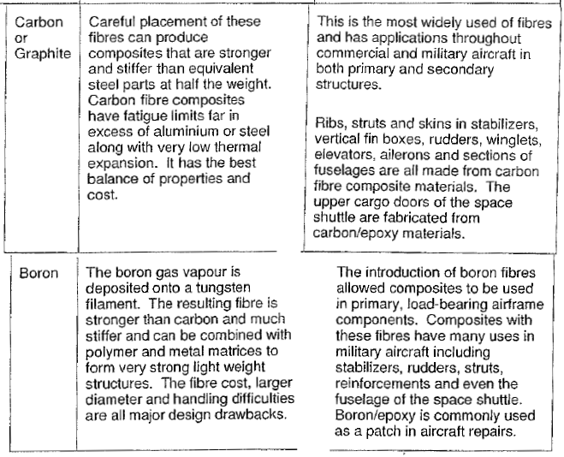

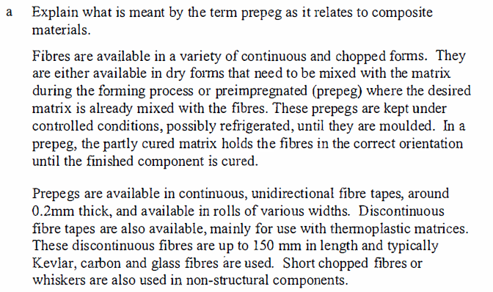**Exercise 7**

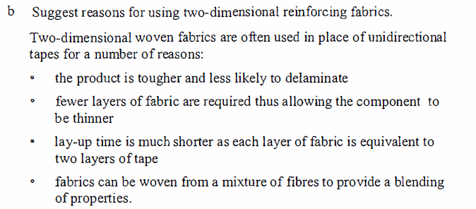

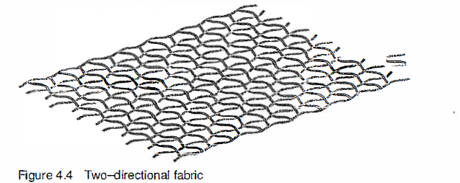

**Exercise 7 (Continued)**

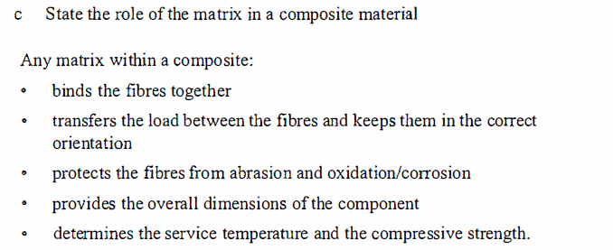

**Exercise 8**

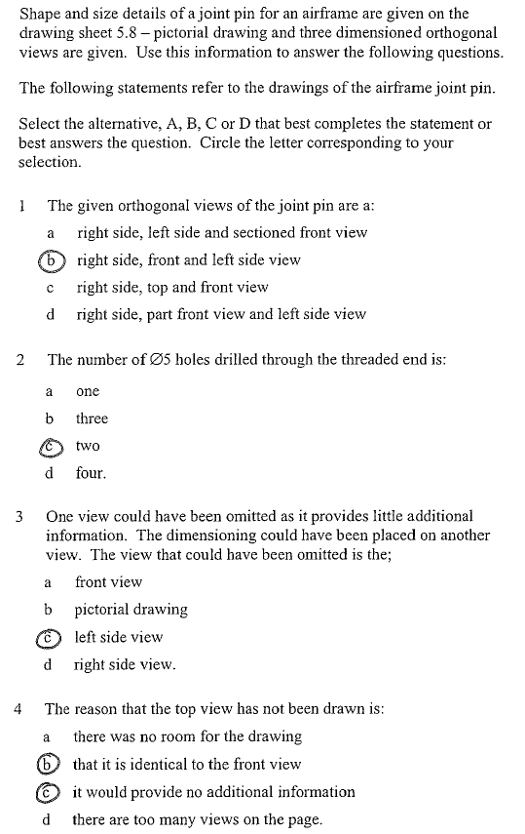

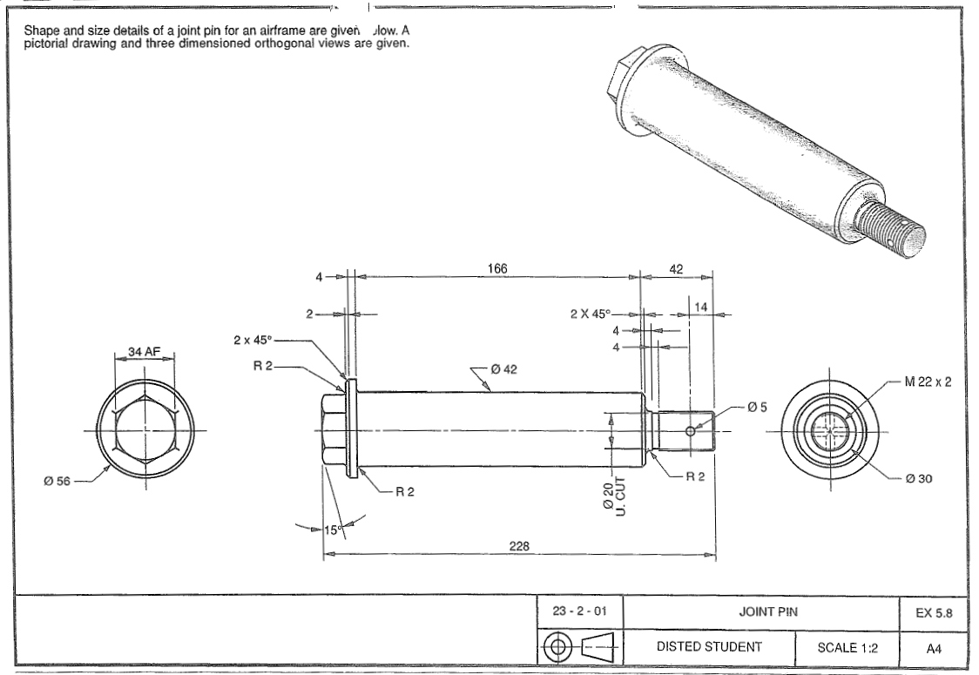

**Exercise 8 (Continued)**

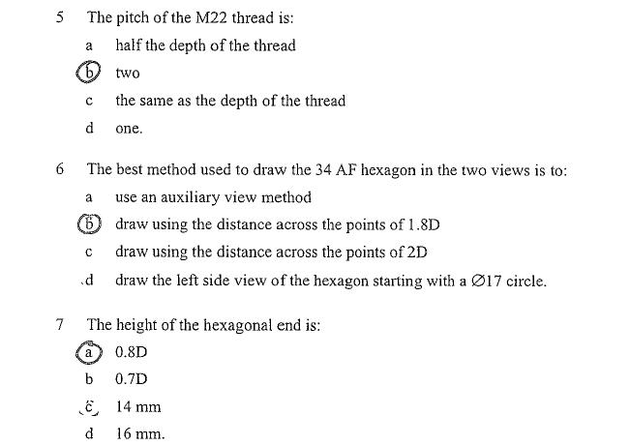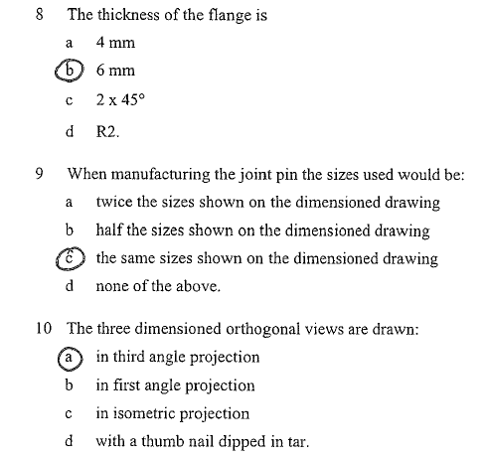**Exercise 8 (Continued)**