**735**

**Titanium Alloy and High Temperature Materials**



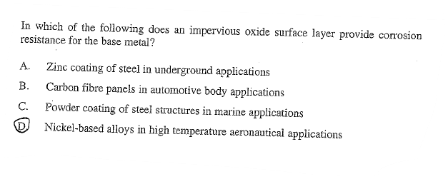**Exercise 1**