Bending stresses

Bending stresses
The behaviour of beams under load depends on the:
- the materials from which the beam is made
- the nature of the forces acting on the beam
- the size of the beam
- the shape of the beam
- the orientation of the beam with respect to the direction of the forces applied.
In this unit we are concerned only with rectangular beams but the concepts discussed apply to more complex shapes.
This unit aims to investigate the nature of internal forces involved in bending and to consider the relationship between beam geometry, bending moments and the resultant bending stress. This information helps engineers to determine suitable materials, cross-sectional shapes and orientations for civil engineering applications.

Internal forces
Consider a simple horizontal beam supported at each end and with a load in the centre, sufficient to cause the beam to bend. The material on the inside of the bend will be placed into compression while the material on the outer side of the bend will be in tension. For a graphic illustration visit Bending of beams where grid lines, drawn on a foam beam prior to bending are distorted in a clear demonstration of compression and tension. If one side of a beam during bending is in tension while the other is in compression it stands to reason that somewhere between the two lies a neutral plane with no loading.

The centroid
The geometric centre of a two-dimensional area is known as the centroid. In relation to beams the centroid will be the geometric centre of the cross-sectional shape of the beam. It is significant because the neutral plane, discussed above, will pass through the centroid of the beam. When considering a rectangular beam, the centroid is simply found by joining the diagonals but becomes more complex for composite shapes.

Orientation of beams
Does a beam have the same strength properties irrespective of its orientation to the forces, that is whether we use it laid flat or on edge? Or, can we improve the strength characteristics of beams by using particular orientations? Activity 1 aims to investigate this concept.
Activity 1
Aim:
To investigate the significance of the geometry of the cross-section and in particular to develop a relationship between distance from the neutral axis and strength.
Preparation:
To carry out this experiment you will need:
- ice-cream sticks, about 8 x 1.5 mm to simulate a “beam”
- a bucket with a handle
- a second bucket with water in it
- a 100 mL measure
- two short lengths of 50 x 25 mm timber pieces with a 1.5 mm slot cut across them to allow the “beam” to be held on its edge (see Figure 1). These slots could be trenched by hand with a tenon saw or by your teacher using a circular saw.
Method:
Step 1. Place the handle of the bucket at the centre of a “beam” and support the “beam” on its edge at both ends with the timber pieces (as shown in Figure 1). Test the “beam” to breaking point by adding water to the bucket 100 mL at a time. Measure and record the water quantity when the “beam” breaks.
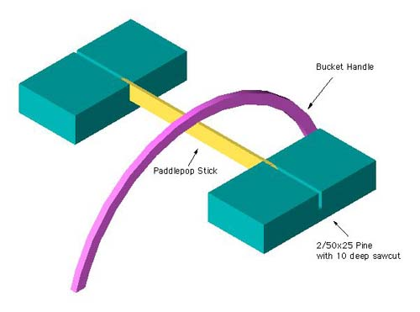
Figure 1 Set up for experiment to test beam on its edge
Step 2. Repeat with the “beam” lying flat as shown in Figure 2.
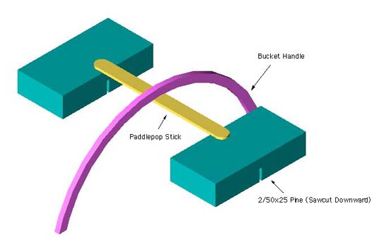
Figure 2 Set up for experiment to test beam lying flat
Note: For greater accuracy this activity should be repeated several times and the results averaged.

Results
You will note a significant difference emerges in the load capacity of the beam depending upon its orientation (see Results of Activity 1). The “beams” are the same size, the same material and the same length, but the load capacity is different for different orientations. In fact, if you measure your ice-cream stick “beam” you should find that the load capacity in each case is in proportion to half the depth of the beam. For example, if your ice-cream stick was 8 mm x 1.5 mm, then the beam on edge should have supported at least five times the load for when it was lying flat.
The result is best explained in terms of the maximum distance from the neutral plane to the top or bottom edge of the “beam”. When the ice-cream stick was lying flat there was a short distance between the bottom of the beam and the neutral axis, whilst when on edge this distance is significantly greater.
Bending moments
When external forces are applied to a beam, they create internal shear forces and bending moments within the beam. The magnitude of these varies from one end of the beam to the other depending on the location and direction of the applied forces and the reactions.
For a beam to resist an applied bending moment, the material from which it is made must develop a moment over its cross-sectional area that resists the applied moment. An extremely thin beam has little ability to resist the applied moment (little material between the neutral axis and the top or bottom of the beam. The more material the beam has on either side of the neutral axis, the greater is its ability to resist the applied moment and therefore the applied load.

Moment of inertia
The nature and calculation of the resistive moment in a beam is very complex. As we have seen, it depends in part on the orientation of the beam and therefore the distance “y” from the neutral plane to the edge of the beam. It also depends on the size, shape and distribution of material about the centroidal axis.
This second component, the moment of inertia, or second moment of area, varies according to the geometry of the beam and is usually calculated or read from tables. The Engineering Studies syllabus requires that the Moment of Inertia (I) is provided and therefore it is not necessary for candidates to calculate the moment of inertia.

Bending stresses
Bending stresses are internal stresses caused by bending moments acting at a given distance from the neutral axis. Their magnitude is given by the formula:
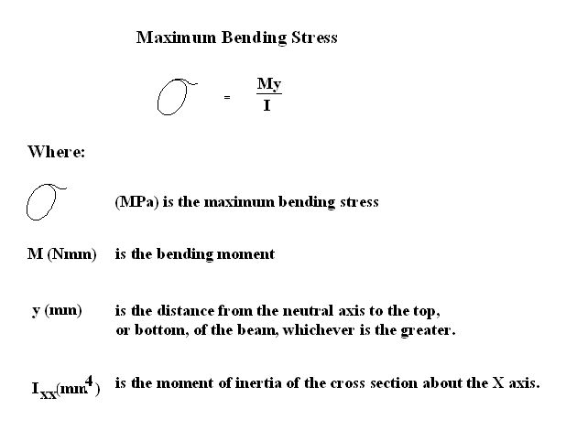

Activity 2
Details of a beam under load are shown. Calculate the maximum bending stress for the beam.
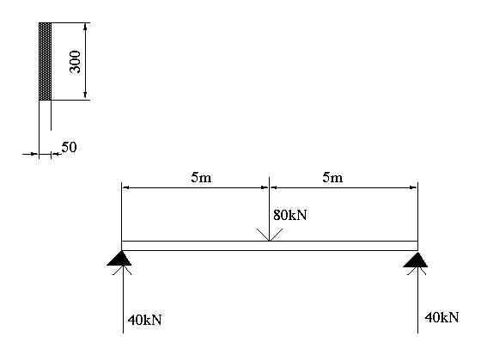

Activity 1
The experiment was set up between two school woodwork benches, as shown in the photograph. Each experiment was repeated three times and the results averaged.
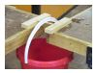
Results
- With the ice-cream stick on edge:
Attempt | Result (L)
1 | 8.5
2 | 8.25
3 | 8.75
- Average = 8.5 L
But since 1 litre of water has a mass of 1 kg
M = 8.5 kg
F = 85 N
- With the ice-cream stick laid flat:
Attempt | Result (L)
1 | 2.0
2 | 2.2
3 | 2.1
- Average = 2.1 litres
But since 1 litre of water has a mass of 1 kg
M = 2.1 kg
F = 21 N
Conclusion
By simply changing the orientation of a beam we can significantly alter its ability to withstand forces. In the case of the ice-cream sticks the one on its edge is capable of holding a force four times as great as the one laid flat.

Activity 2
