Types of Telecommunications Facilities

Base Stations
Mobile multimedia devices, such as mobile phones and multimedia handsets, send and receive radiofrequency waves to and from the nearest base station. Mobile telecommunication networks have a cellular design to maximise the use of limited radiofrequency spectrum. These network cells overlap at the edges to limit gaps in coverage. If the base stations are too far apart, calls may not be handed over from one cell to another and call quality may be impacted resulting in an interruption to service. A base station is comprised of several different components – including an equipment shelter which houses the transceiver and transmission equipment, a tower, mast or support mount which provides the necessary height to give required coverage, and the antennas which are mounted on a tower or mast – or on the roof or sides of buildings. The specific type of antenna required depends upon the shape and range of the coverage area desired and the available mounting locations. An omnidirectional antenna provides 360 degrees of signal propagation and an example includes whip antennas. Directional antennas are used to focus the signal in a particular direction. Examples include panel antennas, Yagi antennas and radiocommunication dishes. Line-of-sight radiocommunication dishes are sometimes used for communication between base stations. These dishes send a radio signal to a neighbouring dish at a nearby base station
The largest area covered by cell base stations occur in sparsely populated rural areas and the smallest in urban centres. In addition, the base station area size in a new 3G network will often be smaller than those required for 2G networks because of user demands for 3G services and the fact that some 3G networks use a higher radiofrequency. An increase in demand requires additional cell base stations as each base station can only support a limited number of calls simultaneously.
3.1.1
Macrocell Base Station Macrocell base stations provide the main infrastructure for a mobile telecommunications network. Antennas for macrocells are usually mounted on monopole towers or masts, or on high voltage towers, rooftops and other structures but may be within a building. They are positioned at a height that is not obstructed by surrounding buildings and terrain. Omnidirectional antennas can be part of a macrocell base station, and radiocommunication dishes can also be part of a macrocell base station. Digital macrocell base stations (2G and 3G) usually use directional antenna. To cover all directions at least three 120 degree angled macrocell antennas are used. The following photographs provide examples of macrocell base stations.
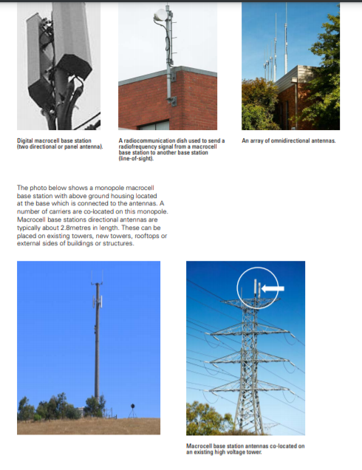

3.1.2
Microcell Installation A microcell comprises one or two antennas and associated equipment units that supplement the mobile network in heavy usage areas by providing localised additional coverage and/or extra call capacity. The antennas for microcells are mounted externally at street level, and are smaller than those used by macrocell base stations and can often be disguised as building features. The antenna(s) can be attached to an existing pole or other street furniture and the equipment unit may be mounted on the pole or structure or on the ground. Microcells provide coverage for a small geographic area and are often found at intersections and in heavy pedestrian traffic areas. They have a range of a few hundred metres. Microcell installations, typically, do not use radiocommunication dishes as the installation is linked into the telecommunication network via cable or optical fibre.
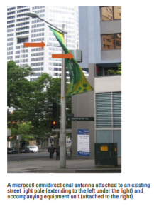

3.1.3
Picocell Installation (In-BuildingCoverage Facility) Picocells (or In-Building-Coverage-Systems) provide a more localised coverage than microcell installations. These are generally found inside buildings where coverage is poor or where there is a dense population of users such as in airport terminals, office buildings, hotels, stadiums, hospitals, train stations and shopping centres. The picocell base station equipment is usually located in the central plant equipment room (near the MDF) of a building or other service area and includes: • cables which run from the base station through the building risers connecting the base station equipment to antennas; and • small antennas located on ceilings or walls Picocells operate in a similar way to microcell external base stations and operate at a low power level.
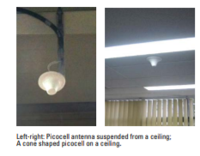

3.2 ASSOCIATED AND UNDERGROUND FACILITIES
3.2.1 Underground housing
Underground housing for telecommunications facilities includes pits, boxes, manholes or other underground equipment or shelter housing that house or provide access to equipment located beneath ground level. Their common feature is a surface lid that sits flush with the adjoining ground surface.
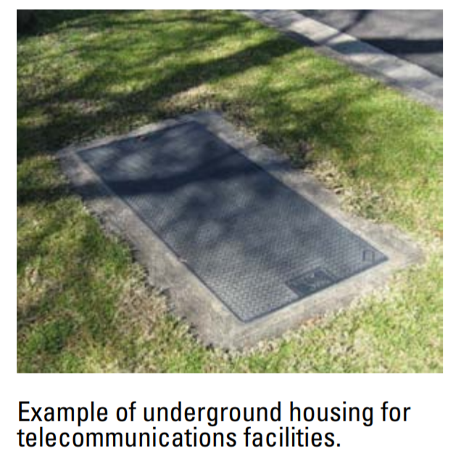

3.2.2
Above Ground Housing
An above ground housing provides shelter for telecommunications infrastructure. Two typical examples of Above Ground Housing are shown in the following photographs.
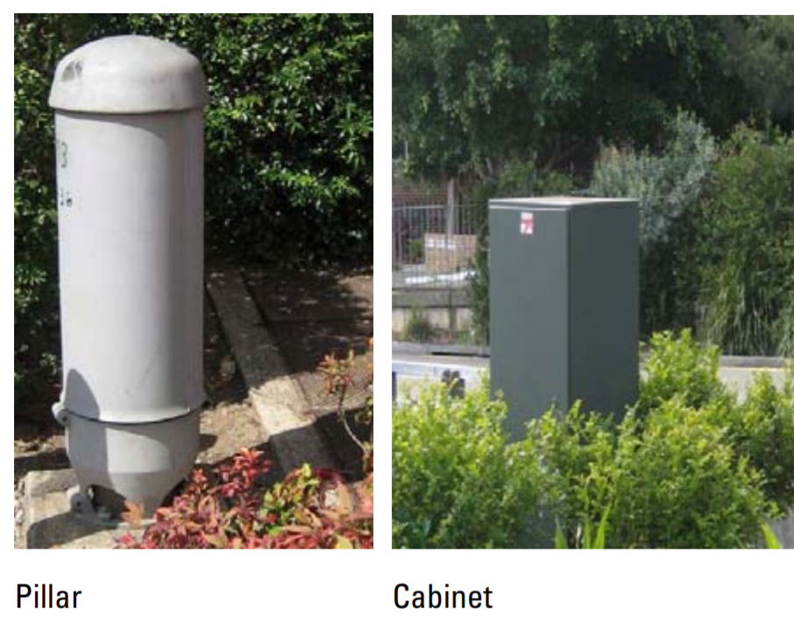

3.2.3 Underground Conduit or Cable An underground conduit or cable is placed into the ground by trenching or direct burial. Once in the ground, the ground is reinstated and the cable cannot be seen. An underground conduit or cable may be on any land. Note: “land” is defined in the EP&A Act.
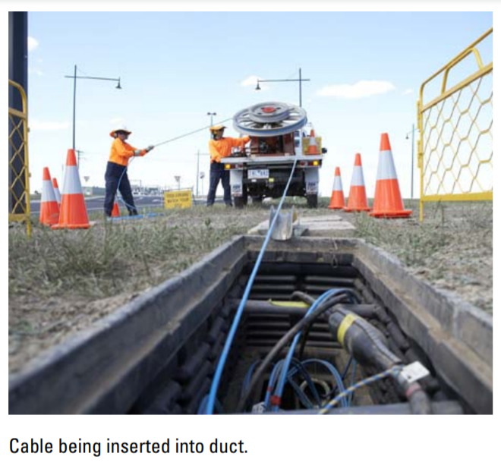

3.2.4
Boring or Directional Drilling
Underground boring or directional drilling is a process whereby a new line is bored or directionally drilled underground. In most cases, a conduit is inserted through the bore hole. A new cable is then hauled through the conduit in the underground bore hole from one end point to the other. 3.2.5 Emergency Facilities In an emergency, telecommunication facilities may be required to protect: (a) the integrity of a telecommunications network or a facility, or (b) the health or safety of persons, or (c) the environment, or (d) property, or (e) maintenance of an adequate level of service.
3.2.7 Ancillary Facilities A new or existing radio base station facility generally requires the installation of ancillary facilities that are not directly related to its transmission capabilities but are necessary to ensure the protection of the facility, the safety of maintenance workers and the general public, to provide access to the facility, to provide screening to minimise visual impacts or which are reasonably necessary fro the construction and/or operation of the facility. These types of facilities may include: (a) Safety rails, fences or guards (b) Staircases and ladders (c) Steel walkways (d) Spreader beams supporting shelters (e) Screens and shrouds (f) Cable trays (g) Pole, rail or pedestal mounts (h) EME safety or operational signage (i) Anti climbing devices (j) Power supply facilities such as cabling, stand by generators and small solar arrays (k) Raised platforms in flood-liable land. 3.2.8 Maintenance of Facilities Maintenance activities are required for the periodic upkeep and repair of facilities, and to ensure the proper functioning of the facility. Maintenance is not to result in any more than a minimal increase in size, area occupied by, or noise levels associated with the facility.
