831

Specialised Equipment

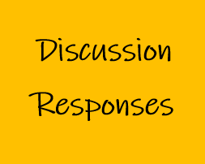

Acknowledgement
Mr John Gibson is a highly regarded educator and engineer. John taught Industrial Arts at a number of high schools before taking a position at Sydney Teachers’ College, then University of Sydney. He had an engineering education consultancy and has extensive experiencing working with NESA on Engineering Studies syllabus development and the HSC examination committee. The STEM Industry School Partnerships (SISP) Program asked John for his responses to the iTeachSTEM topic discussion questions. SISP is grateful to John for submitting these example discussion responses.

What would a continuity tester identify?
In an electrical circuit, a continuity tester is an instrument that would indicate whether there was any resistance to current flow and, how much.

- Explain the process of using a multimeter to measure voltage in a simple electrical circuit.

The multimeter needs to be turned on; must be set to Voltage; at the appropriate range, and polarity. The probes are to be placed across the component that is the subject of the test.

- Explain the process of using a multimeter to measure current in a simple electrical circuit.

The multimeter needs to be turned on; must be set to Voltage; at the appropriate range, and polarity. If there is a resistor in the local part of the circuit, the voltage across the resistor can be measured and, using Ohms law, the current can be calculated.
Alternately, the circuit can be broken and the multimeter inserted either side of the break. The multimeter needs to be turned on; must be set to Current; at the appropriate range, and polarity. A direct current value is read from the multimeter.
The joining must be reconnected before completing the process.
- Name features or values that are commonly measured using an oscilloscope.

- frequency
- voltage
- waveforms

- What factor does an oscilloscope add to a reading that a multimeter does not?

Multimeters allow the interpretation of numerical values where an oscilloscope provides a visual representation. Time is a variable.

