**324**

**Friction Concepts**

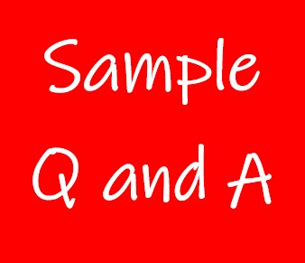

**Exercise 1**

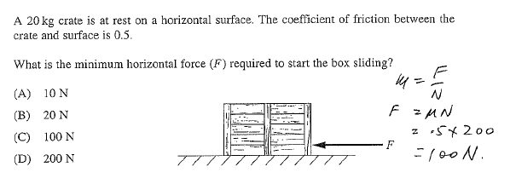**C**

**Exercise 2**

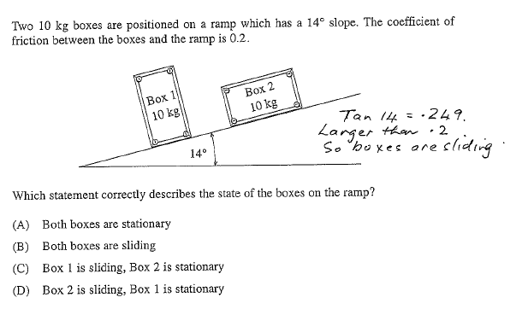**B**

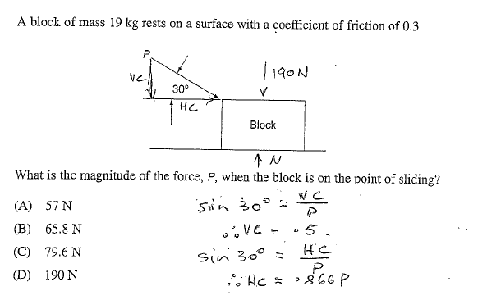**Exercise 3**

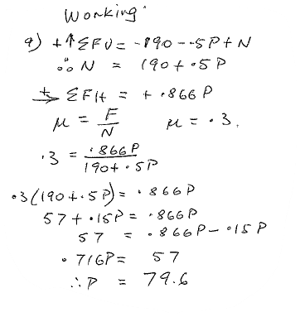

**Exercise 4**

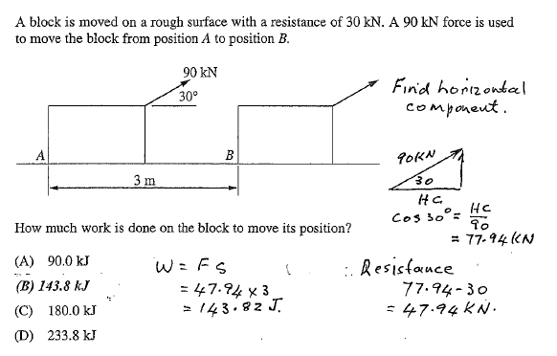

**Exercise 5**

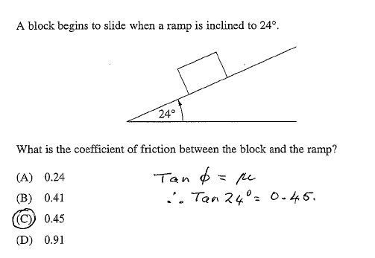

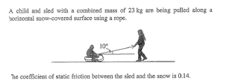**Exercise 6**



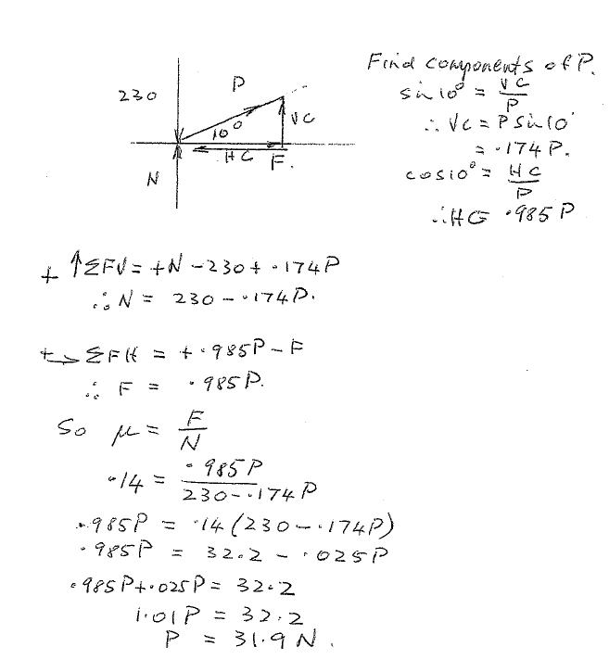

**Exercise 6 (Continued)**

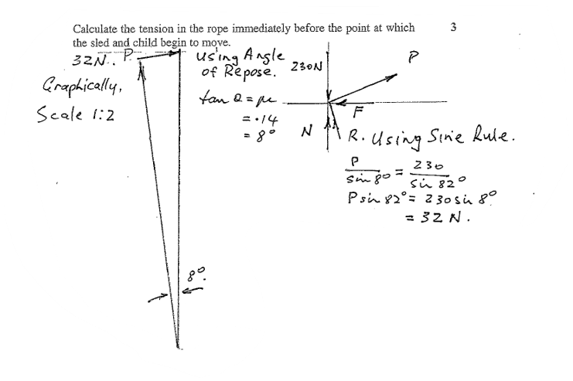

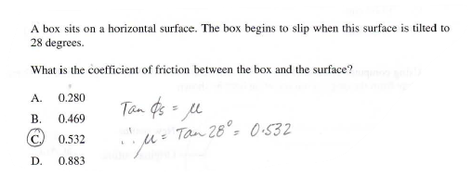**Exercise 7**

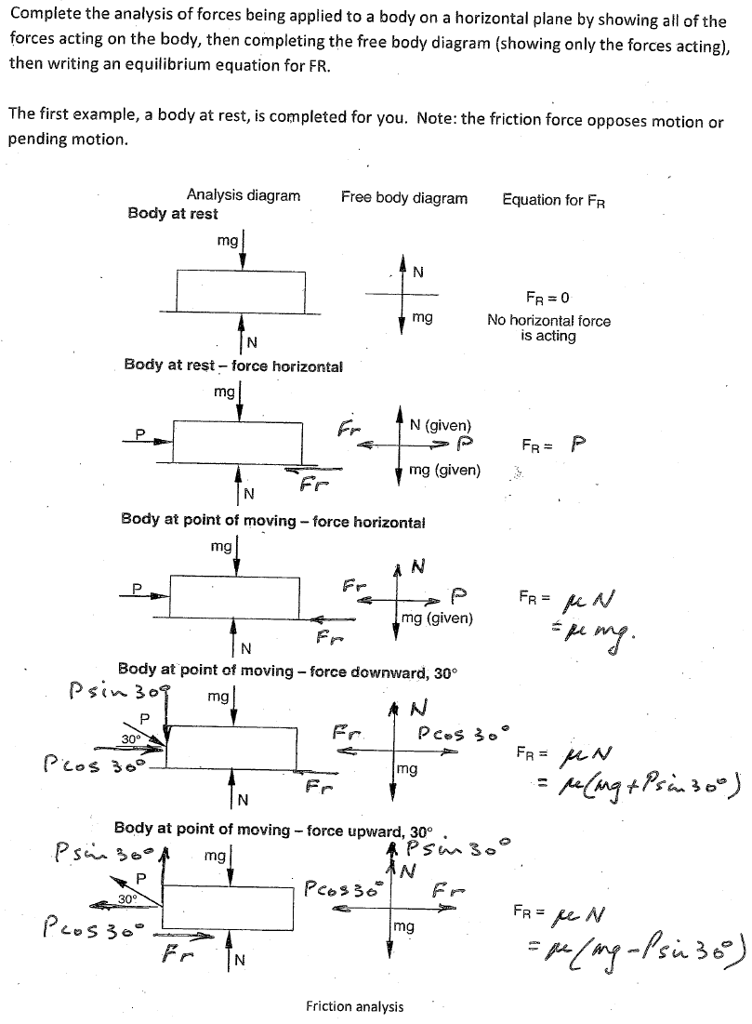**Exercise 8**

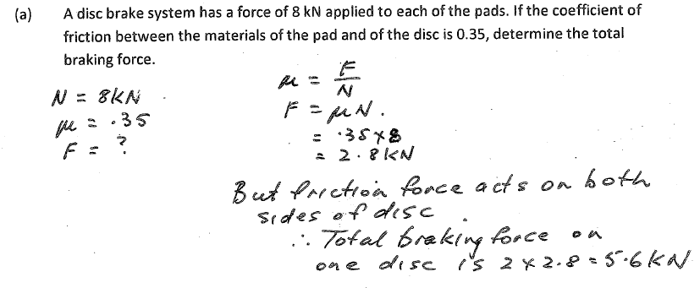**Exercise 8 (Continued)**

https://lh5.googleusercontent.com/Ov-KLdF-ueJ3ECmEjdpXiucFjpORIXucVmTSQk04XcLInWYTT1mey4Lf8Am2jtEFZZ9OLU0wOVz73r61fhnRApoPa2wepcI5p9fPeeLXXqbkZU6dmSOqiXBf1nbBrA

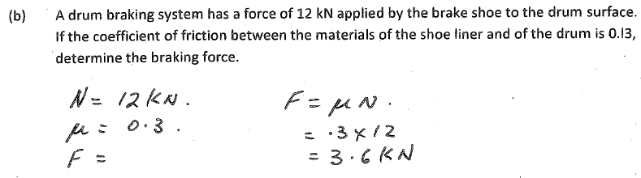

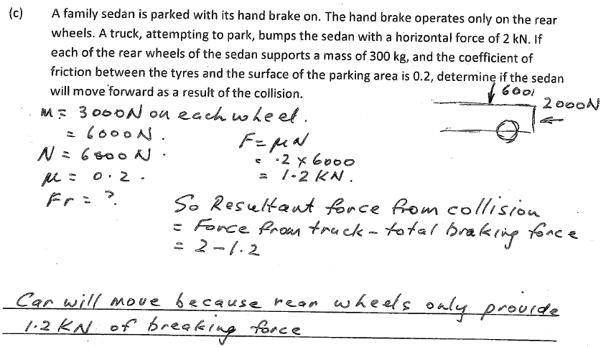**Exercise 8 (Continued)**

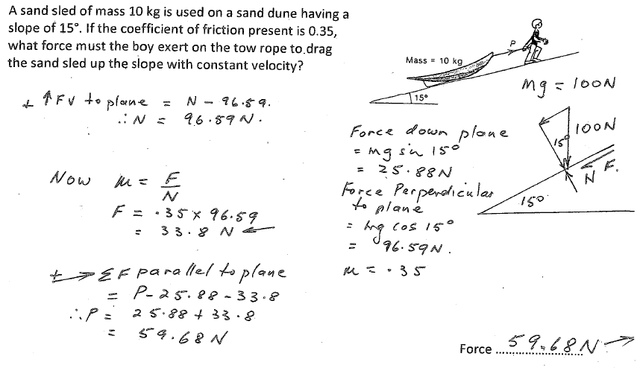**Exercise 9**

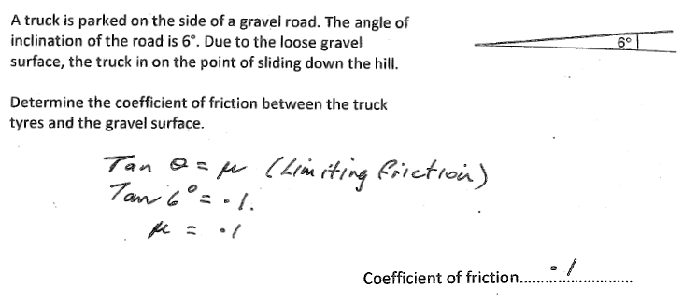**Exercise 10**

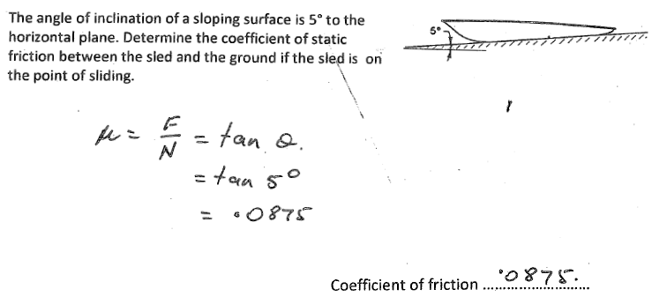**Exercise 11**

**Exercise 12**

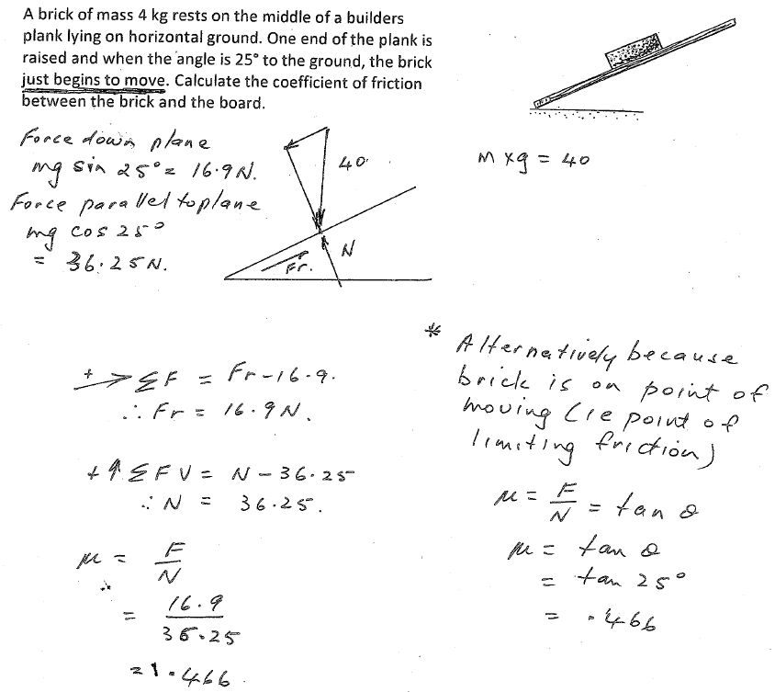

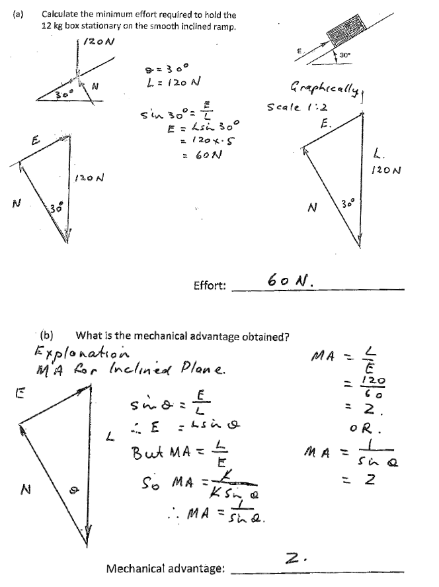**Exercise 13**

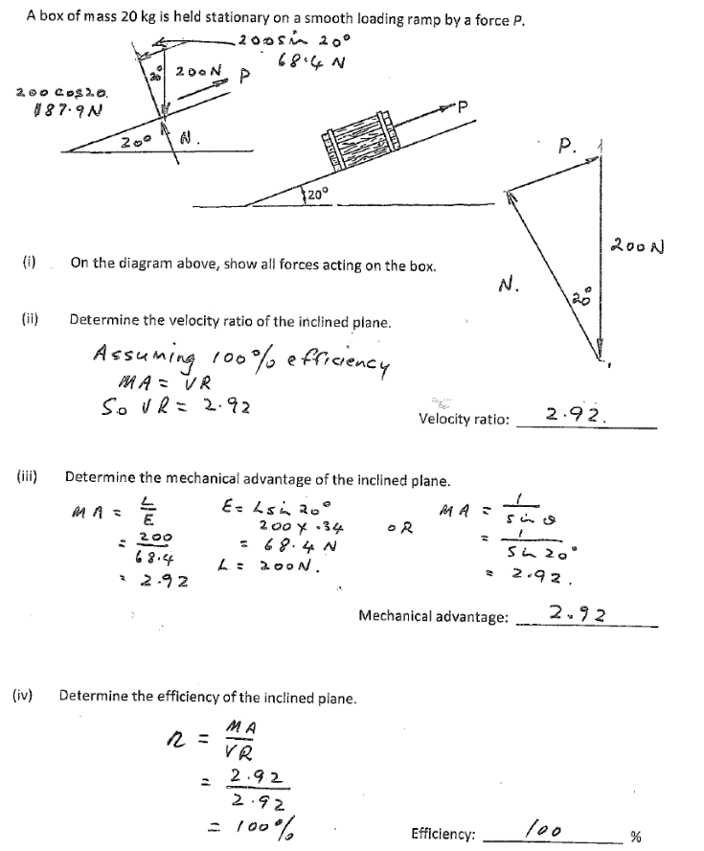**Exercise 14**