**832**

**Copper**

**and**

**Zinc Alloys**

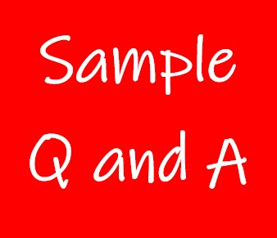

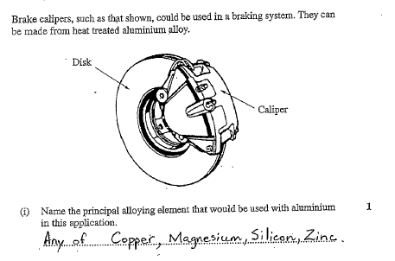**Exercise 1**

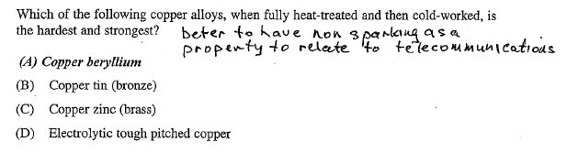**Exercise 2**

**Exercise 3**

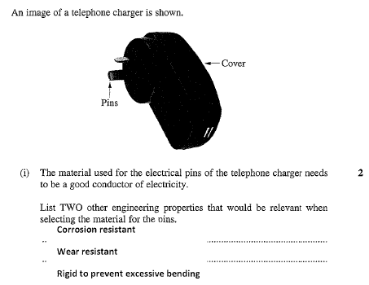

**Exercise 4**

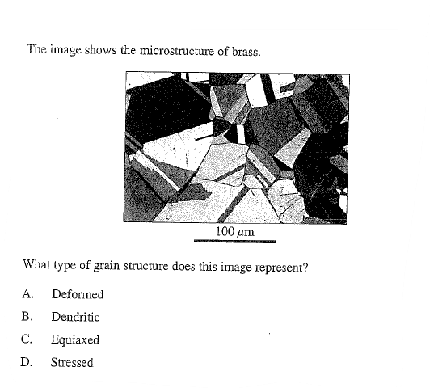

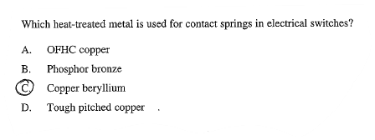**Exercise 5**

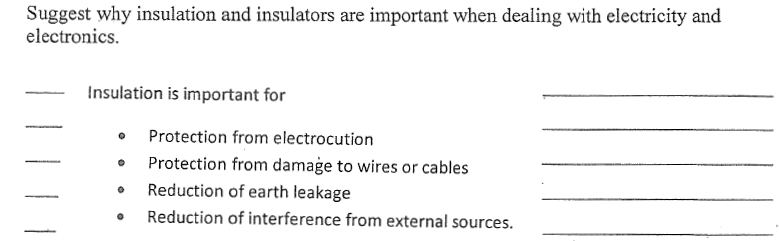**Exercise 6**

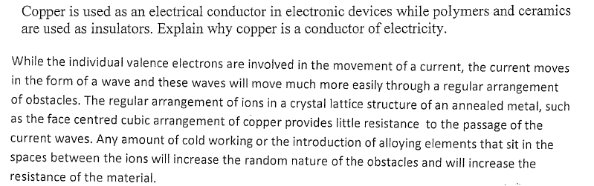

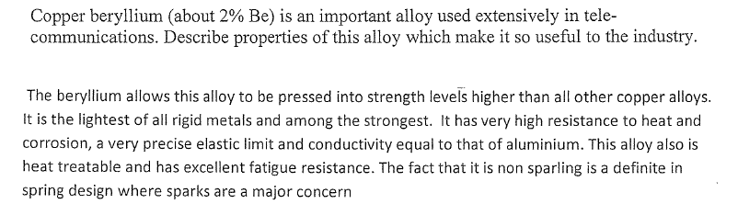

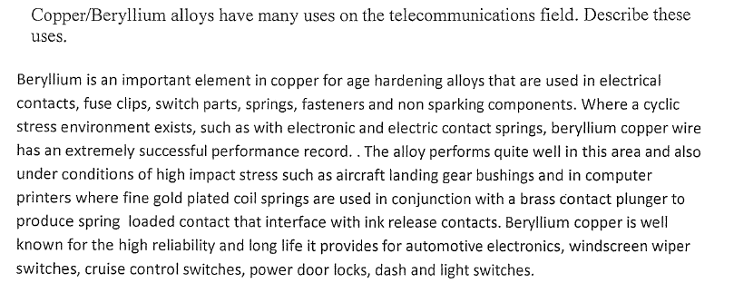**Exercise 7**

**Exercise 8**

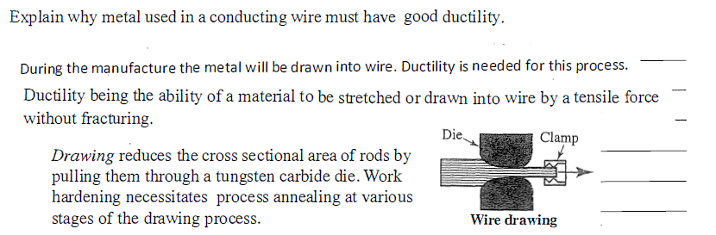

**Exercise 8 (Continued)**

