**834**

**Polymers - Insulators**

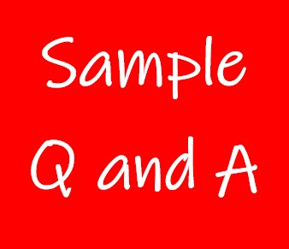

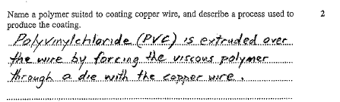**Exercise 1**

**Exercise 2**

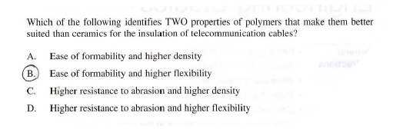

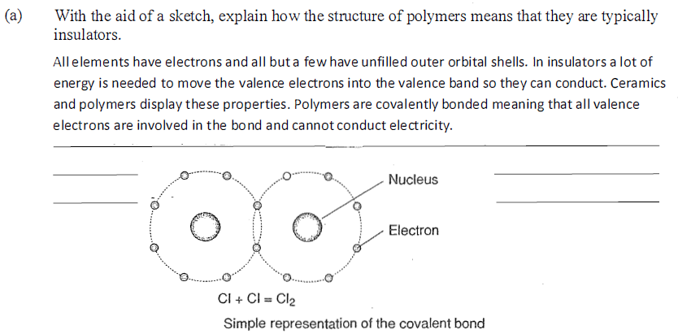**Exercise 3**

