

iSTEM

ALTERNATIVE ENERGY TASK

Engineering Report and Practical Task

TASK NO: xx DUE DATE: xx/xx/20xx
COURSE: iSTEM

TOPIC: Motion & CAD/CAM
MARKS: 200

Part A: STEM Report (Individual Task) /100
Part B: Wind Turbine Rapid Prototyping Task (Group and Individual Components) /100

OUTCOMES TO BE ASSESSED:
5.1.1 develops ideas and explores solutions to STEM based problems
5.1.2 designs and investigates different approaches in the development of engineered solutions
5.3.2 identifies and uses a range of technologies in the development of solutions to STEM based problems
5.4.2 develops skills in using mathematical, scientific and graphical methods whilst working as a team
5.5.1 applies a range of communication techniques in the presentation of research and design solutions
5.6.1 selects and uses appropriate problem solving techniques in a range of STEM contexts
5.7.1 demonstrates an appreciation of the role and potential of STEM in the world in which they live

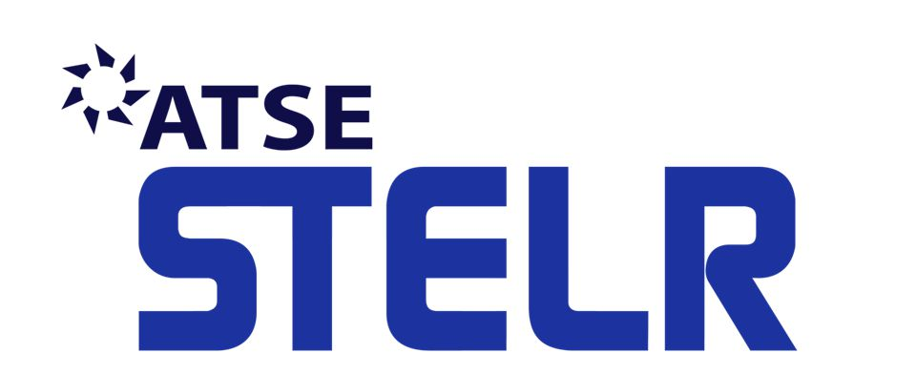
Rationale:

In this unit students are required to complete two parts of an integrated Alternative Energy Project.

Part A: STEM Report based on the growing needs of society for alternative energy generation and the increasing importance of alternative energy sources and the impact they may have on our lives, now and in the future.

Part B: A practical task and written report based on the design, planning, testing and evaluation of a rapid prototyped wind turbine blades using new and emerging technologies. These tasks will provide students the opportunity develop skills and understanding of rapid prototyping techniques using 3D CAD and CAM and build upon their knowledge of different forms of alternative energy.

PART A: STEM Report
Students are required to complete the following
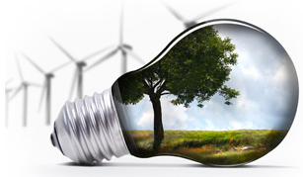
- Explain the nature and purpose of Alternative Energy systems and discuss why they are needed.

- Choose 4 different types of Alternative Energy production from the following:
Wind
Solar (photovoltaic),
Wave,
Human,
Hydroelectric
Geothermal.
Or any other energy source you may have come across in your research and feel is worthy of inclusion
(Include your justification)

Give a detailed examination of all the components of each Alternative Energy System, include diagrams, tables, drawings, etc, in your explanation.

- Draw up a table and evaluate the advantages and disadvantages of each Alternative Energy System.

- (a) Discuss a commercial and /or industrial application for each of the systems. E.g. Hydroelectric – Snowy Mountains Scheme.

(b) Discuss the materials used in this commercial and /or industrial application. E.g. reinforced concrete in hydroelectric dams, composites in wind turbines, etc.

- (a) Explain how each of the Alternative Energy Systems have impacted on society where they have been introduced.

(b) How are these technologies developing at present and what will be their impact on society in the future? From an industrial perspective and personal life style perspective.

Your research report is to include the following:

- Title page including students name, subject, class, teachers name and a suitable graphic,
- Table of content
- Text to be 11 or 12 size font, Arial, Cambria, Trebuchet, Verdana, Garamond, Myriad pro, Tahoma and spaced at 1.15 or 1.5 line spacing.
- New paragraph for each topic.
- Cut and paste is discouraged
- Graphics used throughout to support the textual elements with captions indicating how the graphic relates to the text.
- Glossary of terms
- A bibliography or a record of sources of information that might include books, magazines, websites, newspaper articles, TV shows, podcast, slide shows, research papers etc.

Part A: Report Marking Scale
STEM Report Task: | Marks
Report Components:- Title page, table of contents, abstract, glossary of terms, main body, conclusions, bibliography | 20
Nature and purpose of four alternate energy systems | 10
Examination of components of four different alternate energy systems | 10
Advantages and disadvantages of each system discussed | 10
Commercial or industrial application and materials of each system discussed | 20
Present impact on society | 5
Future impact on society | 5
Supporting use of graphics | 5
Bibliography - sources of information included | 10
Quality of research and Report layout; correct spelling, use of tables, good variety of sources, (no cut and paste) page numbers, captions on images, page layout, line spacing, font size | 10
Total | /100

Marking Guidelines
An Excellent Alternative Energy Task will;  - be professionally presented and will effectively cover all major components of an engineering report including; title page, table of contents, abstract, glossary of terms, main body, conclusions, bibliography  - explain in depth and logically the nature and purpose of Alternative Energy Systems and describe why they are needed  - effectively describe the components of four Alternative Energy Systems , including diagrams, tables, drawings, in the explanation  - include high quality explanations of advantages and disadvantages of each form of Alternative Energy System using a table  - include high quality explanations of the commercial and or industrial applications for each Alternative Energy System  - included high quality explanations of the materials used in the commercial and or industrial applications for each Alternative Energy System  - effective explanation of present and future impacts on society  - exhibit excellent research skills and will be professionally layout | 90 - 100
A Good Alternative Energy Task will;  - be well presented and will effectively cover most major components of an engineering report including; title page, table of contents, abstract, glossary of terms, main body, conclusions, bibliography  - explain logically the nature and purpose of Alternative Energy Systems  - describe the components of four Alternative Energy Systems , including some diagrams, tables, drawings, in the explanation  - include some advantages and disadvantages of each form of Alternative Energy System  - include good explanations of the commercial and or industrial applications for each Alternative Energy System  - include good explanations of the materials used in the commercial and or industrial applications for each Alternative Energy System  - explain present and future impacts on society  - exhibit good research skills and will be laid out logically | 50- 89
A poor Alternative Energy Task will;  - be poorly presented and will on cover some of the major components of an engineering report including; title page, table of contents, abstract, glossary of terms, main body, conclusions, bibliography  - mention briefly the nature and purpose of Alternative Energy Systems  - describe the components of one Alternative Energy Systems , and will not including diagrams, tables, drawings, in the explanation  - include very basic advantages and disadvantages of Alternative Energy System(s)  - not include or only briefly mention explanations of the commercial and or industrial applications for Alternative Energy System  - not included or only briefly mention explanations of the materials used in the commercial and or industrial applications for Alternative Energy System(s)  - briefly explain present and future impacts on society  - exhibit limited research skills and its layout will be of poor quality | 0 - 50

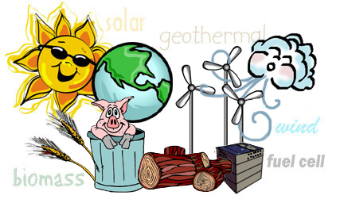

PART 2 Wind Turbine Rapid Prototyping Project
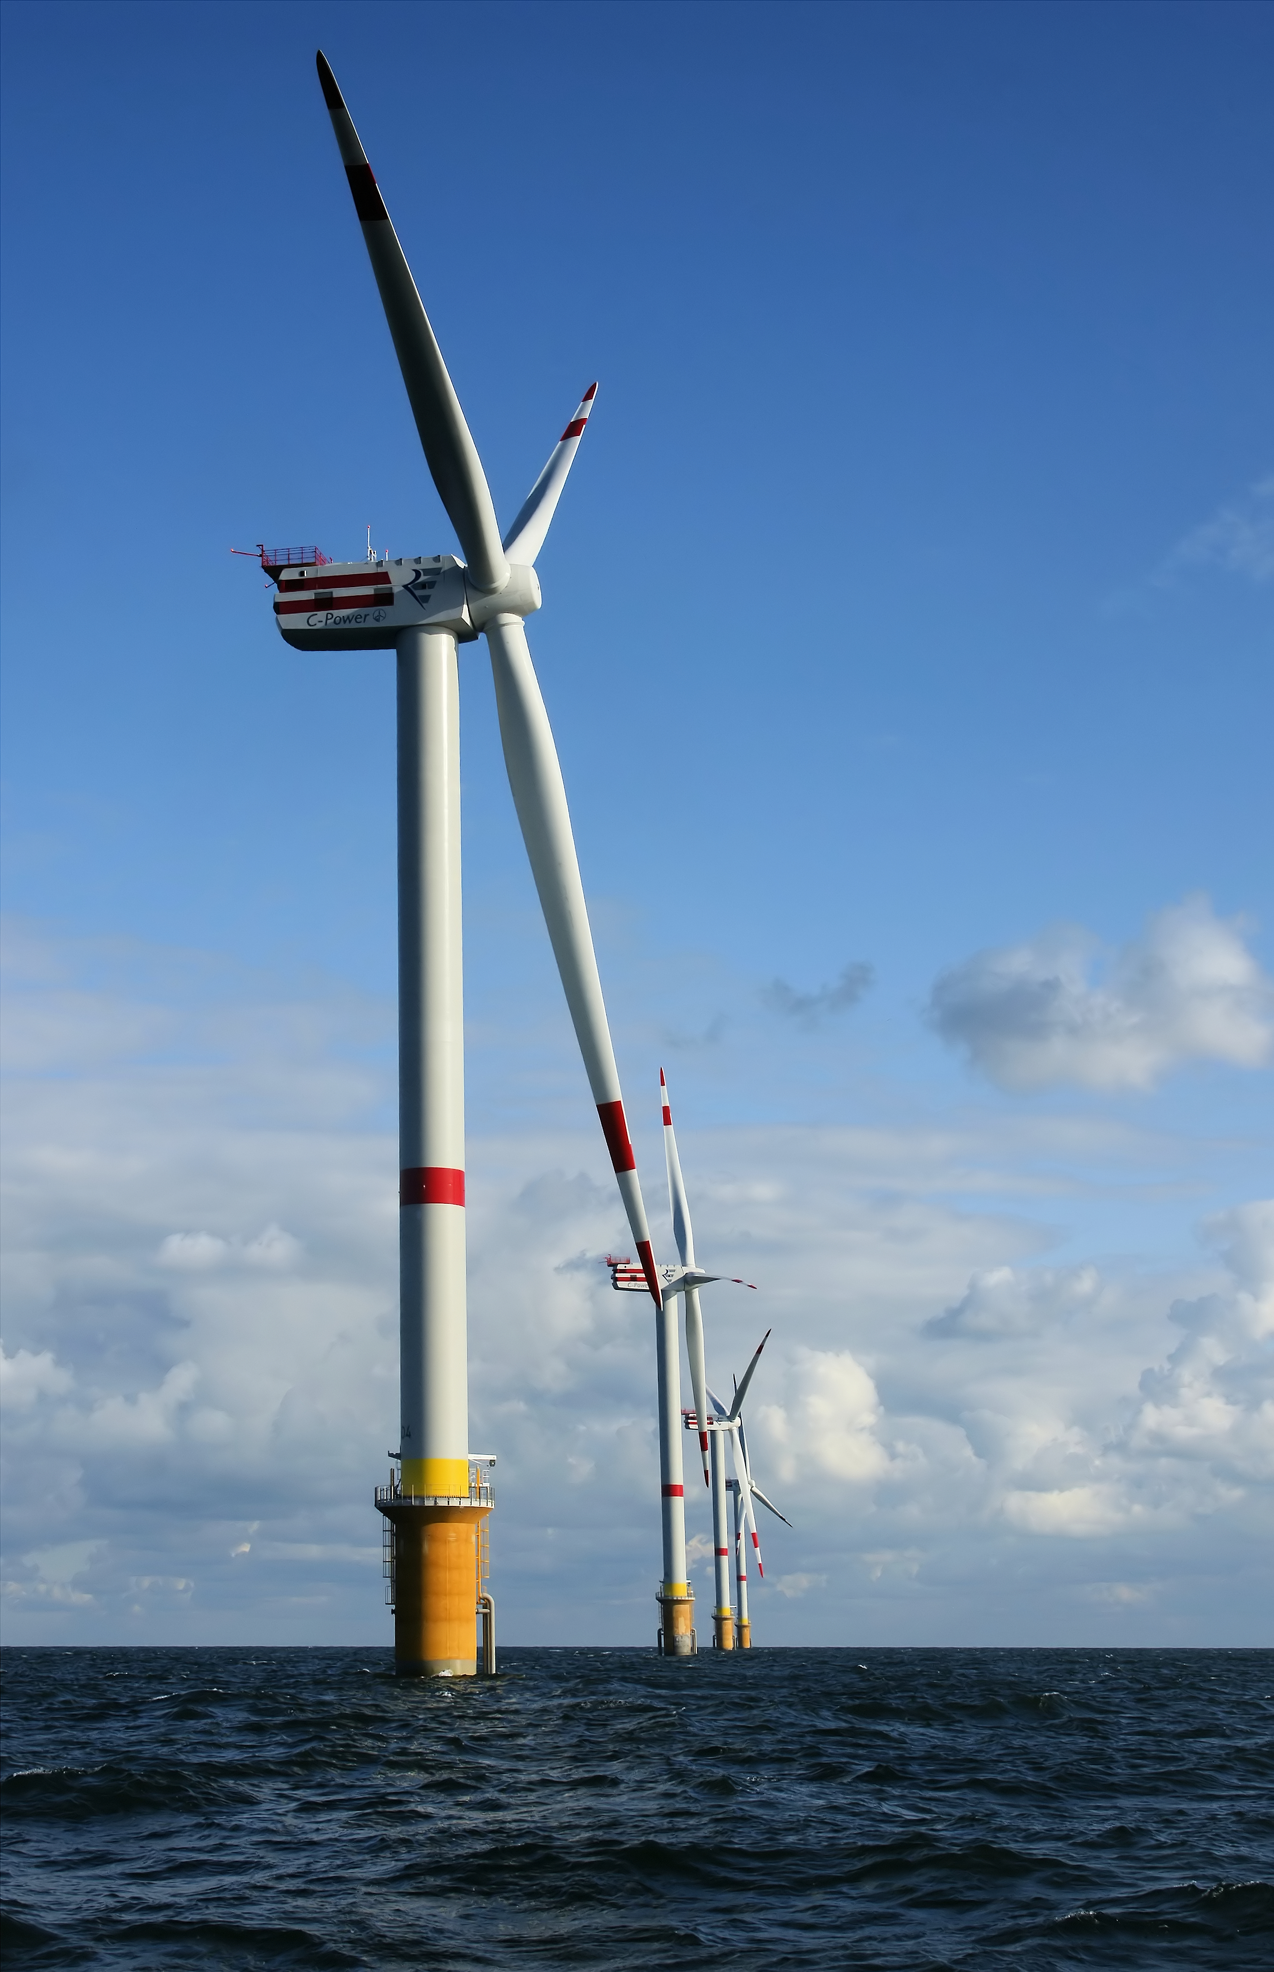
Students are to use an engineering process to design, build, test and evaluate the effectiveness of prototype wind turbine blades using rapid prototyping technologies such as CAD software, 3D printers, and Laser Cutters.

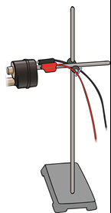
Students are required to work cooperatively in teams of two to three, and will be supplied with the motor gearbox as shown in the apparatus to the right. Groups will need to design and create a prototype of a wind turbine blade using 3D CAD software (CREO) to match the mount provided in the STERL kits. Using a 3D printer or laser cutter, groups are to produce the number of turbine blades necessary to produce the maximum power.

Groups will use the research they completed on wind turbines from the STERL kit experimentation to determine optimum wind turbine specifications. Groups will utilise practical testing of blade designs and if time permits groups will redesign their turbine blades as a result of this testing.

Each team will be required to produce a mini report outlining the process they used to design, plan, experiment, test and evaluate their Wind Turbine blades. Each team member is required to outline the role they played in the success of their prototype demonstrating the effectiveness of teamwork and allocated roles. Photographs, sketches, work samples, 3D CAD drawings are to be shown in this report.

Teams must document the progression of their designs including failures and the method used for testing and evaluation. Teams must also produce a Gantt Chart detailing their time plan. Teams must detail the processes of:

Designing – Planning – Experimenting – Testing - Evaluating

Team roles must be clearly allocated and demonstrated during class practical projects and noted in the report. Orthographic drawings will need to be produced of the wind turbine blades and included in the report.

All designs will need to be tested with the STERL electric fans set at 300mm from the centre of the blades. Results need to be recorded and power calculations made. Higher Power = Higher marks.

Teams will be required to manage the use of the 3D printer/ laser cutter and schedule works around anticipated high demand during class time and and print prototypes overnight, or early morning. All team members are required to learn how to use the 3D CAD software required to produce models and are encouraged to download the CREO (student edition) software for their home computer or BYOD computer.

Other resources will be provided during class time, on Edmodo, on the Wiki page or on Moodle depending upon your teacher’s preference. The practical components of this task will be marked as a group, however, the mini report components are an individual task. Note it is ok to share some resources in the mini report such as photos and role allocations, however, most components should be completed as an individual.

Any student who has difficulty interpreting this task is encouraged to speak to the teacher for clarification and assistance earlier rather than later.

Part A: Report Marking Scale
Wind Turbine Prototype and Mini Report | Marks
Practical: Prototype wind turbine blades quality design and production | 10
Practical: Innovation, creativity and problem solving | 10
Practical: Multiple prototypes produced and tested | 10
Practical: Evidence of experimentation and testing | 10
Practical: Teamwork mark (Marks deducted from team members who did not significantly contribute to the overall success of the project) | 10
Report: Documentation of the engineering processes of designing, planning, experimenting, testing and evaluating | 20
Report: Effective use of photo’s, sketches, drawings | 10
Report: Calculations of Power | 10
Report: Evidence of team work including role allocation | 10
Total | /100

Marking Guidelines
An Excellent Wind Turbine Rapid Prototyping Project will;  - include wind turbine blades which produce power levels that are superior to the STERL models  - be innovative demonstrating creativity and excellent problem solving skills  - have multiple blade designs tested and evaluated  - demonstrate excellent team work approaches to solving problems  - effectively document the engineering processes of designing, planning, experimenting, testing and evaluating in a mini report  - effectively use of photo’s, sketches, drawings  - include calculations of power | 90 - 100
An Good Wind Turbine Rapid Prototyping Project will;  - include wind turbine blades which produce power levels that are equal to the STERL models  - be original demonstrating some creativity and good problem solving skills  - have a single blade design that has been tested and evaluated  - demonstrate good team work  - document most of the engineering processes of designing, planning, experimenting, testing and evaluating in a mini report  - use of photo’s, sketches, drawings | 50- 89
An Excellent Wind Turbine Rapid Prototyping Project will;  - include wind turbine blades which produce power levels that are less than the STERL models  - be similar to the STERL kit models not demonstrating creativity and problem solving skills  - have a single blade design, not printed or cut  - demonstrate average to poor team work  - document a limited amount of the engineering processes of designing, planning, experimenting, testing and evaluating in a mini report  - photos, sketches, drawings not used in the mini report | 0 - 50

