Engineering Encounters Bridge Design Contest
Lesson Plan
Overview
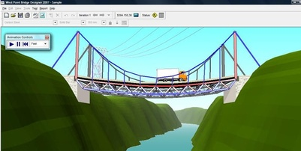
Students will each have a computer and be given instructions on how to “build” a bridge on-line. The computer program (Engineering Encounters Bridge Design Contest - http://bridgecontest.org) will then test the strength of the bridge by simulating a truck driving over it.

Duration
2 x 60 minute lessons

Objectives
Students will be able to construct a prototype that can be tested online.
Students will be able to use the appropriate vocabulary in describing the construction of their bridge.
Students will utilise technology (computer and appropriate program) that will test and evaluate the results via simulation.

Resources
Engineering Encounters Bridge Design Contest (free software available at: http://bridgecontest.org)
Video of Tacoma Narrows Bridge collapse (see website: http://commons.wikimedia.org/w/index.php?title=File%3ATacoma_Narrows_Bridge_destruction.ogg)
http://www.pbs.org/wgbh/buildingbig/lab/index.html

Lesson
This activity works well with the following timing:
Lesson 1: 60 minutes
5 mins – introduce concepts (see PowerPoint), explain activity to students (including time for Q&A)
20 mins – PowerPoint presentation & interactive discussion
10 mins – View Tacoma Narrows bridge collapse on web
25 mins – Build first bridge using “Engineering Encounters Bridge Design” software
Lesson 2: 60 minutes
40 mins – Competition – students build their own bridges – winner is the cheapest working bridge
20 mins – Wrap-up – students can print their bridge design & discuss with the group how they designed their bridge

Accommodations/Modifications
Works best if each student has access to their own computer and the Engineering Encounters Design software but teams of 2 or 3 could work together on 1 computer
Activity can be “scaled up” to a higher challenge level by having students present their designs to the group at the end.

Reflections
Following the activity there will be a discussion on bridge types and a discussion on the design and simulation process. Sample questions:
What advantages does a suspension or cable stayed bridge have over a truss or arch bridge?
What are the disadvantages?
What is the difference between tension and compression?
What costs are involved in building a truss bridge?
What is resonance and how is that a factor in bridge design?

