LEICHHARDT CAMPUS

TAS FACULTY
ASSESSMENT TASK COVERSHEET:
Stage 5 – Year 10 iSTEM
UNIT
YEARLY EXAM – iSTEM.
WEIGHTING:
25%
DUE DATE:
Term 4, Week 4.
TIME ALLOWED:
50 minutes + 5 minutes reading time (in class exam)
OUTCOMES:
5.2.1, 5.3.1, 5.3.2, 5.5.1, 5.7.1
TASK
During the year the students have investigated a range of Science, Technology, Engineering and Mathematical concepts in the iSTEM course.
The yearly exam will assess their understanding of these concepts and ask them to engage in critical thinking when investigating real-world examples of STEM in action.
The exam will consist of multiple choice questions, short answer questions and an extended response and will be completed during class time.
ASSESSMENT CRITERIA
SS
This is a formal assessment item. Absence due to illness, funeral, family situation, etc. must be supported by a medical certificate, presented to the Head Teacher on the first day of your return to school, irrespective of your timetable for this subject. You must be prepared to attempt the task on the first day of your return to school – i.e. when your medical certificate expires.
Penalties for unacceptable late submission and non-attempt of assessment are as follows: One day late- 10% of total mark; Two days late- 20% of total mark; Three days late- 30% of total mark; Four days late- 40% of total mark; Five days late- 50% of total mark; More than five days late- mark of zero. If the work has not been submitted after a week the student/s involved will re-attempt the task in order to meet course outcomes.
If plagiarism is evident an automatic mark of zero will be given and the student/s involved will re-attempt the assessment.
If the assessment is a serious non-attempt or non-attempt noted by both the Teacher and Head Teacher the student will receive zero and will re-attempt the assessment in order to meet course outcomes. Any form of malpractice and misadventure will also result in parental contact by the respective teacher and student/s involved in the malpractice may be further supported through the ‘Leichhardt Way’.

Blank Page

Year 10 iSTEM
Yearly Examination – 2019

TIME ALLOWED
5 MINUTES READING
60 MINUTES WRITING

Instructions to candidates:
- Do not write or mark the examination booklet in any way during reading time.
- There are 17 pages in this booklet including this one. Please check to ensure that this is so.
- Note that the time allocated for the examination is 60 minutes and that 100 marks have been allocated: this should give you a guide as to how much time you should spend on each section.
- There are 3 sections in this booklet: Multiple Choice (30 marks), Short Answer (50 marks) and ALARM Extended Response (20 marks).
- Electronic Devices cannot be used during the exam.
- If you finish early, please do not waste your time: you only get examination time once, so it should not be wasted. Check your work thoroughly: grammar and spelling and use of technical language - read the questions and check your answers to ensure that you have answered the questions asked.
- When the signal to write is given fill in your name, class and teacher details on this booklet (below) before you begin answering any questions.
- All answers in this booklet must be completed in pen. Sketches must be in pencil.
- If you require additional pages they can be provided by you teacher.

Name................................................................
Class.................................................................
Teacher............................................................

Section 1: Multiple Choice (Circle the most correct choice)
This section is worth 30 marks.

Scientific and Mechanical Concepts and Engineering Processes (1 mark each) (5.2.1)

- NASA’s Mars Opportunity Rover was primarily designed to
  - Find signs of life
  - Search for valuable minerals
  - Locate a suitable site for a colony
  - Look for signs of past water activity

- What is an electrical circuit?
- An electrical loop through which current flows
- An electrical loop that contains a switch
- A way of powering electronic devise
- A type of dance move

- Why did the Opportunity Rover fail?
- It ran out of power
- Dust got into its circuits and damaged them
- It ran into a large rock
- Dust covered its solar panels

- The steps in the Metro Minds Design process were:
- Empathise, Define, Ideate, Prototype, Test
- Problem, Research, Idea, Make, Evaluate
- Define, Empathise, Ideate, Prototype, Test
- Empathise, Design, Ideate, Prototype, Evaluate

- When analysing data, Range is?
- A set of outcomes in order.
- The difference between the highest and lowest data points.
- The limit of the highest data point.
- The limit of the lowest data point.

- When analysing data, Mode is?
- The most common number.
- A set of outcomes in order.
- The middle number in a set.
- The data way of saying average.
- If you wanted to build a new and improved type of sneaker, a good way to do background research and specify requirements for your new shoe would be to:
- Go to a shoe store and try on sneakers, taking notes about the important features.
- Talk to your friends and family about what they like and do not like about the sneakers they own.
- Look around at your school and take notes about what type of sneakers are the most popular.
- All of the above

- On the jobs listed below that young Australians might get as one of their first jobs, which skill is most required?
- Problem solving.
- Advanced technology.
- Interpersonal.
- Written communication.
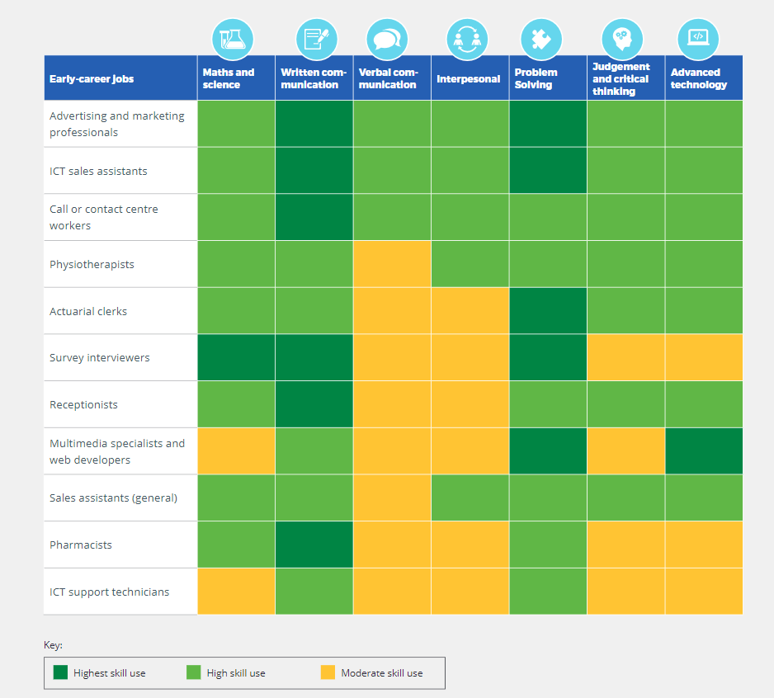

- What is iterative design?
- A cyclic process of prototyping, testing, analysing, and refining a product or process
- A linear process used by engineers
- A cyclic process used by engineers to refine a design
- A cyclic process used by scientists

- A good problem statement
- Focuses on only one problem and describes how people, places or things are advantaged
- Includes more than three sentences and does not include a solution
- Focuses on more than one problem and includes a solution
- Does not include a solution and focuses on only one problem

Range of Technologies Used in iSTEM (1 mark each) (5.3.2)

- What is this?
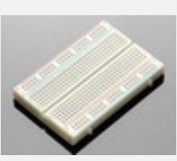
- Arduino duo board
- Raspberry pi
- Breadboard
- Plastic board

- What is Arduino?
- A company selling microcontrollers
- Software used to program microcontrollers
- An open sourced electronics prototyping platform based on flexible, easy to use hardware and software
- A microcontroller

- Why are breadboards used?
- They are cheap
- They are solderless
- They are integrated circuits
- They link to Smartphones

- What are these?
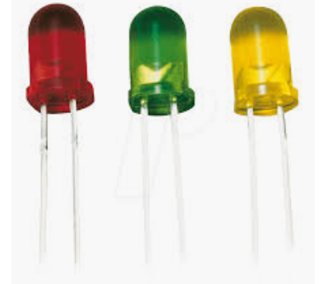
- LED’s
- LAD’s
- Small light globes
- Light sensors

- What does IDE stand for?
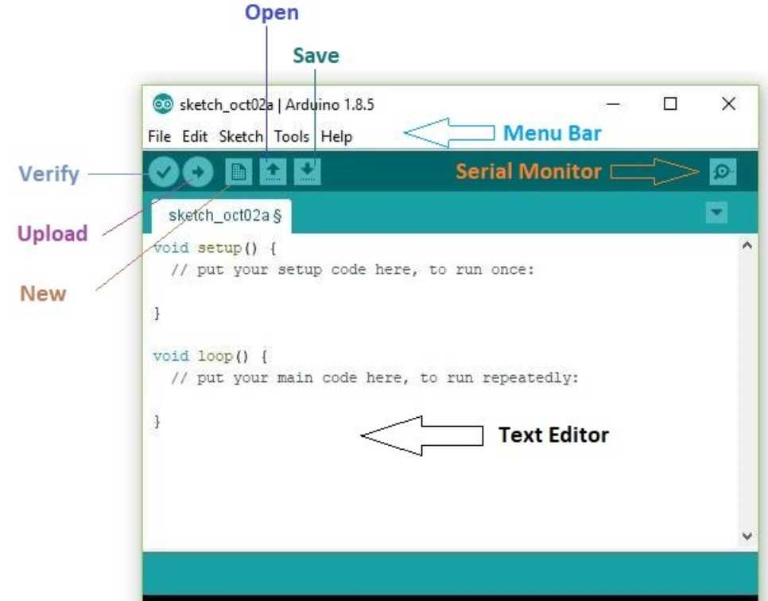
- Integrated Deletion Environment
- Integrated Deletion Energy
- Integrated Development Energy
- Integrated Development Environment

- A program written with the IDE for Arduino is called a
- Sketch
- Editor
- Console
- Workbench

- Why is a resistor important?
- It is not important
- It increases power to a circuit
- It controls the flow of electricity by lessening it to a certain amount
- It resists electricity and makes a circuit safer

- In the RGB LED, the R stands for ___________
- Red
- Read
- Ready
- Read only

- A barometric sensor measures
- Temperature
- Air Speed
- Humidity
- Air pressure

- Which of the following was NOT used in the Ode to Oppy task?
- Electronics
- CAD/CAM
- Hydraulics
- Microcontroller

Communication Techniques (1 mark each) (5.5.1)

- On the Gantt Chart below, how many weeks (approximately) untill the planning team be working on the project?
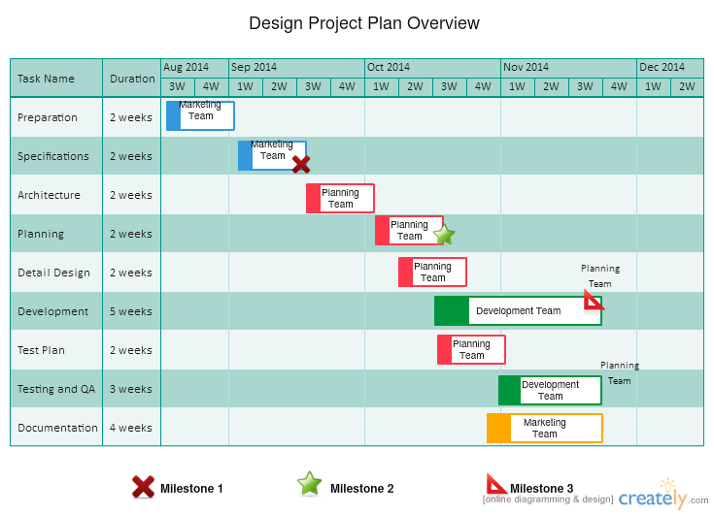
    - 5 weeks b. 6 weeks c. 8 weeks d. 14 weeks

- From the Gantt Chart above, how many tasks (maximum) will the planning team have to manage at the same time?
- 1 task
- 6 tasks
- 3 tasks
- 4 tasks

- From the Gantt Chart above, how many weeks (approximately) will the marketing team be working on the project?
- 6 weeks
- 7.5 weeks
- 5.5 weeks
- 4 weeks

- From the Gantt Chart above, what is the total duration of the project?
- 6 weeks
- 24 weeks
- 13 weeks
- 9 weeks

- In goal setting, what does SMART stand for?
- Specific, Measurable, Achievable, Reasonable, Time-Based.
- Strengths, Measurable, Achievable, Realistic, Time-Based
- Specific, Measurable, Achievable, Realistic, Time-Based
- Specific, Measurable, Achievable, Realistic, Turn-based

- What does acronym SWOT stand for?
- Strengths, Weaknesses, Options, Threats.
- Strengths, Weaknesses, Others, Treats
- Strengths, Weaknesses, Opportunities, Threats.
- Strengths, Weaknesses, Opportunities, Time.

- What is the purpose of a SWOT analysis?
- To develop another list of things that you must think about.
- To make sure that everyone will be safe from the projects threats.
- To allows STEM professional to think about everything that could impact of the success of a new project.
- To analyse the Strengths, Weaknesses, Opportunities and Threats to a project.

- In Metro Minds, what role was responsible for photographs and finalising the concept brief?
- The Organiser
- The Questioner
- The Wordsmith
- The Inventor

- You submitted a concept brief as part of the Metro Minds assessment task. The concept brief
- Outlined the design thinking process used in your project
- Evaluated the ideas your group developed
- Analysed the problem
- Explained the testing completed

- In Metro Minds, what role was responsible for quality control and testing?
- The Organiser
- The Questioner
- The Wordsmith
- The Inventor
Section 2: Short Answer Questions
This section is worth 50 marks.

Comparing Engineering Processes (10 marks) (5.2.1)

Question 1: Through different iSTEM challenges you have used different engineering processes. Describe (or sketch) two processes and compare them.

Process One - | Process Two –
Comparison –
____________________________________________________________________________________________________________________________________________________________________________________________________________________________________________________________________________________________________________________________________________________

Marking Guidelines: 3 marks for successfully describing each different processes. 4 marks for the comparison of the two processes.

Understanding of STEM Principles and Processes (10 marks) (5.3.1)

There are 14 Grand Challenges for Engineering in the 21st Century. Providing access to clean water is one of these challenges

The world's water supplies are facing new threats; affordable, advanced technologies could make a difference for millions of people around the world.
Lack of clean water is responsible for more deaths in the world than war. About 1 out of every 6 people living today do not have adequate access to water, and more than double that number lack basic sanitation, for which water is needed. In some countries, half the population does not have access to safe drinking water, and hence is afflicted with poor health. By some estimates, each day nearly 5,000 children worldwide die from diarrhea-related diseases, a toll that would drop dramatically if sufficient water for sanitation was available..
Question 2:
Imagine you are working with a team of STEM professionals to solve this global challenge.
      - Write a problem statement for this challenge (2 marks)
______________________________________________________________________________________________________________________________________________________________________________________________
      - Write a driving question based on your problem statement (2 marks)
______________________________________________________________________________________________________________________________________________________________________________________________

      - Complete the following SWOT Analysis about the project (4 marks)
 | Positives | Negatives
Internal | STRENGTHS | WEAKNESSES
External | OPPORTUNITIES | THREATS
Marking Guidelines: ½ mark for each strength, weakness, opportunity and threat.
Identifies and uses a range of Technologies (10 marks) (5.3.2)

Select two Technologies (tools or processes) that you have learnt to use during the challenges this year.

Question 3: Describe the first Technology. (2 marks)
_____________________________________________________________________________________________________________________________________________________________________________________________________________________________________________________________________

Question 4: Describe the second Technology. (2 marks)
_____________________________________________________________________________________________________________________________________________________________________________________________________________________________________________________________________

Question 5: Analyse why you used one of the Technologies. (2 marks)
__________________________________________________________________________________________________________________________________________________________________________________________________________________________________________________________________________________________________________________________________________________________________________________________________________________________________________________________________________________________________________________________________________

Question 6: Evaluate the impact one of the Technologies had on your project solution. (4 marks)
__________________________________________________________________________________________________________________________________________________________________________________________________________________________________________________________________________________________________________________________________________________________________________________________________________________________________________________________________________________________________________________________________________

Communication Techniques (10 marks) (5.5.1)
During projects and challenges this year you have been asked to use the Stanford Design Process

Question 7: Use this table to explain what happens in each of the stages of the Stanford Design Process:
:
Stage: | Explanation of Stage

Marking Guidelines: 2 marks for an explanation of each step
Appreciation of STEM and its impact on the World (10 marks) (5.7.1)

STEM jobs are everywhere and growing, using knowledge you have gained during the year describe five STEM careers.

Question 8:
Name Career One and describe the STEM skills required for this career (2 marks)
_____________________________________________________________________________________________________________________________________________________________________________________________________________________________________________________________________

Name Career Two and describe the STEM skills required for this career (2 marks)
_____________________________________________________________________________________________________________________________________________________________________________________________________________________________________________________________________

Name Career Three and describe the STEM skills required for this career (2 marks)
_____________________________________________________________________________________________________________________________________________________________________________________________________________________________________________________________________

Name Career Four and describe the STEM skills required for this career (2 marks)
_____________________________________________________________________________________________________________________________________________________________________________________________________________________________________________________________________

Name Career Five and describe the STEM skills required for this career (2 marks)
_____________________________________________________________________________________________________________________________________________________________________________________________________________________________________________________________________
Section 3: Extended ALARM Response
This section is worth 20 marks.

Read the stimulus material below and complete the extended response.

If you can tick off all these STEM skills, you’re super employable
By Pippa Duffy- March 6, 2019 https://careerswithstem.com.au/stem-skills-employability/

A talent for science is an obvious choice when it comes to working in a STEM (science, technology, engineering and maths) field, but did you know, according to a recent World Economic Forum*, human-based skills – such as critical thinking, creativity and people management – have reached top-10 status when it comes to scoring a cool career.
If you’ve wondered what it even means to be part of the science scene, read on. We talked to the experts and paid attention when the big guns shared their smarts!

Employability checklist

How many STEM skills do you have?
- Problem solving
- Creativity
- Critical thinking (testing your theory/asking the right questions)
- Investigative drive
- Statistics orientated
- Decision making
- Intellectual curiosity
- Flexibility
- Argumentation – supporting your claim
- Entrepreneurial focus
- Tech knowledge
- Researching

What are STEM skills exactly?
“Most people who work in STEM are practical and think logically about problem solving. People in STEM are incredibly diverse, but we all tend to have that logical thought process running throughout.”

STEM skills snapshot

Here’s the percentage of employers who value the following STEM skills
70% – Active learning (i.e. learning on the job)
22% – Programming
23% – System analysis and evaluation
58% – Complex problem solving & critical thinking

Research by the Australian Government’s Office of the Chief Scientist has found that employers are all over the need for STEM-skilled people (like you!) in their workplaces. Here’s why…
• Design thinking is a priority for bosses in information technology, media and telco sectors
• Jobs in finance, insurance, construction, health and social industries rate STEM qualifications higher than non-STEM backgrounds
• Learning on the job, understanding business and creative problem solving are key for Aussie employers
• Businesses say STEM-qualified staff are the most innovative
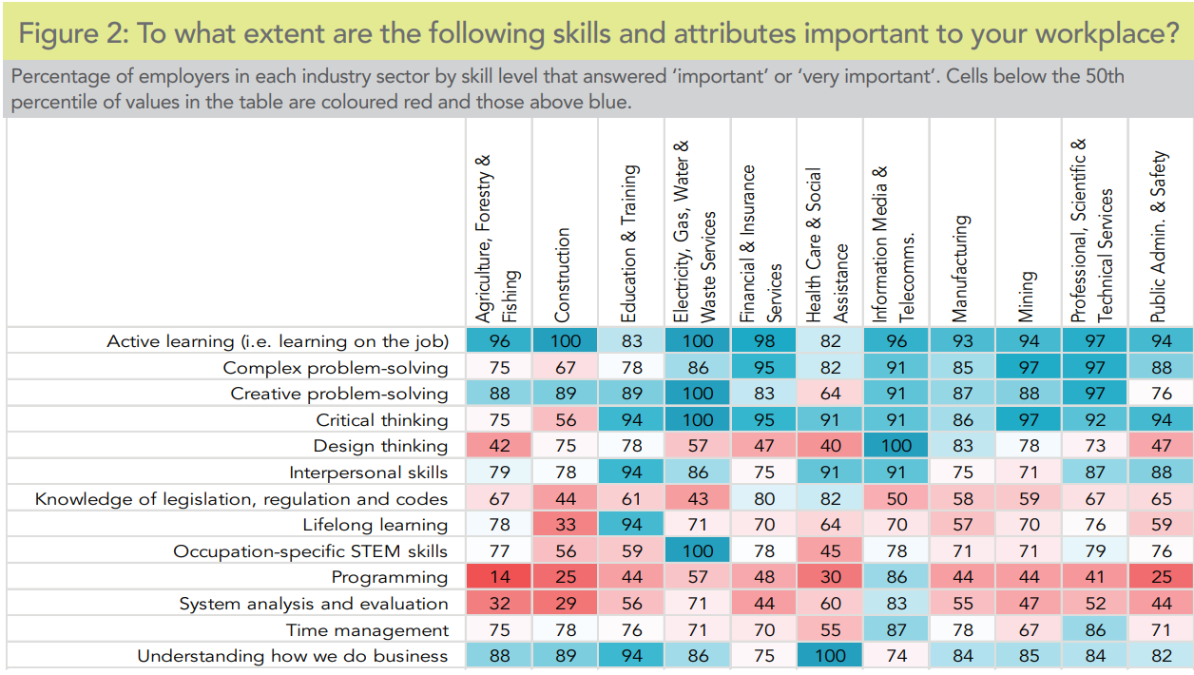

ALARM Matrix Prompt:
Name and Define – Describe – Explain – Analyse - Critically Analyse – Evaluate
ALARM Matrix Prompt:
Name and Define – Describe – Explain – Analyse - Critically Analyse – Evaluate
Use the ALARM writing tool and the stimulus to respond to the following question:
Evaluate the impact of your iSTEM training on preparing you for the future workforce.
Marking Criteria
18-20 | Evaluates impact of iSTEM training
14-17 | Analyses impact of iSTEM training
10-13 | Explains impact of iSTEM training
6-9 | Describes impact of iSTEM training
0-5 | Identifies impact of iSTEM training

End of examination

Blank Page

Examination breakdown/assessment criteria:

Outcome | Multiple Choice | Short Answer Questions | Extended Response
5.2.1 scientific, mathematical and engineering processes | 10 | 10 | -
5.3.1 explains needs and opportunities | - | 10 | 10
5.3.2 identifies a range of technologies | 10 | 10 | -
5.5.1 communication techniques | 10 | 10 | -
5.7.1 appreciation of the value of STEM | - | 10 | 10
Total | 30 | 50 | 20

