LEICHHARDT CAMPUS

TAS FACULTY
ASSESSMENT TASK COVERSHEET:
Stage 5 – Year 9 iSTEM
UNIT
YEARLY EXAM – iSTEM.
WEIGHTING:
25%
DUE DATE:
Term 4, Week 3.
TIME ALLOWED:
1 hour 5 minutes (in class assessment)
OUTCOMES:
5.2.1, 5.3.1, 5.3.2, 5.5.1, 5.7.1
TASK
During the year the students have investigated a range of Science, Technology, Engineering and Mathematical concepts in the iSTEM course.
The yearly exam will assess their understanding of these concepts and ask them to engage in critical thinking when investigating a real world example of STEM in action.
The exam will consist of multiple choice questions, short answer questions and an extended response and will be completed during class time.
ASSESSMENT CRITERIA
SS
This is a formal assessment item. Absence due to illness, funeral, family situation, etc. must be supported by a medical certificate, presented to the Head Teacher on the first day of your return to school, irrespective of your timetable for this subject. You must be prepared to attempt the task on the first day of your return to school – i.e. when your medical certificate expires.
Penalties for unacceptable late submission and non-attempt of assessment are as follows: One day late- 10% of total mark; Two days late- 20% of total mark; Three days late- 30% of total mark; Four days late- 40% of total mark; Five days late- 50% of total mark; More than five days late- mark of zero. If the work has not been submitted after a week the student/s involved will re-attempt the task in order to meet course outcomes.
If plagiarism is evident an automatic mark of zero will be given and the student/s involved will re-attempt the assessment.
If the assessment is a serious non-attempt or non-attempt noted by both the Teacher and Head Teacher the student will receive zero and will re-attempt the assessment in order to meet course outcomes. Any form of malpractice and misadventure will also result in parental contact by the respective teacher and student/s involved in the malpractice may be further supported through the ‘Leichhardt Way’.

Blank Page
Year 9 iSTEM
Yearly Examination – 2018

TIME ALLOWED
5 MINUTES READING
50 MINUTES WRITING

Instructions to candidates:
- Do not write or mark the examination booklet in any way during reading time.
- There are 13 pages in this booklet including this one. Please check to ensure that this is so.
- Note that the time allocated for the examination is 50 minutes and that 100 marks have been allocated: this should give you a guide as to how much time you should spend on each section.
- There are 3 sections in this booklet: Multiple Choice, Short Answer and ALARM Extended Response.
- Electronic Devices cannot be used during the exam.
- If you finish early please do not waste your time: you only get examination time once so it should not be wasted. Check your work thoroughly: grammar and spelling and use of technical language - read the questions and check your answers to ensure that you have actually answered the questions asked.
- When the signal to write is given fill in your name, class and teacher details on this booklet (below) before you begin answering any questions.
- All answers in this booklet must be completed in pen. Sketches must be in pencil.
- If you require additional pages they can be provided by you teacher.

Name................................................................
Class.................................................................
Teacher............................................................

Section 1: Multiple Choice (Circle the most correct choice)
This section is worth 20 marks.

Scientific and Mechanical Concepts (1 mark each) (5.2.1)

- Hydraulics systems work by:
  - Following Pascal’s Law in fluids.
  - Following Newton’s First Law.
  - Following Archimedes' Principle in liquids.
  - Following Bernoulli’s Principle.

- Which of the listed theories explain lift:
  - Bernoulli’s Principle, Angle of Attack, Angle of Incidence.
  - Flaps, Wings, Propellers, Ailerons.
  - Circulation Theory, Bernoulli’s Principle, Angle of Attack.
  - Angle of Incidence, Circulation Theory, Angle of Attack.

- Which sketch demonstrates compression?
 | 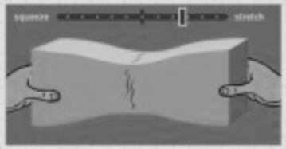 a. | 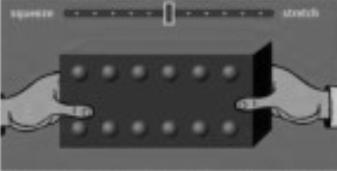 c.
 | 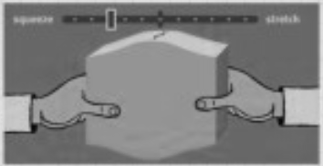 b. | 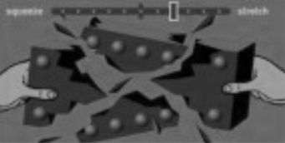 d.

- What is the correct explanation for Aspect Ratio?
  - It is the ratio used in drawings to show size differences.
  - It is used in aeronautics and is the length of the wing divided by the width of the wing.
  - It is ratio of the height of a screen compared to the width of the screen in monitors and televisions.
  - It is the ratio between the height of a building and the width of its base.

- In the marshmallow challenge, the best design can be described as:
  - A series of joined triangular pyramids.
  - A loose scaffold of quadrilateral prisms.
  - A mix of triangular and quadrilateral prisms.
  - A series loose of triangular prisms.

Understanding of STEM Principles and Processes (1 mark each) (5.3.1)

- Which of the following steps is not a part of the engineering design process we investigated?
  - Specify Requirements.
  - Develop and Prototype Solution.
  - Collect Data.
  - Communicate Results.

- Work is measure in:
- Joules.
- Newtons.
- Grams.
- Pascals.

- In the Skylap task which of the following was not a requirement of the brief?
- The fuselage is to be made of balsa wood.
- The wheels can be placed anywhere.
- The wing length and width is up to you.
- The motor can be placed anywhere.

- Validity is:
- How accurate a survey is at measuring what it is trying to measure.
- How correct a result is compared to what you thought would happen.
- The measure of a scientific construct.
- The quality of being logically or factually sound.

- Reliability is:
- The quality of being trustworthy or of performing consistently well.
- The degree to which a research survey produces consistent results.
- Having the same results occur in a survey compared to what you predicted.
- How correct a scientific construct is.

Range of Technologies Used in iSTEM (1 mark each) (5.3.2)

11) | 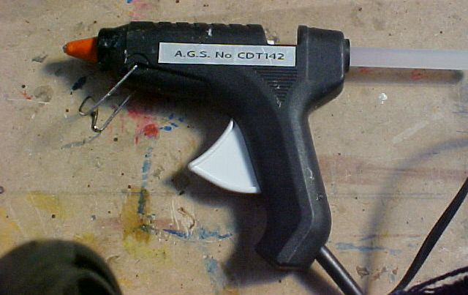 | What is this tool?  - Glue Gun  - Glue Stick  - Hot Glue Gun  - Trigger Gun
12) | 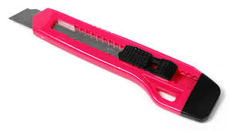 | What is this tool?  - Knife  - Blade  - Craft Knife  - Sliding Blade Knife

- Which is an accurate list of parts available for a Skylap project?
- Balsa sheet, balsa block, wheels, axle, motor, wings.
- Balsa rod, balsa sheet, axle, plastic wheels, propeller, motor.
- Balsa rod, balsa sheet, plastic wheels, propellers, motors.
- Balsa sheet, balsa block, wheels, propeller, motor.

- In Microsoft Excel what is the formula for average?
  - =AVERAGE(number1, number2, ….)
  - =AVER(number1,2,3…)
  - =AVERAGE(NUM1, NUM2, …)
  - =MEAN(number1, number2, …)

- In Microsoft Excel a group of cells is called?
  - Column
  - Display
  - Selection
  - Object

Communication Techniques (1 mark each) (5.5.1)

- What is the correct formula for circumference?
  - π × 2 x diameter.
  - π × diameter.
  - 2π × diameter.
  - π × radius²

- A mass is dropped from a height ‘0’ above the ground and freely falls. Which graphs below correctly describe the displacement (distance) and velocity of the object during the time the object is falling?

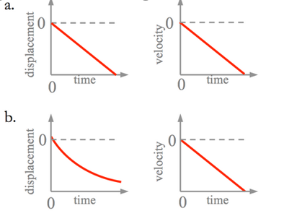 | 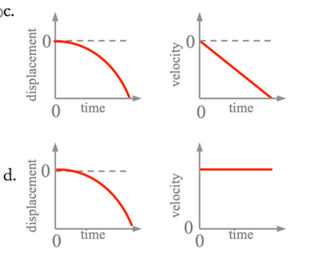
- What is correct Australia Standard for Engineering Drawings?

  - AS4024
  - AS1100
  - AS3300
  - AS2210

- An object is drawn on an engineering drawing at 100mm in length and has a scale or 1:5. This means the real length of the object is?
  - 5000mm
  - 20mm
  - 500mm
  - 2mm

- In the graph below from the Foundation for Young Australians predicts the change of workplace tasks due to automation, what is the net loss of hours for this young worker?
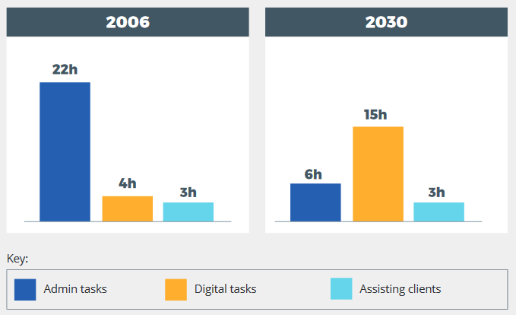 | - 16 hours  - 11 hours  - 0 hours  - 5 hours
Section 2: Short Answer Questions
This section is worth 60 marks.

Understanding of STEM Principles and Processes (3 marks each) (5.3.1)

- Annotate the control surfaces and the axes of rotation in the diagram of the model aircraft below:
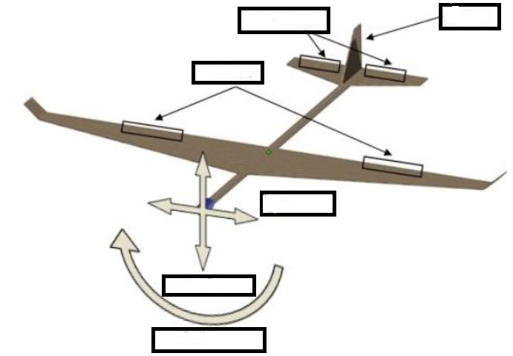

- Annotate the forces of Flight in the diagram of the model aircraft below:
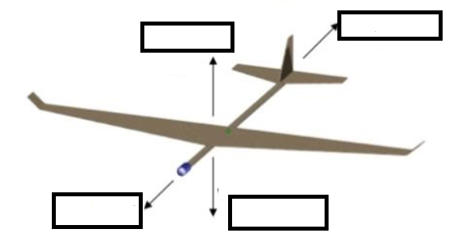

- What causes an aircraft to stall? _____________________________________________________________________________________________________________________________________________________________________________________________________________________________________________________________________________________________________________________________________________________________________________________________________________________

- Briefly describe an experiment you conducted in first semester? _____________________________________________________________________________________________________________________________________________________________________________________________________________________________________________________________________________________________________________________________________________________________________________________________________________________

- Identify three sensors from the EV3 Mindstorm kits:
i: _______________________________________________
ii: _______________________________________________
iii: ______________________________________________

STEM Principles and Processes (3 marks each) (5.3.1)

- What is engineering? _________________________________________________________________________________________________________________________________________________________________________________________________________________________________________________________

- List the steps in an experiment?
_________________________________________________________________________________________________________________________________________________________________________________________________________________________________________________________

- Describe a safe work practice when building a model aircraft.
_________________________________________________________________________________________________________________________________________________________________________________________________________________________________________________________

- What is data?
______________________________________________________________________________________________________________________________________________________________________________________________________________________________________________________

- Describe the design changes you made to one project this year.
____________________________________________________________________________________________________________________________________________________________________________________________________________________________________________________________________________________________________________________________________________________________________________________________________________________________________________________________________________________________________________

Range of Technologies (3 marks each) (5.3.2)

- Describe an experimental aircraft you investigated: ____________________________________________________________________________________________________________________________________________________________________________________________________________________________________________________________________________________________________________________________________________

- Describe your Mindstorms Robot for the Find it Fix It Challenge: __________________________________________________________________________________________________________________________________________________________________________________________________________________________________________________________________________________________________________________________________________________________________________________________________________________________________________________________________________________________________________________

- Correctly label the Excel components highlighted below: 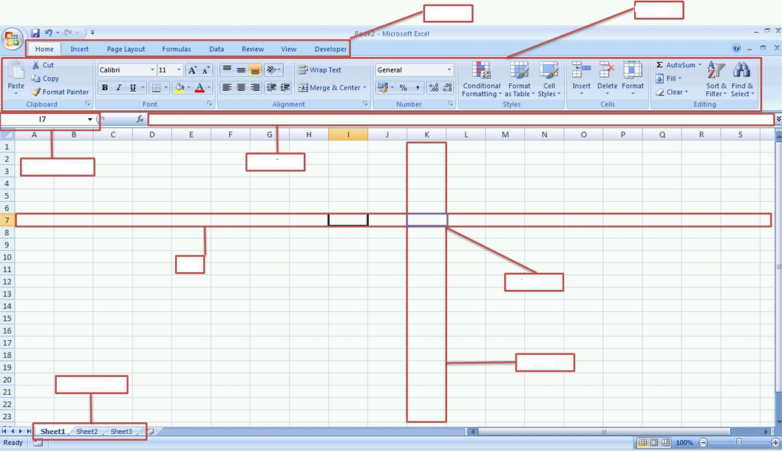

- What cell is ‘active’ in the spreadsheet? _______________________

- Describe three+ tools you used to make the Skylap project: __________________________________________________________________________________________________________________________________________________________________________________________________________________________________________________________________________________________________________________________________________________________________________________________________________________________________________________________________________________________________________________

- Communication Techniques (3 marks each) (5.5.1)

- Draw and annotate Angle of Incidence:

- Draw and annotate Bernoulli’s Effect:

- Represent 40% three different ways mathematically:
____________________________________________________________________________________________________________________________________________________________________

- Correctly identify the following EV3 Coding Blocks
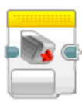
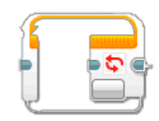
:
- Sketch an EV3 Robotic Motor:
Section 3: Extended ALARM Response
This section is worth 20 marks.

Read the stimulus material below and complete the extended response.

2075: WHAT DOES THE FUTURE OF HEALTH LOOK LIKE IN 50 YEARS?
- https://careerswithstem.com.au/2075-future-of-health/

Eliza Brockwell asks three experts to peer into their crystal balls to predict some of the major medical breakthroughs we’ll see in the next 50 years…

Robots and machine learning will overhaul surgeries
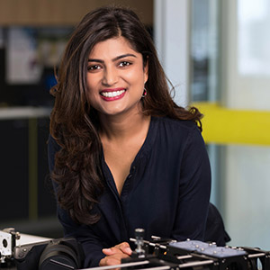
“More than 540 million years ago, there was a burst in evolution and simple organisms developed into more complex beings. No-one really understands the reasons why, but it was thought to be a change in the oxygen levels, a change in temperature and, most importantly, an evolution of vision. We’re seeing the same thing with robots; we believe vision in robotics is the key to unlocking their potential.
“Technology is constantly redefining how we learn and interact with the world around us and it will have massive impact on how we practise medicine. By building robots, we want to give surgeons very simple, affordable and smart machines that allow surgeons to perform safer and faster operations.
“Human acceptance of robots in healthcare is going to be a big barrier. You can’t replace human empathy, but robots have more potential than people realise. We want to build medical robots and devices that are easy to use and don’t require a lot of training, so they can be transported anywhere. When machine learning techniques are added to this, diagnoses will be available at the click of a button. It will also allow people in the developing world to access affordable, high-quality healthcare.”

Anjali Jaiprakash
“Human acceptance of robots in healthcare is going to be a big barrier.”

Anjali Jaiprakash is a research fellow at the Australian Centre for Robotic Vision, and part of QUT’s Medical Healthcare Robotics Lab.

Personalised medicine will revolutionise cancer cures
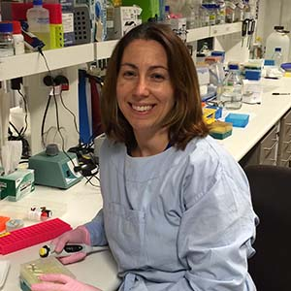
“Brain cancer is one of the biggest causes of death in children with cancer. Research shows that every child and every cancer is different, and a one-size-fits-all approach to treatment doesn’t work.

Dr Maria Tsoli
“I’m very excited about what this means for kids with hard to treat cancers, such as brain cancer.”
“In the next 50 years, personalised medicine will help us find the best treatments for individual children with cancer. We’re already making progress. The Children’s Cancer Institute and Sydney Children’s Hospital, Randwick, just opened a national clinical trial called Zero Childhood Cancer for around 400 children with the most aggressive cancers. We analyse the biology and genetics of patients’ tumours in incredible detail then test the cancers in the lab with anticancer drugs to see which work best for each child.
“This could revolutionise the way childhood cancer is treated in the future. I’m very excited about what this means for kids with hard-to-treat cancers, such as brain cancer.”

Dr Maria Tsoli is a senior research officer at The Children’s Cancer Institute and team leader of the Preclinical Core Testing Team at Zero Childhood Cancer, Randwick, NSW.

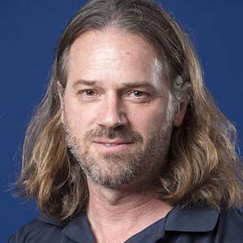
Wearable tech will be the future of health
“With sports and health tech, especially in the wearable or consumable space, 50 years is just too far in the future. I predict in 10 years, the landscape is going to be more akin to something from Blade Runner.
“Within a decade, whether it’s for health or fitness, we’ll be wearing disposable band-aid like patches, connected to the cloud via a smart device – I’m loathe to say a smartphone as I believe even those will be obsolete in 10 years’ time. These patches will measure everything from blood sugar and lactate levels to temperature and heart rate, to start with.
“Your doctor or coach will be able to monitor your health or training status remotely and in real-time, potentially even triggering other body-worn devices to remotely and automatically apply medication. Of course, this technology has implications for anti-doping technology and testing. It won’t be out of the question for elite athletes to have to wear patches for a prescribed number of hours a day to allow the Australian Sports Anti-doping Authority or World Anti-Doping Authority to continuously monitor their blood make up, making it very difficult for athletes to take banned substances and evade detection.
“The challenge – and for me the space that is going to be interesting to watch – is how this data gets curated, managed and protected. In the future, we’ll all have digital bio-identities that we’ll carry with us as we change wearable brands, sports, doctors, etc. To do that there will need to be open standards to allow data mobility, but also new and stronger security, perhaps blockchain or quantum-inspired encryption, to ensure your personal data can’t be stolen, copied or manipulated. Wherever it takes us, it’s an exciting world ahead in sports science and medicine, and I would encourage STEM students to think about the sports sector for a career choice.”

Joseph Winter
“Within a decade, we’ll be wearing disposable band-aid like patches, connected to the cloud via a smart device.”

Joseph Winter is the head of Innovation, Research and Development at the Australian Institute of Sport.
ALARM Matrix Prompt:
Name and Define – Describe – Explain – Analyse - Critically Analyse – Evaluate
Use the ALARM writing tool to respond to the following question:
Using the stimulus material and your research throughout the year, evaluate the opportunities available to people with STEM careers.
END OF EXAMINATION

