iSTEM

**NEED FOR SPEED CO2 DRAGSTERS**

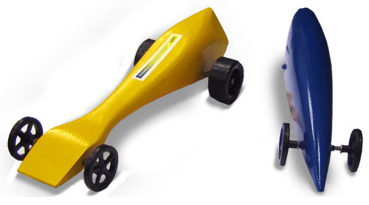

**RESEARCH BOOKLET**

**Glossary of Terms**

**Aerodynamics**  
The study of the motion of gas on objects and the forces created.

j0078804

**Aesthetics**  
A quality dealing with the appearance of an object.

**Airflow**  
The movement of air around the chassis of the race car.

**Bearings**  
mechanical device for lessening the friction or a machine part in which another part turns or slides

**Bernoulli Effect**states that the pressure of a fluid (liquid or gas), decreases as the fluid (liquid or gas),  
flows faster.

**Brainstorming**  
A stage used in the design and problem-solving process to generate a number and  
variety of ideas in a noncritical atmosphere.

**C.A.D.**  
Computer-Aided Design (and Drafting): a precision-drawing software program that  
speeds up the design process by making it easier to create and modify draft designs.

**C.A.M.**  
Computer-aided manufacturing; the operation of a machine controlled by a host  
computer.

**Chassis**  
Refers to all mechanical parts of the car attached to the structural frame.

**Design brief**  
A concise problem statement developed by a student or teacher that identifies what thestudent will do and what the successful solution will achieve.

**Design portfolio**  
A record of the development of a project from inception to completion.

**Design process**  
A planning and decision-making process that produces a solution.

**Downforce**  
A vertical force directed downward, produced by airflow around an object. Downforce is generated from the front and rear wings and the venturi tunnels on a ground effect car.  
**Drag**  
Force acting on an object in motion through a fluid (in this case air) in an opposite  
direction to the objects (chassis) motion, produced by friction.

**Hydraulics**  
Using fluids to transmit and regulate the forces in a machine or device.

**Laminar**  
Laminar flow means the fluid is moving in smooth layers around the object. Air flow  
becomes turbulent moving from the front to the rear of the car, forced around obstructions such as mirrors, helmets, and rollbars.

**Lift**  
The upward reaction of an aircraft to the flow of air forced over the shape of the wing  
(airfoil). The front and rear wings of ground effect cars are shaped like inverted wings tocreate downforce or negative lift.

**Monocoque**  
A Body structure that derives its strength and rigidity from unitized construction, rather than a framework of thick members.

**Pneumatics**  
Using air or gas pressure to operate mechanical devices.

**Prototype**  
A model used to test and evaluate a design before final production.

**rpm**  
Revolutions per minute, or rpm, is a measure of engine speed as determined by crankshaft spin.

**Specifications**  
A detailed description of design criteria for a piece of work

**Technical drawings**  
Drawings that contain the detailed information required to produce an object or system (e.g., measurement, scale, material, finishing information).

**Turbulent**  
Turbulent airflow is when the fluid streamlines break into eddies and complex changing patterns. This can cause unstable forces on an object. As the airflow moves from the front of the car to the rear it becomes turbulent.

**Venturi**  
A narrow tunnel under the side pod, shaped like an inverted wing. As air enters and is forced through the narrow center, its speed increases, creating a low-pressure area between the bottom of the car and the track. This creates a suction effect, which holds the car to the track.

**Venturi Effect**  
Fluid speed increases when the fluid is forced through a narrow or restricted area. The  
increased speed results in a reduction in pressure. The underbody venturi is shaped to  
create a low pressure area between the road and chassis which creates downforce.

**Wind Tunnel**  
A tube like structure where wind is produced usually by a large fan to flow over the test object. The object is connected to instruments that measure and record aerodynamic forces that act upon it.

**Need for Speed / CO2 Dragsters**

## A) ANALYSING NEEDS, PROBLEMS AND OPPORTUNITIES

**You’re a Car Designer!**

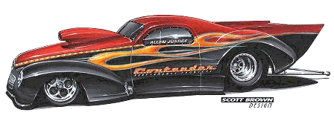In this unit you will learn how to design, build and race your own dragster. It’s not a car you ride in but a real one just the same. The race car drivers at Bathurst, the mechanics in the V8 supercars, the automobile designers at Holden in Adelaide, and the automobile engineers in Germany all had to start somewhere. They started small. Then as they learned and progressed they moved on to bigger and better things.

## Design Brief:

Design a vehicle (to the specifications given) to travel a distance of 20m in the fastest time possible using the power provided by a single standard CO2 cartridge.

**Design, Build and Race your own Dragster!**

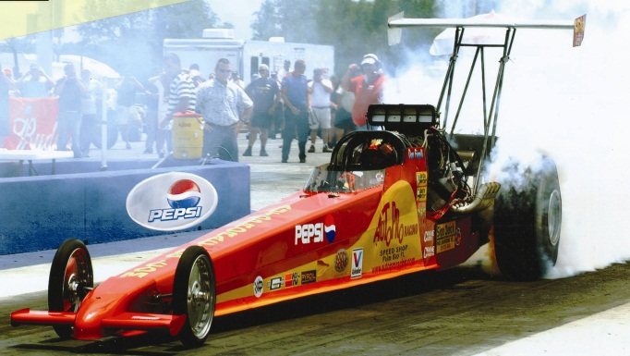This is your chance to learn how it is done. You are going to come up with a super, fantastic idea for your dragster. Next, you will refine your idea. When everything is just right, you will make a prototype of how your dragster will look. After you have worked out all the bugs you are going to build a miniature dragster. The final test will come when you race against others in your class. All cars will be compared for excellence in design, neatest idea, best craftsmanship and fastest racing time.

## B) THE DESIGN PROCESS

## To make it easy and fun you should design and build your dragster in five easy steps. We call this the ‘Design Process’. This process can take a few minutes or several hours. It can be easy or somewhat difficult. Quite often this process is not as hard or complex as some people make it.

## Nicolas-Garfias-design-sketch-lg

As you go through each step you will be using the same methods used by big car manufactures in Adelaide, Detroit and Germany. They start with drawings and ideas on paper. After the ideas have been refined they produce a prototype. Next, they will build a mock-up model that is actual size. The final stage is the production of a teat car. And when all is finally perfected the car is mass produced for the consumer market. Many years of planning and testing goes into each year’s new model automobiles. Read the four design process steps which follow.

***A finished car begins with an idea drawn on a piece of paper.***

**THUMBNAILS**

1

Thumbnails are very little drawings on paper. They help you see how your dragster is going to look. They can be drawings of the whole car or just part of the car such as the front end. They are called thumbnails because they are small. They are not detailed drawings, just quick sketches to give you ideas.



## Rough ske

**ROUGH SKETCHES**

2

Sketches are more detailed drawings of what your dragster will be like. They are larger than thumbnail drawings and will show your car from different points of view.

## 

**FINAL DRAWING**

3

Final drawings show the details of your dragster and they are drawn to exact size. You will draw these on grid paper that will be used as a pattern to produce the final car. These drawings should be very exact and work as a blue print.



**PRODUCTION**

4

When producing the final dragster, good craftsmanship is very important. Your dragster will perform its best if you build it very carefully.

## 

**Examples of Dragster Shapes and Styles**

**1. Shell Cars – Wheels hidden inside the body**

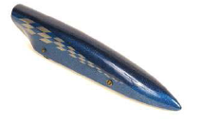 

## 2. Rail Cars – Wheels outside the body



## 3. Hybrids – Wheels inside and outside the car



## Design Parameters/Limitations:

Design Parameters or limitations in the design process lets you know what you can and can not do. The better you understand your limitations; the better you will be able to construct your dragster.

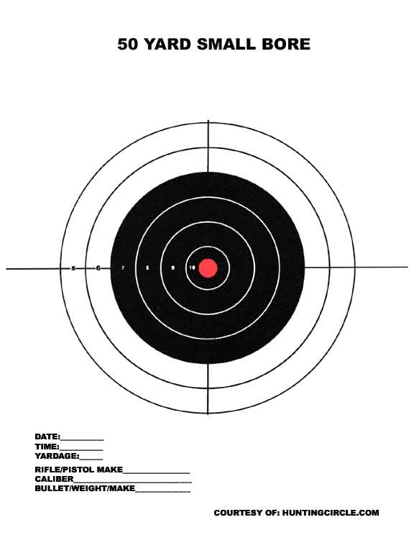

**On Target!**

Think of limitations as a target. On a target the circles get smaller until you reach the smallest circle of all, the bull’s eye. Without these circles it would be impossible to shoot and hit the centre. They provide limits that tell you whether you are close or far away from the centre.

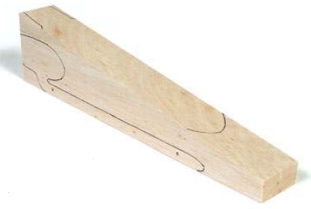**Parts of your CO2 Dragster**

1) Dragster Body – Block of balsa wood cut to the dimensions shown below

2) Axles – 2 metal axles

3) Bearings – 2 straw bearings

4) Washers – 4 metal washers

5) Screw Eyes – 2 metal screw eyes

6) Wheels – 2 Plastic front wheels, 2 plastic rear wheels

**Know the Limitations**

Your dragster must be made within certain limitations and specifications. To produce it properly you must learn what these requirements are before beginning the design process.

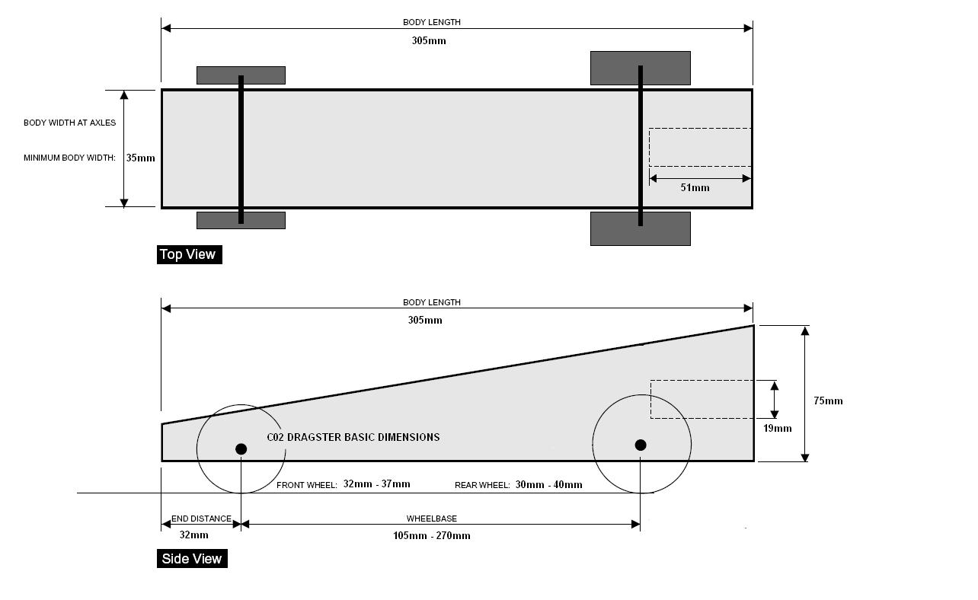

**Design Carefully!**

This page lists what your production specifications are. You will start with a block of balsa wood cut to the dimensions shown in the diagram on the previous page and from the table below. It can not be any longer or wider than the measurement shown. The engine for the dragster is a pressure-filled CO2 cartridge which fits into the back of the dragster. Make sure the cartridge can be fully inserted when the dragster is finished. Follow all given specifications.

|  |  |  |  |
| --- | --- | --- | --- |
|  | **Production Specifications** | **Min** | **Max** |
|  | **Dragster Body** |  |  |
| A | Dragster body length | 200mm | 305mm |
| B | Dragster body height at rear with wheels |  | 75mm |
| C | Dragster body mass / weight with wheels | 45g | 170g |
| D | Dragster body width at axles – front & back | 35mm | 42mm |
| E | Dragster Body width (including wheels) |  | 90mm |
|  | **Axles / Axle Holes / Wheelbase** |  |  |
| F | Number of axles | 2 | 2 |
| G | Bottom of axle hole above bottom of dragster | 5mm | 10mm |
| H | Rear axle hole from rear of dragster | 9mm | 100mm |
| I | Wheelbase | 105mm | 270mm |
|  | **Spacers / Washers / Clips** |  |  |
| J | Spacer washers |  | 8 |
| K | Axle clips or similar |  | 8 |
|  | **Power Plant ( CO2 Cartridge Hole)** |  |  |
| L | Power plant: depth of hole | 50mm | 52mm |
| M | Power plant: housing thickness (around entire housing) | 3mm |  |
| N | Power plant: housing (diameter) Please use a 3/4″ (19.5mm) Drill for best results. | 19.5mm | 19.5mm |
| O | Power plant: lowest point of chamber diameter to race surface with wheels | 26mm | 36mm |
|  | **Screw Eyes** |  |  |
| P | Screw eye or eyelet inside diameter | 5mm | 8mm |
| Q | Screw eyes (2) distance apart at farthest point | 155mm | 270mm |
|  | **Wheels** |  |  |
| R | Wheels: front diameter | 32mm | 37mm |
| S | Wheels: front width at surface contact point | 2mm | 5mm |
| T | Wheels: rear diameter | 30mm | 40mm |
| U | Wheels: rear at surface contact point | 15mm | 18mm |

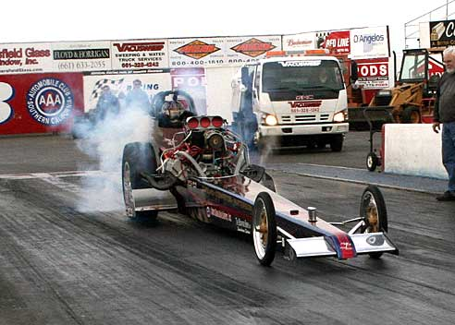

**C) PROJECT DEVELOPMENT**

**The Science of CO2 Racing**

**Expanding Gas: Boyle's Law**

How does a CO2 cartridge propel a car down the track? The answer has to do with Boyle’s Law.   
  
**Volume and Pressure**  
In a confined container, the volume of a gas is inversely proportional to the pressure that is applied when the temperature is constant. Stated another way, if you double the pressure, you reduce the volume by half.

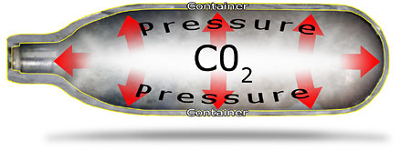

This is exactly the case with CO2 cartridges. At the factory, they are filled with pressurised carbon dioxide gas and then sealed. The CO2 is confined to a small container; the volume of the gas would be much greater if it were released into the air. The large volume of CO2 can fit inside the small cartridge because of the pressure that has been applied to it.

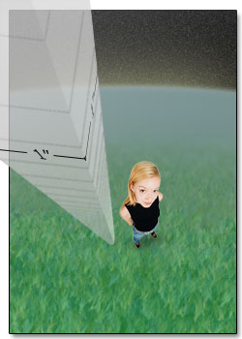  
**Atmospheric Pressure**  
The air around us is actually under pressure as well. Atmospheric pressure is 10.2 tonnes per square meter at sea level. Imagine a one meter cube of air. Now imagine a stack of one meter air cubes that reaches from the ground all the way to the edge of the Earth’s atmosphere. That stack of air cubes actually weighs 10.2 tonnes.   
  
The pressure inside a CO2 cartridge is far greater than atmospheric pressure. That’s why the gas escapes so rapidly when the cartridge is punctured. The gas continues escaping until the pressure inside the cartridge equals the atmospheric pressure outside the cartridge.

**Inertia**

Merriam-Webster's Collegiate Dictionary defines inertia as: “a property of matter by which it remains at rest or in uniform motion in the same straight line unless acted upon by some external force.”

What this means for a racecar: The greater the mass of the car, the more energy required to get the stationary car moving. If two cars use the same amount of propulsive energy, the car with the lower mass will accelerate faster.

***Surface friction*** and ***fluid friction*** also come into play as the inertia of the stationary car is overcome. If the masses of two cars are equal, then the winner will likely be the car with the least friction.   
  
Because all CO2 racecars use the same amount of propulsive energy (the escaping gas from a CO2 cartridge), it is important to reduce all factors that contribute to inertia.

**Thrust: Newton's Third Law of Motion**

Sir Isaac Newton’s third law of motion states that for every action (or force) there is an equal reaction (or opposing force) in the opposite direction.   
  
CO2 cars are propelled by carbon dioxide rapidly escaping from a small container called a cartridge. The cartridge is positioned in the car so that the escaping gas moves in a rearward direction. The rearward force of the escaping gas is the initial action described by Newton.   
  
The reaction part of Newton’s law is fulfilled by the car’s movement. Remember that the reaction occurs in the opposite direction: when gas escapes in a rearward direction, the car moves forward. As the car begins to move, its resting inertia is overcome.

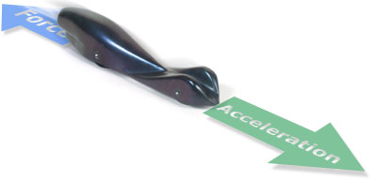

**Friction**

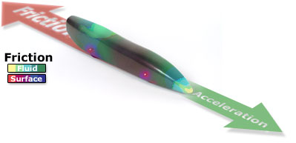

Friction – a: the rubbing of one body against another; b: the force that resists relative motion between two bodies in contact.  
(Source: Merriam-Webster's Collegiate Dictionary)

Two types of friction come into play with CO2 racecars: ***surface friction*** and *fluid friction*. Both of these are inversely proportional to speed!

**Surface Friction**

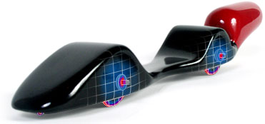

Depending on a car’s design, friction may occur between the wheel and axle or the axle and body material. An often overlooked fact: Smaller diameter wheels rotate more times as they travel a given distance than larger diameter wheels do. Therefore, friction is more prevalent with smaller diameter wheels.

Friction also occurs between the wheel and the track surface. In a passenger car, friction between the tire and road surface gives you traction, which is a good thing. The wheels, however, do not propel a CO2 car, so the less wheel/road surface friction, the better. While friction may be reduced for better performance, it cannot be totally eliminated.

**Fluid Friction**

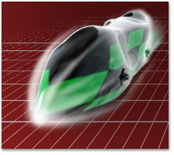As the racecar travels down the track, it moves through a fluid. Most people don’t think of air as a fluid, but it is. While in motion, the car’s surface contacts air molecules. Because there is relative motion between the car and air molecules (the car is in motion while the air is stationary), friction occurs.   
  
Fluid friction contributes to aerodynamic drag, which is a resistance to the forward motion of a body through a fluid (the air).

Automotive engineers test their designs in wind tunnels. A wind tunnel simulates road airflow conditions by moving a stream of air around a stationary car. The speed of the moving air can be varied from very slow speeds to fast highway speeds.

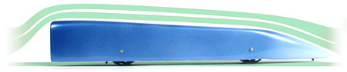

Well-designed wind tunnels produce a laminar airflow. Laminar flow is a straight, layered flow of air without turbulent air pockets known as eddies. It is desirable for a car in the tunnel to disturb the laminar flow of air as little as possible. Features such as large side mirrors jut out into the air stream and cause turbulence. The presence of turbulence increases the aerodynamic drag, which resists the car’s forward motion.

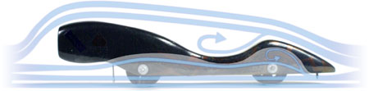

CO2 racers can also test their cars in the schools wind tunnel. It measures the frontal drag force in grams. An add-on accessory called the Fog Maestro enables the introduction of a visible vapour into the test chamber, clearly indicating any turbulence generated around the car body.

**Speed**

How fast is your car going? Calculating the speed (average speed) of a racecar is pretty simple. The formula is:

**Average Speed = Distance/Time**

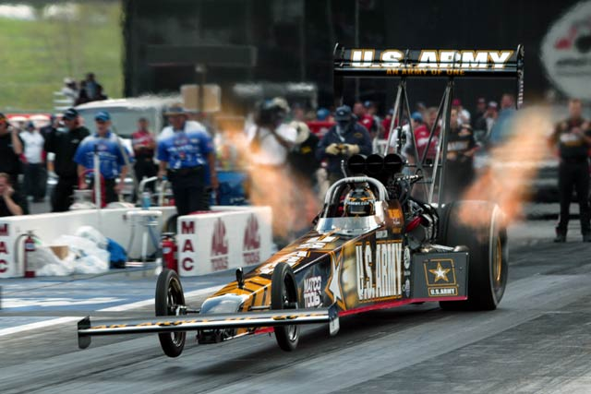

To plug in some numbers, our distance will be 20 Meters (m) (official distance) and our time will be 1.22 seconds (s) (a pretty fast race time).

20 m/1.22 s = 16.39 m/s

To convert your speed to kilometres per hour (kph) we have to know a few things. There are:

1000 metres in a kilometre  
3600 seconds in an hour

Plug in those numbers and we can figure out the speed in kph.

16.39 m/s x 3600 s/1000m = 59 kph

Our dragster is roughly 1/20th the size of a top-fuel dragster.  
If it were full size, it would be going almost 1180 kph! (20 x 59 kph)

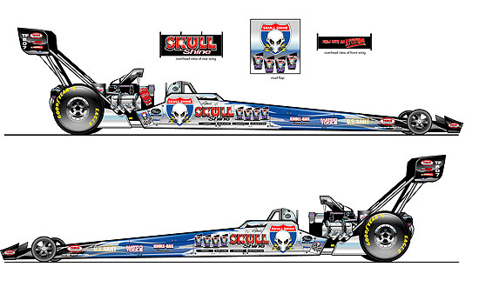

**Communicating Ideas**

As part of the design process you will be asked to draw your designs on graph paper as shown below. This will act as a template for your CO2 Dragster design which will assist in the construct of your final design.

***Directions on how to use graph paper:***

Lightly draw you car's shape in the top and side view boxes below. Once you are happy with your design, darken in your design using good, hard lines drawn with drafting equipment. Finally, lightly shade in the design adding any possible paint schemes you may wish to add to your car.



In the box below it shows some of the evaluation criteria that will be used to assess your design work.



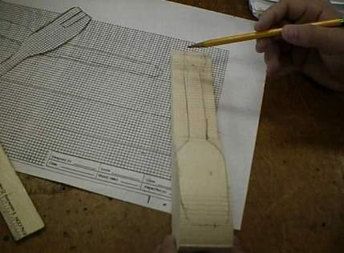

**D) PROJECT REALISATION**

**CO2 Dragsters Design and Construction Notes for Students**

**Working Drawings**



The working drawing is a precise, 1:1 scale drawing that describes your car and its features. Working drawings should have top and side, or profile, views. An accurate working drawing is important for two reasons:

1) A copy of the working drawing serves as a template for rough-cutting your car blank.

2) You may be required to submit your working drawing. It could be part of your grade or even be scored for competition points (ask your teacher about this).



**Transferring Design to Body Blank**

Cut out the top and side (profile) views from a copy of your working drawing. Then, carefully trace the outline of the views onto the wood blank.

**Drilling Axle Holes**

1. Transfer the axle hole locations onto the blank by using a sharp pointed tool such as an bradawl to puncture through the template and into the wood blank.

2. Lay the car blank on its side and drill 3mm axle pilot holes. The holes should be drilled perpendicular to the car’s longitudinal axis in order for the car to roll freely and straight down the track. A drill press is highly recommended because it makes drilling perpendicular holes a cinch.

3. These pilot holes can be enlarged to the size you need later.

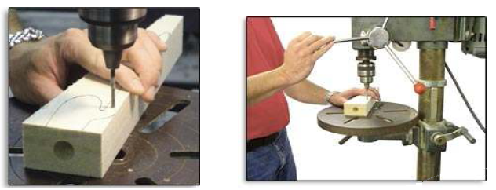

**Note:** Drill First: Axle holes in the body blank should be drilled before doing any shape cutting. Otherwise, it's difficult to drill straight.



**Rough Shaping the Car Body**

1. Use a scroll saw or get the teacher to use the band saw to roughly shape the blank:

a. Turn the blank on its side and cut out the profile view first.

b. Fit the waste pieces and working piece back together and secure them by wrapping two bands of masking tape around the assembly.

c. Set the blank assembly upright and cut out the top view.

d. Remove the masking tape and discard all the waste pieces.



2. Smooth the corners of your car body. Use a wood rasp, files, or rough sandpaper (80 grit) to smooth the car to its basic rounded shape.

3. Periodically check your car against the spec sheet (especially weight) to make sure the car is still within tolerances. When weighing your car, put the wheels, axles, washers, screw eyes, and any other necessary hardware on the scale along with the body. Allow for the weight of paint coats too.



If your design calls for a hollowed-out body, a high-speed rotary multi-tool works nicely. A variety of milling and sanding bits are helpful for making cavities in the car body. When using power tools to shape the car body, go slowly and cautiously. It’s very easy to remove too much wood and ruin your car!

**Fine Shaping the Car Body**



At this point, your car has assumed its basic shape. Now you’re at the stage that separates the really fine cars from the mediocre cars. Extra time and effort spent during the fine shaping, or pre-painting, stage have a huge payoff in the kerbside appeal of the final product.

Use sandpaper to remove unwanted bumps and irregularities from the body. Use progressively finer grit paper as you go. For example, you might start with 80-grit paper (very course, removes a lot of material) and progress to 220-grit (fine paper for smoothing surfaces).



Check your car for symmetry, and sand the body as needed. Also, exposing your car to bright light can help reveal imperfections that need attention.

**Painting Your Car Body**

As in the fine shaping stage, extra patience and effort put into the finishing stage can pay big dividends.

Be aware that using several coats of paint can add weight to your car.

1. Make up a handle and hanger. Cut a 500mm length of flat cut (5mm X 18mm approx) timber.

Slightly sand off the edges at one end and drill a hole in the other.



2. Insert the handle into the power plant housing of the car body so that the timber jams slightly against the sides of the power plant hole. Enough to hold it on the handle when it is hanging down.

This makes a very convenient handle for turning the body to paint it from all angles and you can hang it from a nail over a drip container while the paint dries.

3. Apply undercoat and sand between coats.

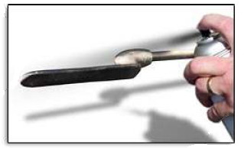

4. Use a spray can or airbrush to apply paint to the body. Spray light coats and wait several minutes between coats to allow the paint to dry.

**TIP**

**Filler:** To achieve a super smooth finish on porous balsa wood use a wood filler and sanding primer to fill problematic end-grain areas.

**Final Assembly**

Mounting Wheels and Hardware

Don’t overlook the importance of this stage. A huge factor in race performance is how smoothly the car rolls down the track. Some meticulously shaped cars have failed to finish races because of improperly installed hardware!



1. Gather your hardware: two axles, two straw bearings, four wheels, four washers, and two screw eyes. Depending on the configuration of the car body, different hardware might be required. Shell cars (with internal wheels) often require wheel spacers and clips to affix the axles to the car body.

2. Check your spec sheet for rules about wheels, axles, washers, and spacers.

3. Check that the wheels have no plastic joining tabs on the rims. If they do, trim them off with a craft knife.



4. Carefully mount the wheels and axles as dictated by your design. Be careful not to damage the fragile car body during installation.

5. Roll test the car on a smooth, horizontal surface. The car should roll freely, and the wheels should spin without restriction. Make adjustments if necessary.



Install the screw eyes on the underside of the car body. Important: Plan the location of the screw eyes so the guideline does not rub against the car body or wheels.

**TIP**

Just a Dab: A drop of epoxy glue can help solidify screw eyelet mountings in soft balsa.

**TIP**

Screwy Eyes: Don’t use screw eyelets that are partially open. Doing so can cause your car to detach from the guideline and slow or even damage your car.

**TIP**

Lube 4 Speed: Heard of dry powder graphite? It's a great lubricant for axles.

Notes on construction assembled by I B MCKENZIE Sept 2008 © brucenancy@xtra.co.nz [www.CO2dragsters.co.nz](http://www.co2dragsters.co.nz)

**E) Testing**

Good Luck! You’re now ready to roll. Now you have the race to look forward to. But before then, the dragster should be tested. The class should build an inclined test ramp by supporting a raised end of a plywood board

When you roll the dragster down the ramp, check for the following points.

* Does the dragster roll in a straight path?
* Are the wheels on straight?
* Do the wheels spin freely?
* Were the washers mounted with the axles?
* Are the tires tight against the wheel hub? They should not spin on the hub.
* Try to find out what might be causing problems.

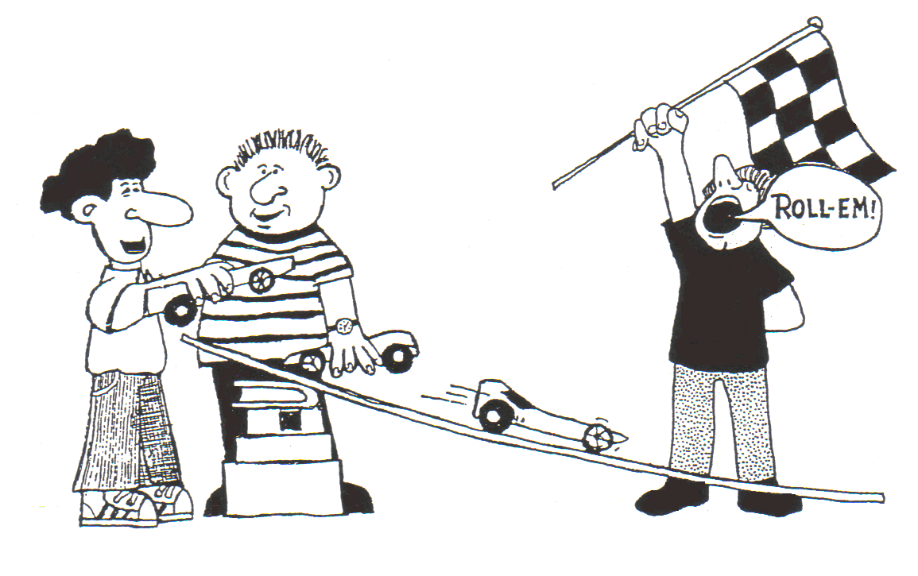

**F) Evaluating**

The final stage of the process is to evaluate your design. From the criteria that you set yourself at the beginning of the design process you need to determine if this project was successful. Remember that all cars will be compared for excellence in design, neatest idea, best craftsmanship and fastest racing time.

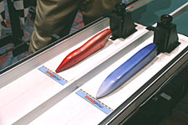

***At the start gates***