STEM Inquiry Based Unit of Work – S3
Plants in Space
Duration – eight weeks, one and a half to two hours each week or equivalent
Science and Technology focus: Working Scientifically, Design and Production, Living World, Material World

Driving question:
What are the challenges of space exploration and, more specifically, to growing plants in space? Can we develop a solution to meet one of the challenges of growing plants in space?

Project Description
As humans seek to explore and colonise outer space, it is critical to develop efficient ways to grow plants to provide a reliable source of renewable food and oxygen. Finding solutions to the challenges of growing plants in space requires innovative thinking and an understanding of both the growth requirements of plants and of the environmental conditions experienced in space.
Note: Given the time required to grow plants, overlapping Learning Sequence 2 (Conduct a scientific experiment) and Learning Sequence 3 (Research and identify the challenges of space exploration and colonisation) is recommended.

Unit aims and objectives
Students:
- design and conduct fair tests
- develop a deeper understanding of the growth requirements of plants
- define problems faced by scientists as they seek to grow plants in space
- develop teamwork and collaboration skills
- are introduced to the design thinking process
- are encouraged to solve real-world problems
- apply their knowledge to develop a design solution to meet one of the challenges to growing plants in space
- engage with critical and creative thinking
- provide and receive constructive feedback.

Key inquiry questions
- How can we test for the growth requirements of plants?
- What are the challenges of space exploration and, more specifically, to growing plants in space?
- What design solutions can we develop to meet the challenges of growing plants in space?

Syllabus outcomes

Science and technology
Science and Technology | Science and Technology outcomes
Working Scientifically | ST3-1WS-S: plans and conducts scientific investigations to answer testable questions, and collects and summarises data to communicate conclusions
Design and Production | ST3-2DP-T: plans and uses materials, tools and equipment to develop solutions for a need or opportunity
Design and Production | ST3-3DP-T: defines problems, and designs, modifies and follows algorithms to develop solutions
Living World | ST3-4LW-S: examines how the environment affects the growth, survival and adaptation of living things

Mathematics
Mathematics | Mathematics outcomes
Working Mathematically | MA3-2WM: selects and applies appropriate problem-solving strategies, including the use of digital technologies, in undertaking investigations
Measurement and Geometry - Length | MA3-9MG: selects and uses the appropriate unit and device to measure lengths and distances, calculates perimeters, and converts between units of length
Measurement and Geometry - Volume and Capacity | MA3-11MG: selects and uses the appropriate unit to estimate, measure and calculate volumes and capacities, and converts between units of capacity
Measurement and Geometry - Mass | MA3-12MG: selects and uses the appropriate unit and device to measure the masses of objects, and converts between units of mass
Statistics and Probability - Data | MA3-18SP: uses appropriate methods to collect data and constructs, interprets and evaluates data displays, including dot plots, line graphs and two-way tables

English
English | English outcomes
Speaking and listening | EN3-1A: communicates effectively for a variety of audiences and purposes using increasingly challenging topics, ideas, issues and language forms and features
Reading and Viewing | EN3-3A: uses an integrated range of skills, strategies and knowledge to read, view and comprehend a wide range of texts in different media and technologies
Thinking Imaginatively, Creatively, Interpretively and Critically | EN3-7C: thinks imaginatively, creatively, interpretively and critically about information and ideas and identifies connections between texts when responding to and composing texts

Learning sequence 1: Design and conduct fair tests

Learning intention
The intention of this learning sequence is to determine students’ prior knowledge about plant growth requirements and for students to plan a fair test.

Success criteria
Students will be able to:
- represent their current understanding about plant growth requirements
- demonstrate an understanding of what defines a fair test
- design a fair test, to determine the needs of growing plants.
Inquiry/focus question and content | Resources | Assessment opportunities
Find out (brainstorm) what the students know or think they know about the growth requirements of plants. This could be done as a whole group, small groups or think-pair-share. Consider light (including source and colour of light), soil, nutrients, water, temperature, air, and space to grow.  Challenge these assumptions: How do students know that these assumptions about plant growth requirements are true?  Ask students what they predict will happen if one of these growth requirements is taken away or changed | Butcher’s paper and coloured markers or an interactive collaborative brainstorming or mind mapping tool such as MindMeister or Padlet  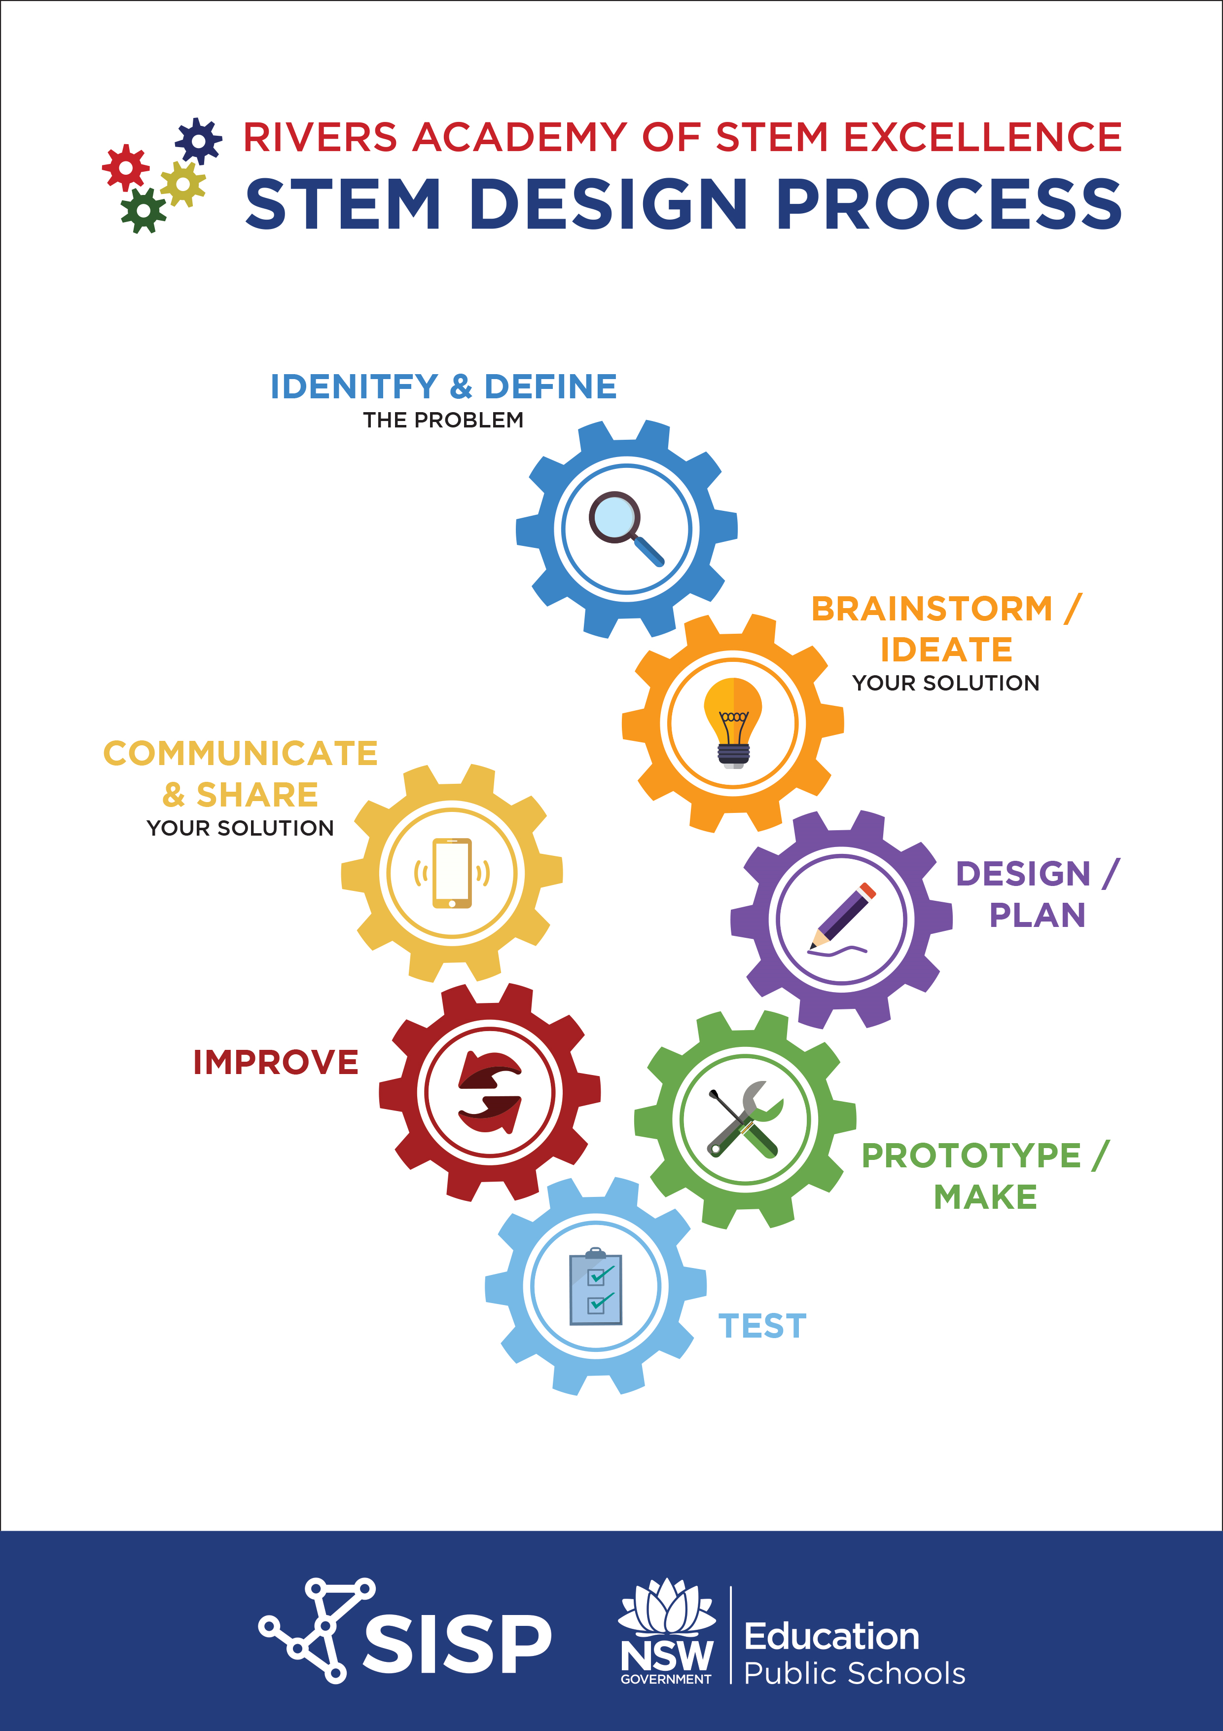 | Brainstorming chart  Participation in discussion (check for use of relevant vocabulary and explicitly teach any gaps in knowledge and understanding)
Can we design an experiment to demonstrate plant growth requirements?  - Introduce or recap the concept of a fair test (either through a physical demonstration or by viewing an information text online).  - Highlight the need to change only one variable at a time.  - In a fair test, variables are things that can be changed or kept the same. Scientists change one variable (for example, the amount of light) to see what affect this has (for example on the height of a plant).  Notes: There are different categories of variables. The thing being changed is called the independent variable (e.g. amount of light) and the thing being affected by the independent variable is called the dependent variable (plant height).  Controlled variables are all the things that could be changed but are kept the same (for example, keep the amount of water, size of container, temperature, amount of soil, plant type etc. the same for each plant and only change the amount of light). In this example, only the impact of changes in light are being measured. This is a fair test. | Digital resource: Plant Lab - This resource enables students to explore the concept of a fair test. Using Plant lab, students design and run an investigation to test the effects of changes in four physical conditions (variables) on plant growth. Results can be generated as a PDF report | PDF report from Plant Lab virtual experiment. Did students change one variable at a time? Did they demonstrate an understanding of why only one variable is changed at a time?
In small teams, students choose one testable plant growth requirement (for example light).  Students brainstorm and pose a testable question to test for this requirement. They then submit a design plan which includes:  - predictions about the investigation  - materials needed for the experiment (with consideration for sustainability)  - a labelled and annotated design drawing  - what is being measured and how. | Science journals (in the form of a notebook, online file folder, PowerPoint etc.) | Design Plan (including annotated drawings, photos, diagrams etc.)
Write up the proposed experiment in science journal.  Scaffold this process for students:  - aim of investigation  - hypothesis (what student predicts will happen)  - materials  - method – (ensure students select appropriate measurement methods and are measuring for one variable)  - observations and Results (discuss with students how they plan to collect, record and analyse data and observations)  - conclusions.  Ask students: What are they changing (the independent variable), what are they measuring (the dependent variable) and what is going to stay the same (controlled variables). | Science journals | Science journals – look for a clear outline of the experiment and that students demonstrate understanding of the concept of a fair test. Are students changing only one variable? What are they looking for by changing a variable? Are the methods they have chosen to measure results appropriate for the task?

Learning sequence 2: Conduct a scientific experiment

Learning intention
Students conduct a fair test to demonstrate growth requirements of plants. They present and discuss their findings with the whole class.

Success criteria
Students:
- work scientifically to plan and conduct a fair test
- process and analyse data to demonstrate an understanding of the growth requirements of plants.
Focus/inquiry question and content | Resources | Assessment opportunities
Following steps in science journal, teams set up their experiments  Teams may find that they need to adjustment their experiments – this trial and error is part of the process of working scientifically.  Safety note: Soil may contain mould and bacteria. When working with soil, work in a ventilated space, wear gloves, avoid inhaling the mix and wash hands thoroughly after use. | Soil, seeds or seedlings, plastic bottles, containers, measuring cylinders, scales, water, cotton wool, tape, rulers  Students collect additional resources for their experiment.  Brainstorming chart from Learning Sequence 1. | Team work observations. Do all students in the team have a meaningful role? Encourage students to reflect on their teamwork and collaboration skills  Presentation and interpretation of findings.
Record observations in journals - include annotated drawings, photos, and tables/charts. These will be incorporated into team presentations.  - Model to students how to draw a scientific diagram (draw in pencil and include a title, scale and clear labels).  - Model to students how to record and graph results.  Support students to construct tables and graphs to organise data and look for patterns. They use this evidence to compare with their predictions, draw conclusions and develop explanations. | Science journals, cameras (Students may wish to include photographic evidence to record experiment.) | Science journals – are diagrams clearly labelled? Is data recorded in correct units of measure? Is data recorded in a clearly labelled table? Are graphs clear and reflective of the data collected?  Science and Technology: Analyse predictions and use discussions to determine if students can: make predictions about possible findings, record observations accurately and honestly using observational drawings, collect data from observations  Mathematics: Use work sample analysis of data collection and discussion to determine if students can: accurately create and interpret a picture or column graph from data collected in a table. Data could be published in electronic form using a table or excel
Presentation.  - Findings are presented and discussed with whole class. The presentation provides an opportunity for students to incorporate digital technologies.  Teacher Questioning:  - Were there any unexpected findings? (For example, plants that grow without light.)  - Why do you think the results happened?  - Did your investigations support the ideas you had before the experiment? (compare data with predictions)  Unexpected results or no observable changes are to be welcomed and used to initiate further scientific investigation and design. | Presentation resources (such as posters, Prezi, PowerPoint, oral presentation with props etc.) | Presentation and interpretation of results - do students demonstrate an understanding of key concepts? Do their conclusions relate back to their original predictions? Is their information from reliable sources? Do their arguments and reasoning demonstrate a grasp of central ideas and concepts?  Analyse predictions and use discussions to determine if students can; make predictions about possible findings, record observations accurately and honestly using observational drawings, collect data from observations.

Learning sequence 3: The challenges of space exploration and colonisation

Learning intention
Students develop research and inquiry skills and share knowledge with peers. Students research and identify the challenges of space exploration and colonisation

Success criteria
Students:
- demonstrate research skills and record and share ideas
- demonstrate an understanding that growth and survival of living things are affected by the physical conditions of their environment.
Inquiry/focus question and content | Resources | Assessment opportunities
Inquiry questions to facilitate learning: Should humans attempt to colonise space? Why is Earth the only planet humans have colonised?  Students explore the question: How are conditions in space different from conditions on Earth and what challenges does this present to humans as they seek to explore and colonise space?  Identify challenges faced during space exploration. Facilitate discussion that considers both physical and social challenges of space travel and make lists that will be revisited for further investigation.  - physical problems to consider; breathing, eating and drinking, bathing, going to the toilet, temperature extremes, micro-gravity, solar radiation, having enough water, food, and air, muscle degeneration, rubbish treatment/removal, communication, renewable power sources, being impacted by meteorites and meteoroids  - social problems to consider; feelings of isolation, homesickness, working in a team for long periods of time, experiencing anxiety or depression | Collaborative brainstorming or mind mapping tool such as MindMeister or Padlet  Model for students how they might research the challenges of space exploration and colonisation. Co-develop a list of keywords to support them and model researching using keywords  Example websites to engage students  Just another day in the office: life in space  In this short clip (7:50) from ABC Education, an astronaut describes what life is like on the International Space Station (ISS) and what types of experiments they conduct on the ISS  Living on the moon (2mins 43secs) This clip supports concepts around how physical conditions affect growth and survival  Growing vegetables in space  How it works: The International Space Station Tour of the ISS by NASA astronaut, Sunita Williams | Mind maps showing thinking processes – have students identify both physical and social/emotional challenges of space exploration? Have they identified cause and effect relationships? (For example, the importance of home comforts in helping overcome sense of isolation and loneliness when travelling for long periods of time in space)
Students choose one challenge faced by space explorers and find out what sorts of solutions already exist. In Learning Sequence 4, students will develop and present their own innovative solutions to the challenge. | Internet, identified experts in their field etc. | Were students able to identify more than one new solution to the challenge of space exploration?

Learning sequence 4: Critical and creative thinking design production project

Learning intention
Students extend what they have learned through research and experimentation to create a design solution that addresses and identified problem.

Success criteria
Students:
- clearly identify a challenge to growing plants in space
- propose and design an innovative solution to the problem
- evaluate the effectiveness of their design solution against criteria set in assessment rubric.
Inquiry/focus question and content | Resources | Assessment opportunities
Either individually or in small teams, research and identify a problem encountered when growing plants in space and design a solution to this problem. Students follow the design process to achieve their solutions.  Depending on experience and capabilities, some students may need support with formulating ideas. Suggestions could include:  - design a bio-dome (terrarium) in Minecraft Edu and/or build a working scale model  - design and make a robotic hand to work with plants in space environment  - make an automated watering system  - design and make a hydroponic system  - design a mechanism to pollinate plants  - design and make a space-saving garden (images vertical gardens may provide ideas)  - code a system to water or deliver fertiliser to plants (an unplugged version could be similar to a Rube Goldberg Machine). | Integrated STEM Design Process  Since projects will be student-led, a variety of resources will be required  Encourage the use of recycled and sustainable resources  Minecraft Education Edition and Minecraft Edu Building a Biome may be useful and engaging for those students wishing to demonstrate their design solution in digital format | Research skills – critical and creative thinking  Team dynamics – team work, communication, collaboration, every team member having meaningful input and a role to play  Note: Through this project, students may meet other outcomes for either Science and Technology or other KLAs, depending on the topic and nature of how it is explored and presented. (For example: Aboriginal and Torres Strait Islander Cross-curriculum priorities: Investigate Aboriginal and Torres Strait Islander peoples’ knowledge of the physical conditions necessary for the survival of certain plants and animals in the environment.)
Students:  - research and plan their design solution  - submit a project plan  - consider resources required, timeline, audience, functionality, sustainability and aesthetics.  - create, test and improve their design solution |  | Project plan – does the plan indicate systematic thinking? Have they identified resources required and other planning aspects such as time constraints, audience, sustainability etc.
Whole-class presentation. Using an assessment rubric as a guide, students communicate their design solutions to a large audience (this may be their class, whole school or to the wider school community).  Students should have the opportunity to present their work to experts.This helps legitimise the project in the students' eyes by having feedback about their prototype in terms of how it would fit to a real-life situation.  Presentations provide students with opportunities to demonstrate their understanding to an audience. The format may be spoken or written, multimedia or a combination of these.  Presentations may be prepared or impromptu, depending on the activity requirements.  Peer and self-assessment may be used in conjunction with this assessment strategy. | Assessment rubric (teacher to create) | Presentation – did all team members demonstrate an understanding of the growth requirements of plants and the challenges of growing plants in space?  Was their design solution well planned and executed?  Do their arguments and reasoning demonstrate a grasp of central ideas and concepts?  Assessment activities may include:  - Formal assessment task: presentation of prototype and accompanying design drawing and explanation of prototype in action to a panel of experts  - prepared and impromptu presentations (eg role-plays, debates, dramatic presentations)  - presentations using ICT tools (eg preparation of a 20-second radio news bulletin, podcast, vodcast, documentary filmed on location using green-screen technology)  - web publication of learning (eg learning blogs, student-created websites) and the use of social technologies as a platform for presenting assessment activities and/or capturing evidence of student performance  - poster presentation explaining what worked and what did not  - drawings, symbols and words to connect the ideas and relationships between concepts  - student self-assessment against success criteria  - panel feedback.  When presentations are used for assessment purposes, students may be assessed on their ability to:  - identify, comprehend and evaluate sources  - use appropriate terms and concepts  - use appropriate forms to communicate their understandings  - present their findings using a variety of media  - combine visual and digital elements for a variety of audiences and purposes. (NESA: K-6 Assessment Strategies)

Evaluation and reflection
Use this space to evaluate and reflect on the unit, e.g. what worked well, what adjustments needed to be made to the learning sequence, future changes to the unit or professional development required.

Science and Technology K-6 Syllabus © NSW Education Standards Authority (NESA) for and on behalf of the Crown in right of the State of New South Wales, 2017.
English K-10 Syllabus © Board of Studies, for and on behalf of the Crown in right of the State of New South Wales, 2012.
Mathematics K-10 Syllabus © Board of Studies NSW for and on behalf of the Crown in right of the State of New South Wales, 2012.

